[[](https://bsky.app/profile/marinelives.bsky.social)](https://bsky.app/profile/marinelives.bsky.social)

[· 11/09/2024](https://bsky.app/profile/marinelives.bsky.social/post/3l3vjtbouer2r)

Temos um manual preliminar em português para apoiar voluntários interessados em trabalhar com o MarineLives na verificação e correção de transcrições automáticas em inglês/latim de documentos do Tribunal do Almirantado do século XVII. [raw.githubusercontent.com/Addaci/HCA/m...](https://raw.githubusercontent.com/Addaci/HCA/main/Working_with_Aurelius-HTR_Ch_1-5_PORTUGUESE_Ver.1.1_10092024.txt)

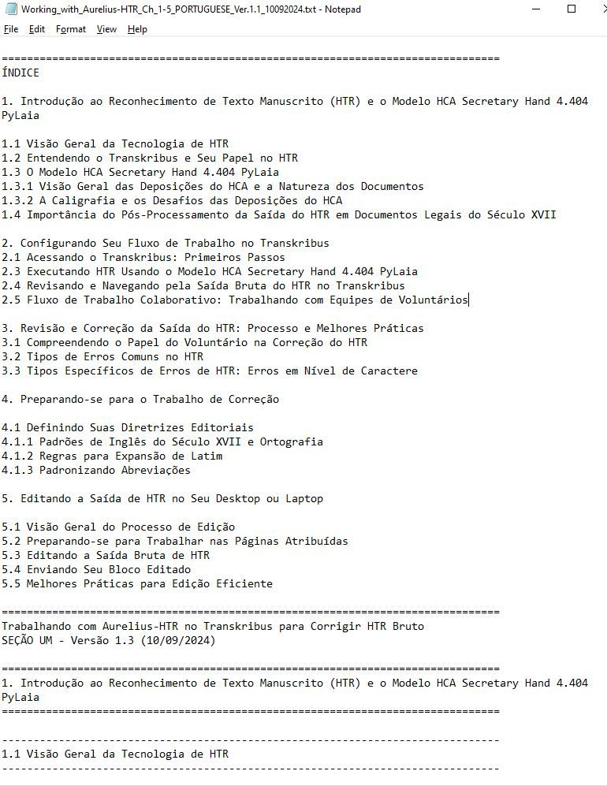

2

7

[[](https://bsky.app/profile/marinelives.bsky.social)](https://bsky.app/profile/marinelives.bsky.social)

[· 11/09/2024](https://bsky.app/profile/marinelives.bsky.social/post/3l3vbumipgo2r)

Asking for volunteers with an interest in the [#earlymodern](https://bsky.app/hashtag/earlymodern) and in [#palaeography](https://bsky.app/hashtag/palaeography) to review/test/improve a manual I am writing for the editing and correction of Transkribus HTR text from C17th legal depositions. You can access text here (1st 5 chapters of 10): [raw.githubusercontent.com/Addaci/HCA/m...](https://raw.githubusercontent.com/Addaci/HCA/main/Working_with_Aurelius-HTR_Ch_1-5_Ver.1.0_10092024.txt)

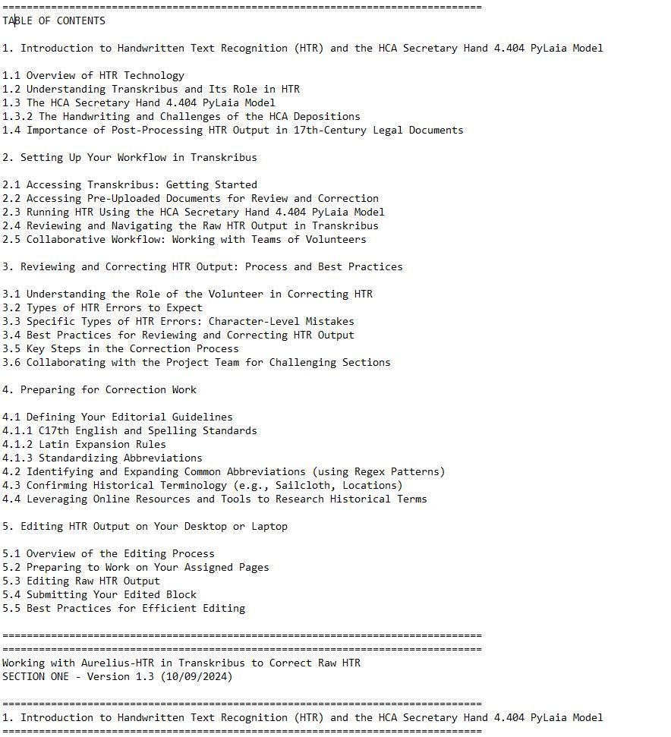

1

6

[[](https://bsky.app/profile/marinelives.bsky.social)](https://bsky.app/profile/marinelives.bsky.social)

[· 11/09/2024](https://bsky.app/profile/marinelives.bsky.social/post/3l3vchnjzon2r)

Some of the key pieces of feedback we need on the manual are: Does the correction process as described work? Does the manual explain teh process well and consistently? How ould you as an experienced palaeographer/historian/genealogist improve the process and the manual?

[[](https://bsky.app/profile/marinelives.bsky.social)](https://bsky.app/profile/marinelives.bsky.social)

[· 11/09/2024](https://bsky.app/profile/marinelives.bsky.social/post/3l3vc3t6n4p2p)

Would love your help or that of your students or colleagues

[@thiagokrause.bsky.social](https://bsky.app/profile/did:plc:m6ub6fozxlo3gzqn2rayoiwy)

[@brodiewaddell.bsky.social](https://bsky.app/profile/did:plc:44em43qq5kem43otrh3vejy5)

[@plymprivateer.bsky.social](https://bsky.app/profile/did:plc:kfm7zs4ptqe5s4oo64b4jxxo)

[@michwatsonoz.bsky.social](https://bsky.app/profile/did:plc:dszj4xibjjzzur72bqv5khzp)

[@sarageorgini.bsky.social](https://bsky.app/profile/did:plc:n7lu6umburdqswwqxqxdahnx)

[@egcarr.bsky.social](https://bsky.app/profile/did:plc:qrb3ipshc73c77m2ghqslw7f)

[@onslies.bsky.social](https://bsky.app/profile/did:plc:2xh3ekkjbuyi3e5pbfnakuyt)

[@annacusack.bsky.social](https://bsky.app/profile/did:plc:mwadlr3gdheshrk6aohdn3iv)

[[](https://bsky.app/profile/marinelives.bsky.social)](https://bsky.app/profile/marinelives.bsky.social)

[· 11/09/2024](https://bsky.app/profile/marinelives.bsky.social/post/3l3vbumipgo2r)

Asking for volunteers with an interest in the #earlymodern and in #palaeography to review/test/improve a manual I am writing for the editing and correction of Transkribus HTR text from C17th legal depositions. You can access text here (1st 5 chapters of 10): raw.githubusercontent.com/Addaci/HCA/m...



3

[[](https://bsky.app/profile/marinelives.bsky.social)](https://bsky.app/profile/marinelives.bsky.social)

[· 11/09/2024](https://bsky.app/profile/marinelives.bsky.social/post/3l3v4kw7gdt2s)

I encourage you all to read this well researched review of student use and awareness of Generative AI. The researched group are students at Oregon State Univesit: online, hybrid, and campus based. Data from Fall 2023, still relevant [#Skystorians](https://bsky.app/hashtag/Skystorians) [#earlymodern](https://bsky.app/hashtag/earlymodern) [ecampus.oregonstate.edu/research/wp-...](https://ecampus.oregonstate.edu/research/wp-content/uploads/Online-Students-Perceptions-of-AI-Report.pdf)

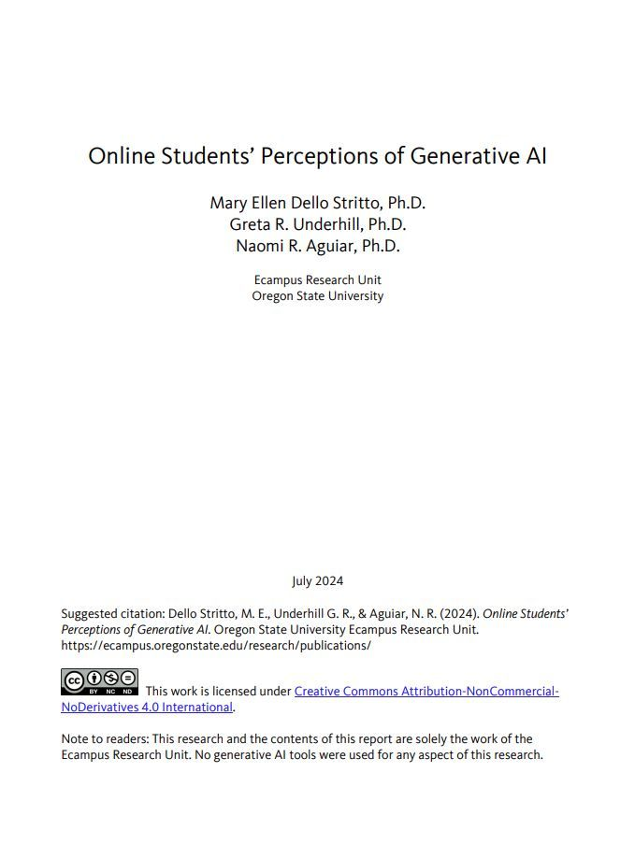

1

[[](https://bsky.app/profile/marinelives.bsky.social)](https://bsky.app/profile/marinelives.bsky.social)

[· 11/09/2024](https://bsky.app/profile/marinelives.bsky.social/post/3l3ursoocyb2o)

Please follow us and DM us on BlueSky if you would like a copy of our manual on using Aurelius-HTR to edit and correct raw-HTR output through a combination of machine and human correction [#earlymodern](https://bsky.app/hashtag/earlymodern) [#Skystorians](https://bsky.app/hashtag/Skystorians) [#machinelearning](https://bsky.app/hashtag/machinelearning) [chatgpt.com/g/g-5RyFZvdj...](https://chatgpt.com/g/g-5RyFZvdjH-aurelius-htr)

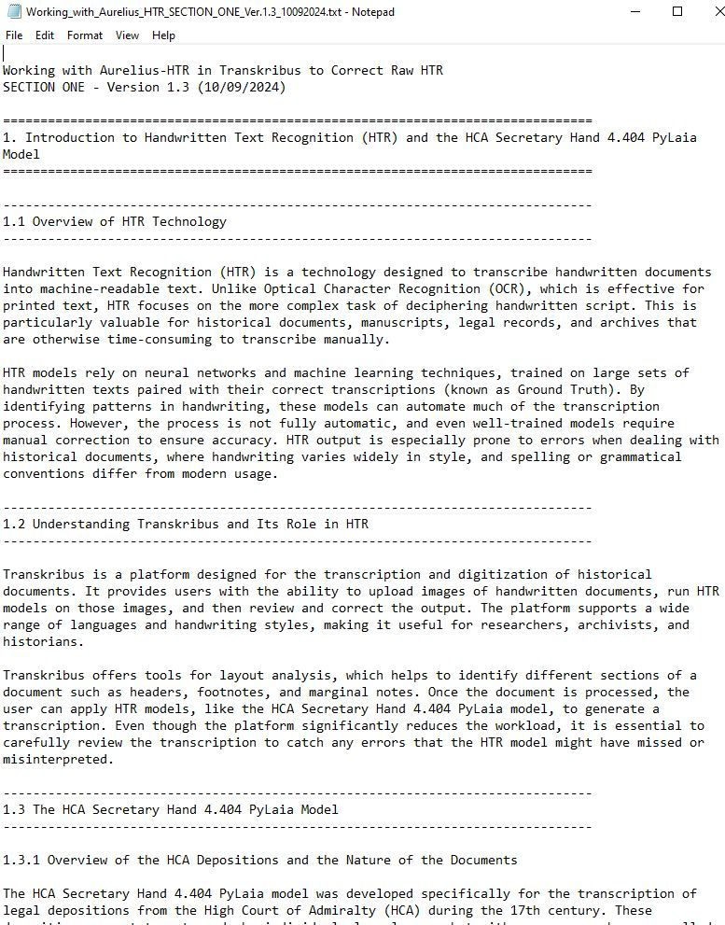

1

1

[[](https://bsky.app/profile/marinelives.bsky.social)](https://bsky.app/profile/marinelives.bsky.social)

[· 11/09/2024](https://bsky.app/profile/marinelives.bsky.social/post/3l3us7ue5lh2j)

Section 1.4 in our manual. It is tailored to the specific nature of High Court of Admiralty depositions & typical HTR errors - the MarineLives team would be happy to help you analyze your own HTR output & to write a manual for your own transcription project [#earlymodern](https://bsky.app/hashtag/earlymodern) [#Skystorian](https://bsky.app/hashtag/Skystorian)

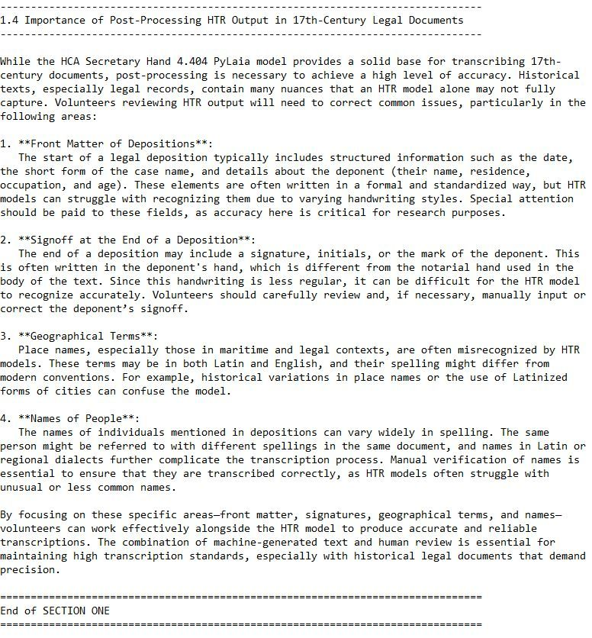

1

[[](https://bsky.app/profile/marinelives.bsky.social)](https://bsky.app/profile/marinelives.bsky.social)

[· 11/09/2024](https://bsky.app/profile/marinelives.bsky.social/post/3l3uhwghysv2m)

1/ I am teaching Aurelius-HTR to edit & correct C17th English High Court of Admiralty depositions. Let me start by showing you before (raw HTR) & after (machine corrected HTR, no human edits. Then in following posts I will show you how we got there in terms of prompts. [#earlymodern](https://bsky.app/hashtag/earlymodern) [#machinelearning](https://bsky.app/hashtag/machinelearning)

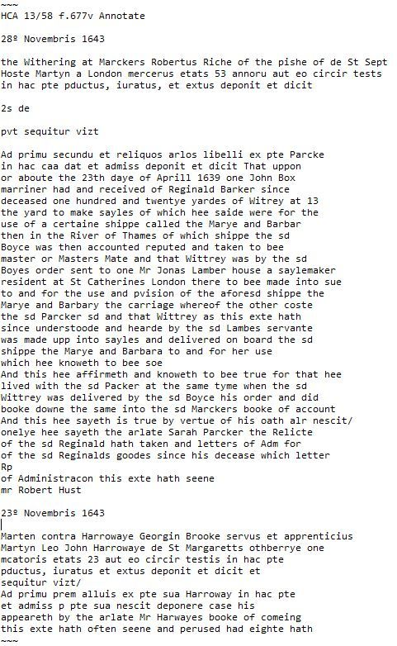

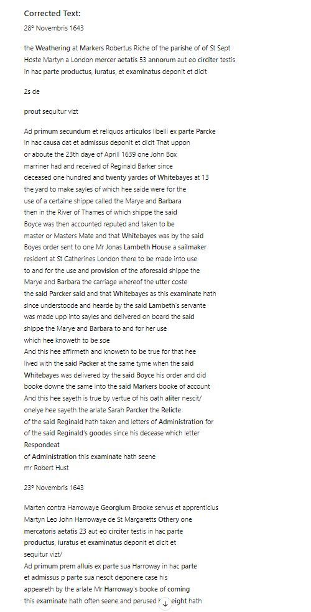

1

1

[View full thread](https://bsky.app/profile/did:plc:3haql47cl6jucf32mlqtre4p/post/3l3uhwghysv2m)

[[](https://bsky.app/profile/marinelives.bsky.social)](https://bsky.app/profile/marinelives.bsky.social)

[· 11/09/2024](https://bsky.app/profile/marinelives.bsky.social/post/3l3uqp4shcb2x)

9/ Why don't you try out Aurelius-HTR using your own C17th texts? I will be uploadeing the manual which Aurelius and I are co-writing into Aurelius-HTR's internal knowledge, so it will be able to draw on our joint insights for future machine/human raw-HTR correction [chatgpt.com/g/g-5RyFZvdj...](https://chatgpt.com/g/g-5RyFZvdjH-aurelius-htr)

[[](https://chatgpt.com/g/g-5RyFZvdjH-aurelius-htr)](https://chatgpt.com/g/g-5RyFZvdjH-aurelius-htr" \t "_blank)

**[ChatGPT - Aurelius-HTR](https://chatgpt.com/g/g-5RyFZvdjH-aurelius-htr" \t "_blank)**

[Helping historians work with Transkribus and other open source HTR programs to generate and clean up HTR-text.](https://chatgpt.com/g/g-5RyFZvdjH-aurelius-htr" \t "_blank)

[chatgpt.com](https://chatgpt.com/g/g-5RyFZvdjH-aurelius-htr" \t "_blank)

1

[[](https://bsky.app/profile/marinelives.bsky.social)](https://bsky.app/profile/marinelives.bsky.social)

[· 11/09/2024](https://bsky.app/profile/marinelives.bsky.social/post/3l3uqtbukwf2m)

10/ You can also check out the mini-research project we are working on which to fine-tune three small LLMs to assist clean up of raw HTR. Do contact us if you would like to get involved and look at the models and datasets we are developing [huggingface.co/MarineLives](https://huggingface.co/MarineLives)

[[](https://huggingface.co/MarineLives)](https://huggingface.co/MarineLives" \t "_blank)

**[MarineLives (MarineLives)](https://huggingface.co/MarineLives" \t "_blank)**

[Use of LLMs in post-production clean up of HTR for Early Modern Legal depositions](https://huggingface.co/MarineLives" \t "_blank)

[huggingface.co](https://huggingface.co/MarineLives" \t "_blank)

[[](https://bsky.app/profile/marinelives.bsky.social)](https://bsky.app/profile/marinelives.bsky.social)

[· 10/09/2024](https://bsky.app/profile/marinelives.bsky.social/post/3l3sidsxvml2r)

So I have an eel story for you!

[@greenleejw.bsky.social](https://bsky.app/profile/did:plc:vtulckfwhlh3ndn4iqfcg3an)

[www.nytimes.com/2024/09/09/s...](https://www.nytimes.com/2024/09/09/science/eels-escape-fish-stomach.html)

[[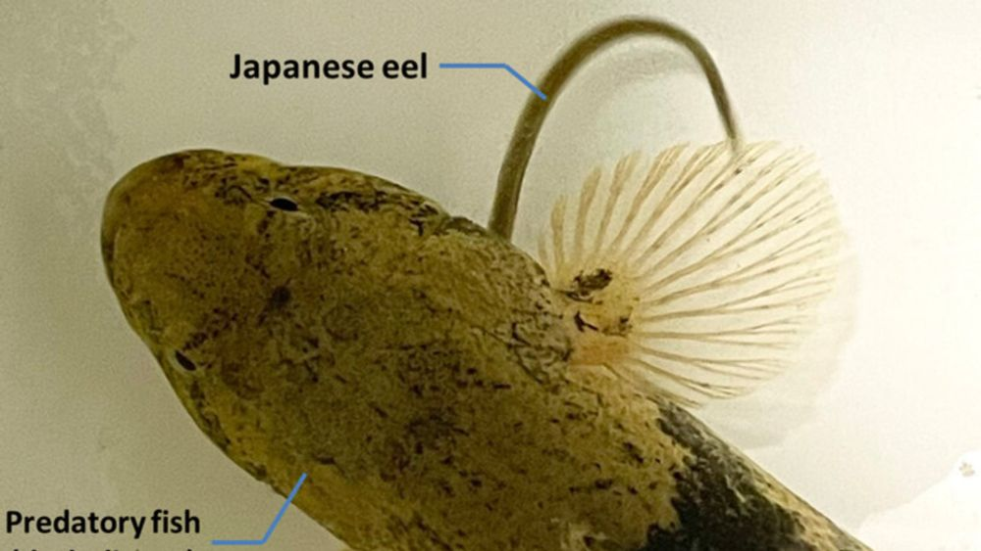](https://www.nytimes.com/2024/09/09/science/eels-escape-fish-stomach.html)](https://www.nytimes.com/2024/09/09/science/eels-escape-fish-stomach.html" \t "_blank)

**[The Terrifying Way That Eels Escape a Hungry Fish’s Stomach](https://www.nytimes.com/2024/09/09/science/eels-escape-fish-stomach.html" \t "_blank)**

[X-ray videos showed that some young Japanese eels demonstrated that they were not content to become a predator’s meal.](https://www.nytimes.com/2024/09/09/science/eels-escape-fish-stomach.html" \t "_blank)

[www.nytimes.com](https://www.nytimes.com/2024/09/09/science/eels-escape-fish-stomach.html" \t "_blank)

[[](https://bsky.app/profile/marinelives.bsky.social)](https://bsky.app/profile/marinelives.bsky.social)

[· 10/09/2024](https://bsky.app/profile/marinelives.bsky.social/post/3l3rsyqbjxh24)

We are looking at the potential integration of small fine-tuned LLMs into the cleanup of HTR produced C17th text. Would love to speak to archivists, linguists, and machine learners interested in this topic [#earlymodern](https://bsky.app/hashtag/earlymodern) [#machinelearning](https://bsky.app/hashtag/machinelearning) [huggingface.co/MarineLives](https://huggingface.co/MarineLives)

[[](https://huggingface.co/MarineLives)](https://huggingface.co/MarineLives" \t "_blank)

**[MarineLives (MarineLives)](https://huggingface.co/MarineLives" \t "_blank)**

[Use of LLMs in post-production clean up of HTR for Early Modern Legal depositions](https://huggingface.co/MarineLives" \t "_blank)

[huggingface.co](https://huggingface.co/MarineLives" \t "_blank)

[[](https://bsky.app/profile/marinelives.bsky.social)](https://bsky.app/profile/marinelives.bsky.social)

[· 09/09/2024](https://bsky.app/profile/marinelives.bsky.social/post/3l3ppqv3imo2n)

Fascinating. I'm using GPT4o to teach me how to explore GPT2-Small on my desktop. It has written me a tutorial summarising what we have done this morning. I'm working on text from C17th English legal depositions [#machinelearning](https://bsky.app/hashtag/machinelearning)

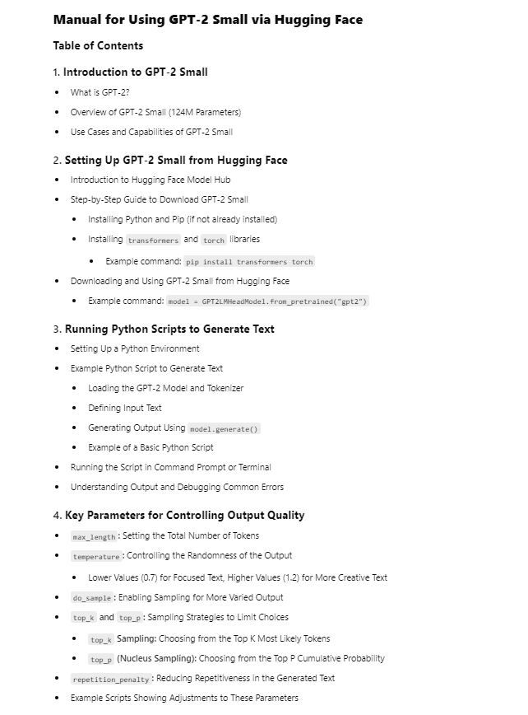

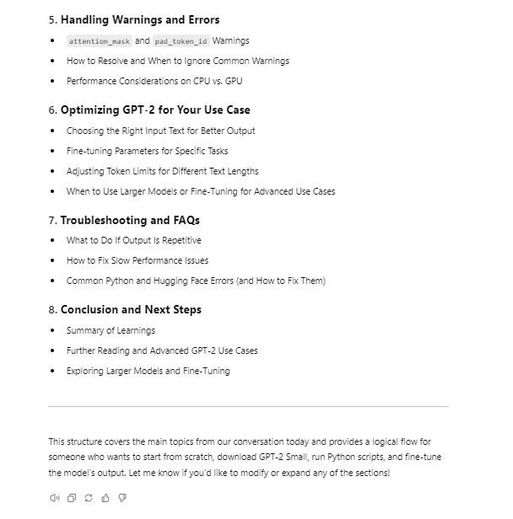

[[](https://bsky.app/profile/marinelives.bsky.social)](https://bsky.app/profile/marinelives.bsky.social)

[· 08/09/2024](https://bsky.app/profile/marinelives.bsky.social/post/3l3msyt5cyc2w)

MarineLives now has a HuggingFace organisation and will in the near future be publishing datasets to HuggingFace for community use in training and finetuning Large Language Models [#machinelearning](https://bsky.app/hashtag/machinelearning) [#SkyML](https://bsky.app/hashtag/SkyML)

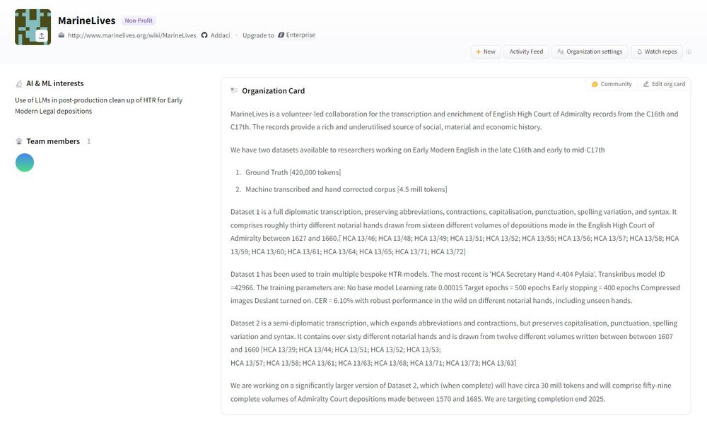

[[](https://bsky.app/profile/marinelives.bsky.social)](https://bsky.app/profile/marinelives.bsky.social)

[· 07/09/2024](https://bsky.app/profile/marinelives.bsky.social/post/3l3kwzdsa4q2f)

MarineLives are looking for a creative, motivated Masters student or first year doctoral student in [#compsci](https://bsky.app/hashtag/compsci) or [#machinelearning](https://bsky.app/hashtag/machinelearning) who would like to work with excellent data and a fast moving energetic team of volunteers to do exciting novel stuff which matters.

[@tedunderwood.me](https://bsky.app/profile/did:plc:565ebob5f6hw33hjdkxty6qj)

[@jwbaker.bsky.social](https://bsky.app/profile/did:plc:fvq2ectc56unbolhmeymsjfu)

[[](https://bsky.app/profile/marinelives.bsky.social)](https://bsky.app/profile/marinelives.bsky.social)

[· 07/09/2024](https://bsky.app/profile/marinelives.bsky.social/post/3l3kwpk2lea27)

To support the editorial work we are finetuning a GPT-2 Small LLM model to help volunteers correct machine transcribed text. The LLM will help train volunteers and editors, share best practices, ensure editorial standards, and help with the corrections #Skystorians #earlymodern #machinelearning

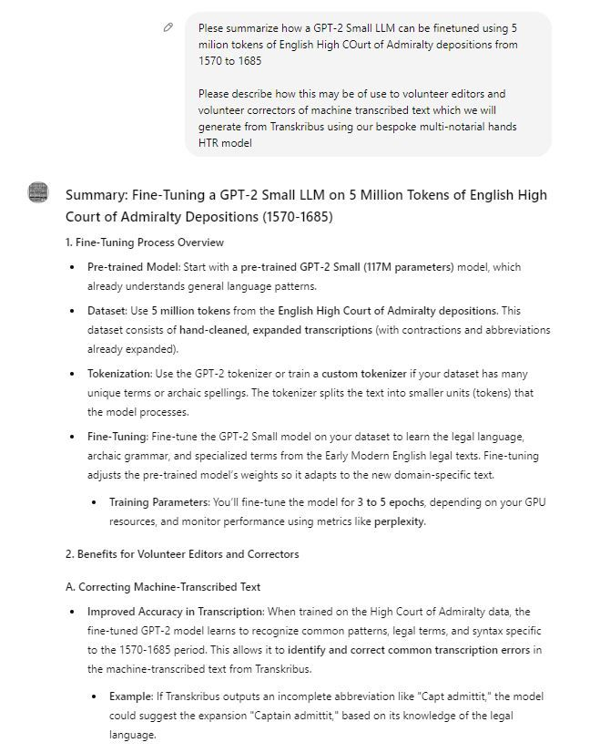

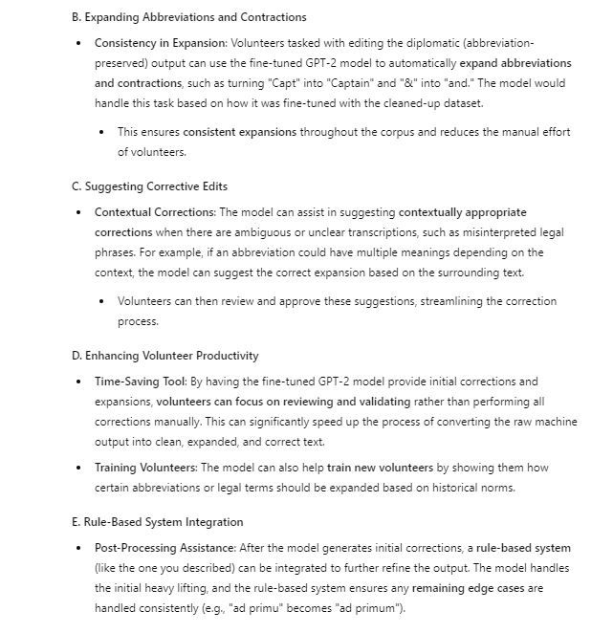

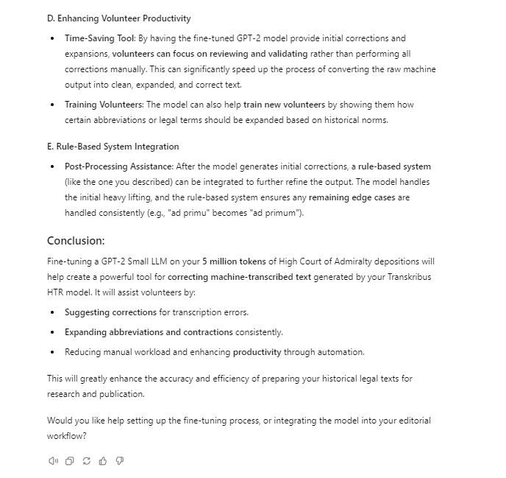

1

2

[[](https://bsky.app/profile/marinelives.bsky.social)](https://bsky.app/profile/marinelives.bsky.social)

[· 07/09/2024](https://bsky.app/profile/marinelives.bsky.social/post/3l3kxfgwf2h2d)

It is a great use case. Topics to explore from a [#compsci](https://bsky.app/hashtag/compsci) [#machinelearning](https://bsky.app/hashtag/machinelearning) perspective include in wild benefit of (1) fine tuning vs. full training (2) increasing parameter size of LLM (we will eventually have 30 mill tokens) (3) Broadening Early Modern text training data (books/manuscripts)

[[](https://bsky.app/profile/marinelives.bsky.social)](https://bsky.app/profile/marinelives.bsky.social)

[· 07/09/2024](https://bsky.app/profile/marinelives.bsky.social/post/3l3kw5fagr72d)

We are looking for volunteer editors for individual volumes of English High Court of Admiralty depositions. You decide which pages to machine transcribe in which order and work with Colin Greenstreet and other volunteers to machine and hand correct the text [#Skystorians](https://bsky.app/hashtag/Skystorians) [#earlymodern](https://bsky.app/hashtag/earlymodern) [#machinelearning](https://bsky.app/hashtag/machinelearning)

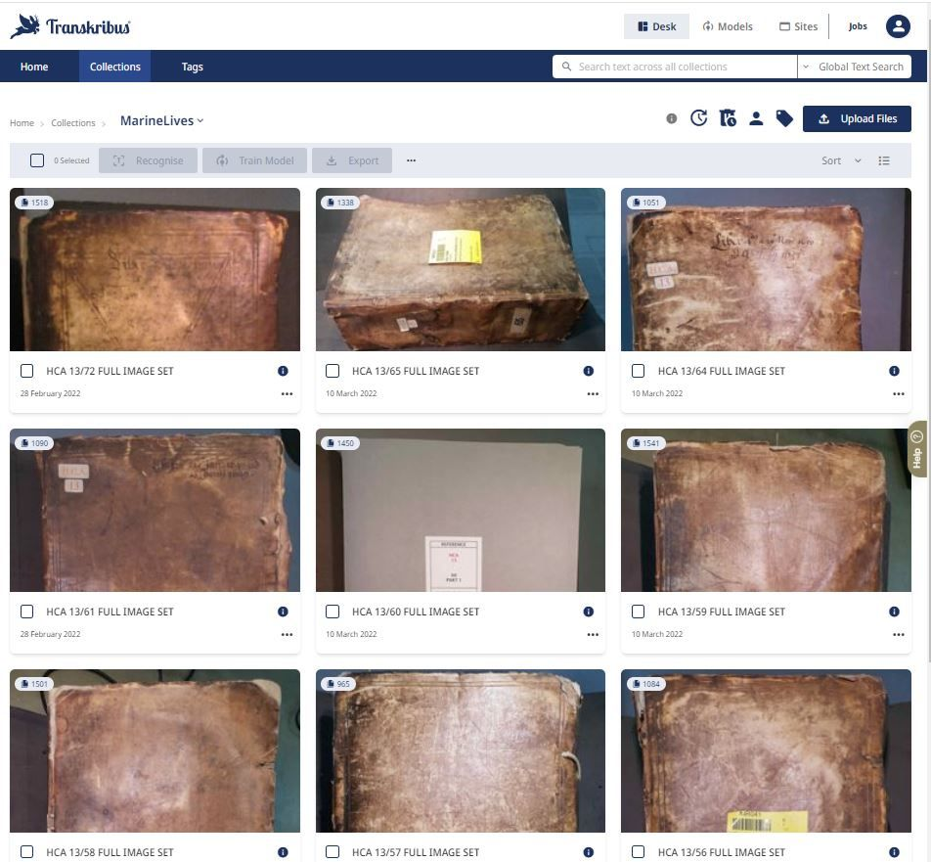

1

7

[[](https://bsky.app/profile/marinelives.bsky.social)](https://bsky.app/profile/marinelives.bsky.social)

[· 07/09/2024](https://bsky.app/profile/marinelives.bsky.social/post/3l3kwpk2lea27)

To support the editorial work we are finetuning a GPT-2 Small LLM model to help volunteers correct machine transcribed text. The LLM will help train volunteers and editors, share best practices, ensure editorial standards, and help with the corrections [#Skystorians](https://bsky.app/hashtag/Skystorians) [#earlymodern](https://bsky.app/hashtag/earlymodern) [#machinelearning](https://bsky.app/hashtag/machinelearning)







1

1

[[](https://bsky.app/profile/marinelives.bsky.social)](https://bsky.app/profile/marinelives.bsky.social)

[· 07/09/2024](https://bsky.app/profile/marinelives.bsky.social/post/3l3kqdrpt5k2a)

An offer to [#Skystorians](https://bsky.app/hashtag/Skystorians) and [#earlymodern](https://bsky.app/hashtag/earlymodern). Tell MarineLives which 10 or 50 pages you would like transcribed from any volume of Admiralty Court volumes betw. 1600 and 1670 and we will machine transcribe them same day and publish to the commons. The compute time costs £5 per 50 pages. See before/after

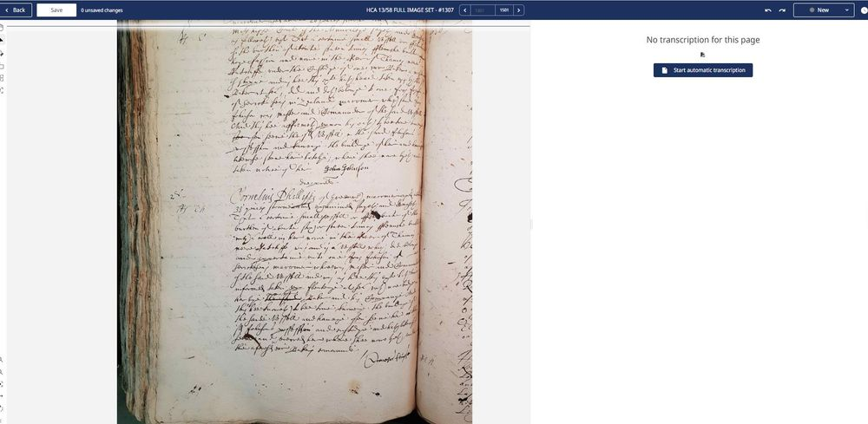

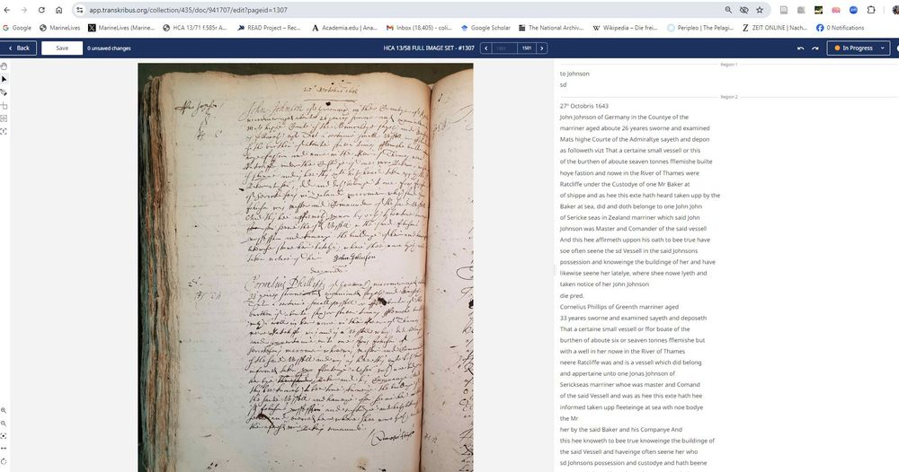

1

14

[View full thread](https://bsky.app/profile/did:plc:3haql47cl6jucf32mlqtre4p/post/3l3kqdrpt5k2a)

[[](https://bsky.app/profile/marinelives.bsky.social)](https://bsky.app/profile/marinelives.bsky.social)

[· 07/09/2024](https://bsky.app/profile/marinelives.bsky.social/post/3l3kuxme2wa2w)

Transkribus struggles when text is significantly off the horizontal. Let's see how well it does on HCA 13/58 f.737r. If it messes up I will need to hand transcribe

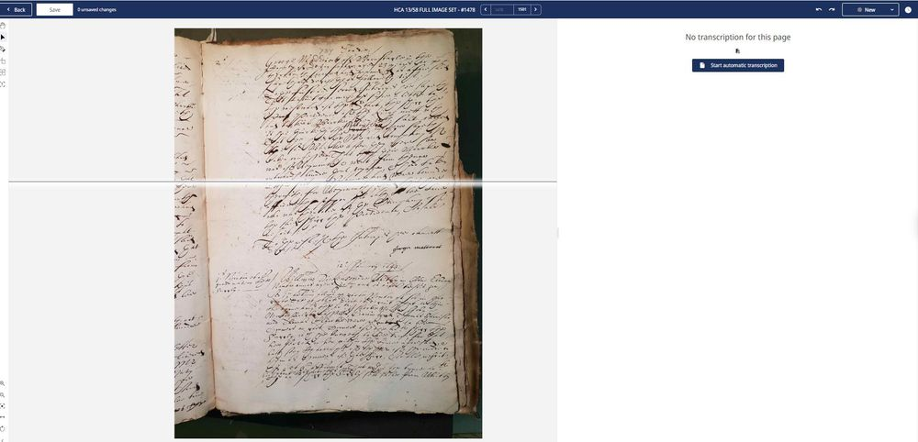

1

[[](https://bsky.app/profile/marinelives.bsky.social)](https://bsky.app/profile/marinelives.bsky.social)

[· 07/09/2024](https://bsky.app/profile/marinelives.bsky.social/post/3l3kv2qca722v)

A pleasant surprise - Useable text!

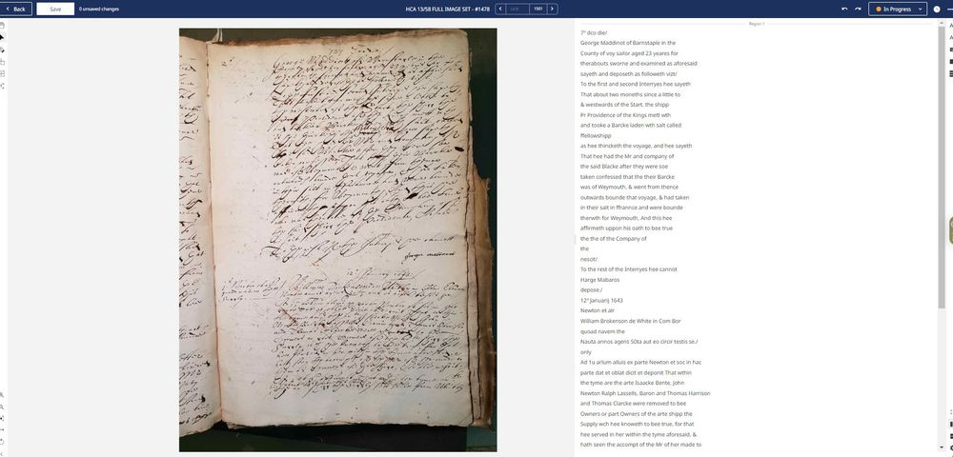

[[](https://bsky.app/profile/marinelives.bsky.social)](https://bsky.app/profile/marinelives.bsky.social)

[· 07/09/2024](https://bsky.app/profile/marinelives.bsky.social/post/3l3kns4emtk2a)

Hellow [#Skystorians](https://bsky.app/hashtag/Skystorians) and [#earlymodern](https://bsky.app/hashtag/earlymodern). We are looking for three volunteers with interest in the period 1642 and 1643 in English & European history to alpha test our online publication of images & transcriptions for HCA 13/58 (1500 pages ca. 600,000. Available online end next week.

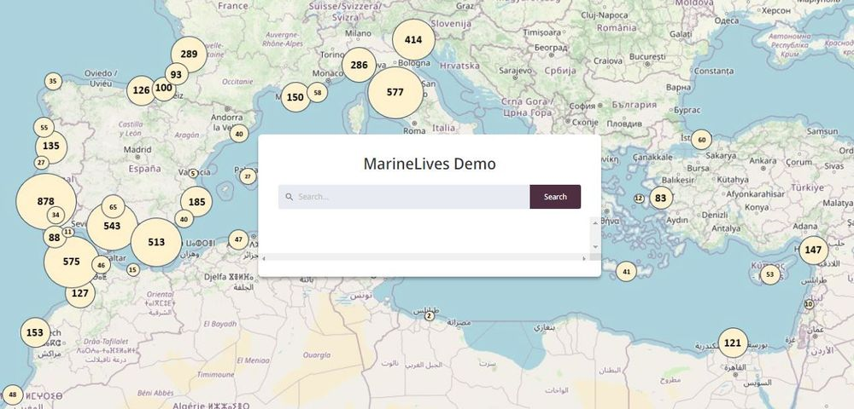

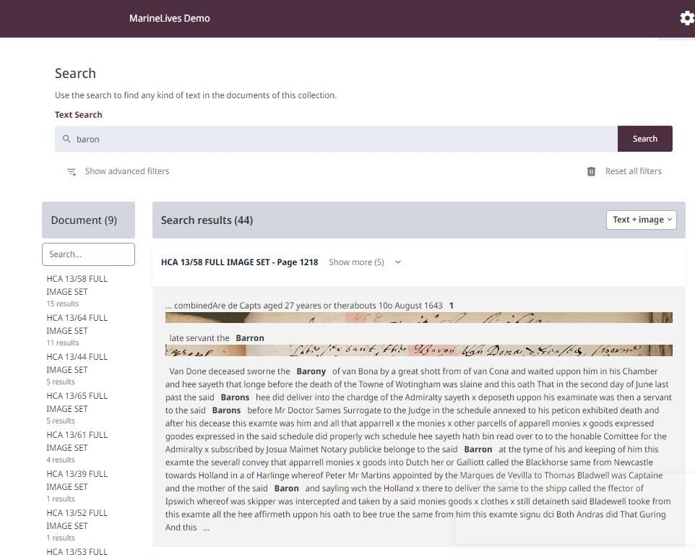

1

7

[[](https://bsky.app/profile/marinelives.bsky.social)](https://bsky.app/profile/marinelives.bsky.social)

[· 07/09/2024](https://bsky.app/profile/marinelives.bsky.social/post/3l3ko75clkb26)

Choice of exact word search, medium fuzzy and high fuzzy search. Click on search result to get to image and machine transcription. Separate searchable .txt volume with hand corrected machine transcription, which will eventually be fully integrated.

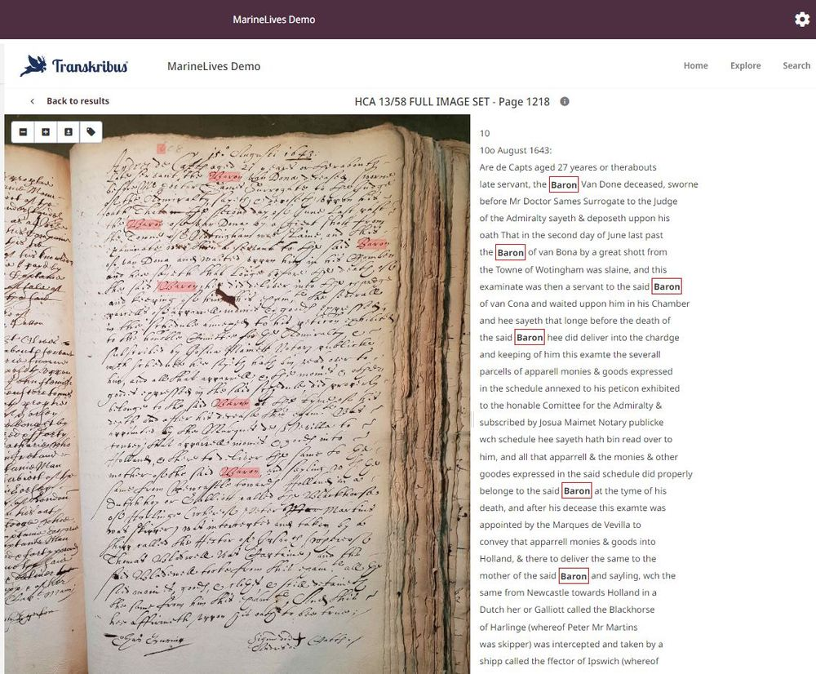

[[](https://bsky.app/profile/marinelives.bsky.social)](https://bsky.app/profile/marinelives.bsky.social)

[· 07/09/2024](https://bsky.app/profile/marinelives.bsky.social/post/3l3kh5loht726)

Who can tell us about the Baron van Dona? Killed by a great shot at the town of Nottingham in June 1642 [HCA 13/58 f.608r] [#Skystorians](https://bsky.app/hashtag/Skystorians) [#earlymodern](https://bsky.app/hashtag/earlymodern)

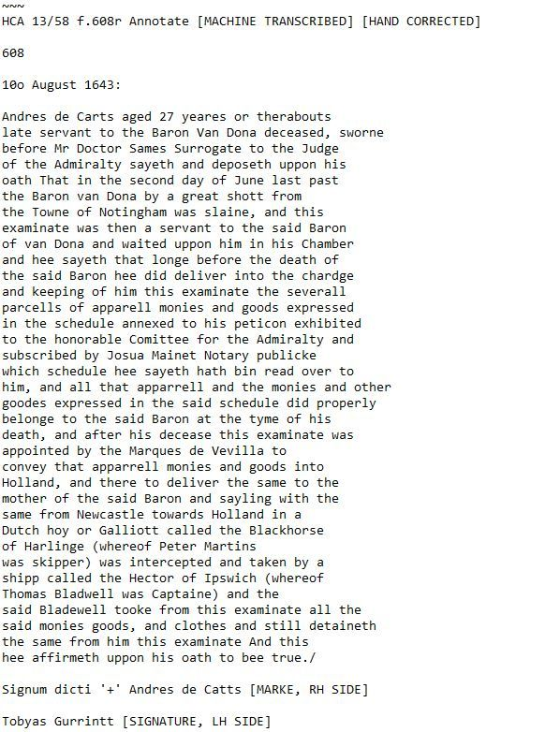

2

[View full thread](https://bsky.app/profile/did:plc:3haql47cl6jucf32mlqtre4p/post/3l3kh5loht726)

[[](https://bsky.app/profile/marinelives.bsky.social)](https://bsky.app/profile/marinelives.bsky.social)

[· 07/09/2024](https://bsky.app/profile/marinelives.bsky.social/post/3l3khtunpk62a)

Here's a summary of the deposition and events mentioned

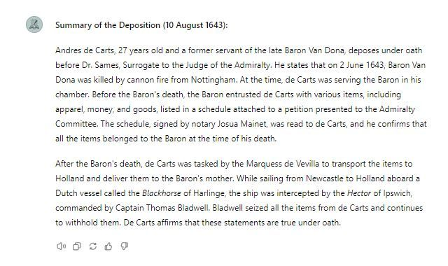

1

[[](https://bsky.app/profile/marinelives.bsky.social)](https://bsky.app/profile/marinelives.bsky.social)

[· 07/09/2024](https://bsky.app/profile/marinelives.bsky.social/post/3l3kiqqohn52w)

Looks like it was Heinrich von Dohna. He died aged 19 at Nottingham. He was a son of Christoph von Dohna and Ursula (zu Solms-Braunfels) con Dohna. From a Prussian family of burgraves. His older brothers Friederich & Christian Albrecht von Dohna held significant military and displomatic positions

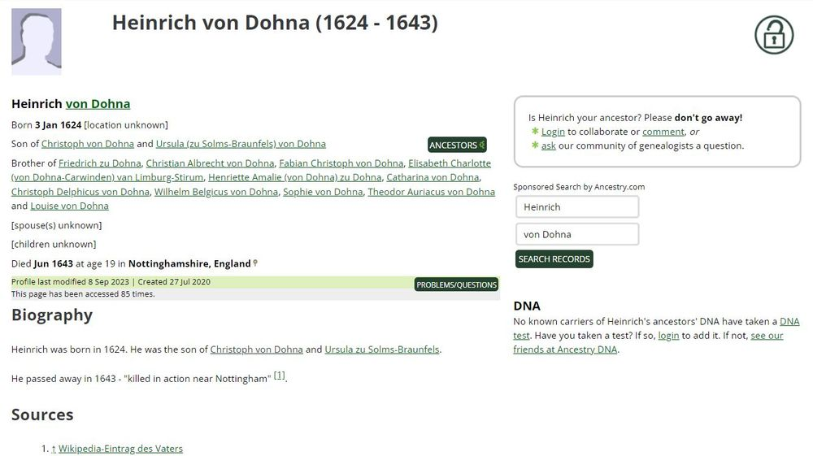

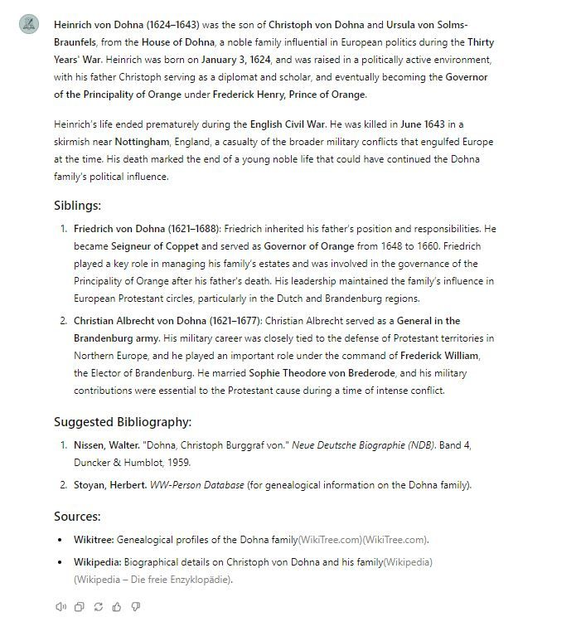

1

[Reposted by you](https://bsky.app/profile/marinelives.bsky.social)

[[](https://bsky.app/profile/maxkasy.bsky.social)](https://bsky.app/profile/maxkasy.bsky.social)

[· 06/09/2024](https://bsky.app/profile/maxkasy.bsky.social/post/3l3ijdjtkmk2j)

Starting Monday: Oxford summer school, incl my course foundations of [#ML](https://bsky.app/hashtag/ML) for [#economics](https://bsky.app/hashtag/economics): [buff.ly/3TmVkFV](https://buff.ly/3TmVkFV) New this year: 1) Intro to supervised learning using [#python](https://bsky.app/hashtag/python): [buff.ly/3TjkWmW](https://buff.ly/3TjkWmW) 2) Transformers for natural language processing: [buff.ly/4d3n7Cw](https://buff.ly/4d3n7Cw)

[[](https://buff.ly/3TmVkFV)](https://buff.ly/3TmVkFV" \t "_blank)

**[Foundations of Machine Learning - Oxford summerschool 2024](https://buff.ly/3TmVkFV" \t "_blank)**

[Research on machine learning, experimental design, economic inequality, and optimal policy](https://buff.ly/3TmVkFV" \t "_blank)

[buff.ly](https://buff.ly/3TmVkFV" \t "_blank)

**2**

[[](https://bsky.app/profile/marinelives.bsky.social)](https://bsky.app/profile/marinelives.bsky.social)

[· 06/09/2024](https://bsky.app/profile/marinelives.bsky.social/post/3l3ig5nmxln24)

Ping [#earlymodern](https://bsky.app/hashtag/earlymodern)

[[](https://bsky.app/profile/marinelives.bsky.social)](https://bsky.app/profile/marinelives.bsky.social)

[· 06/09/2024](https://bsky.app/profile/marinelives.bsky.social/post/3l3i5r2uk432a)

We are working on machine transcribing English High Court of Admiralty depositions. Volume HCA 13/58 [1642 & 43] available to Commons end next week. 1500 pages. Please repost this message if you want to support our work, and make a small donation #skystorians www.gofundme.com/f/help-marin...

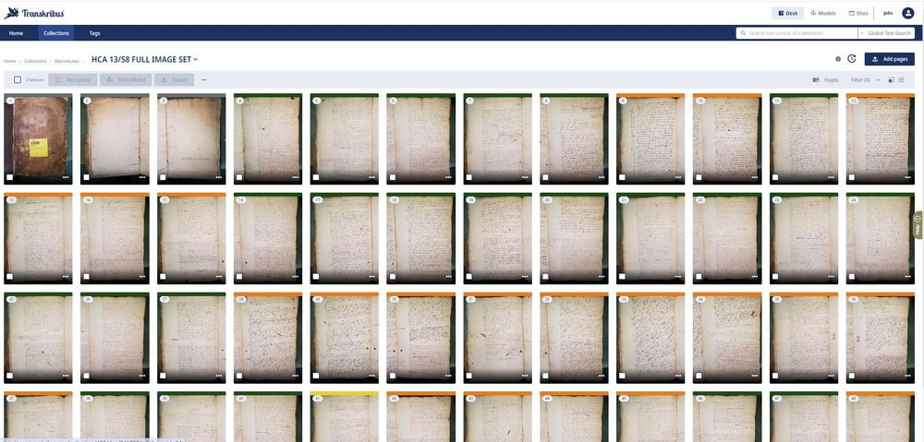

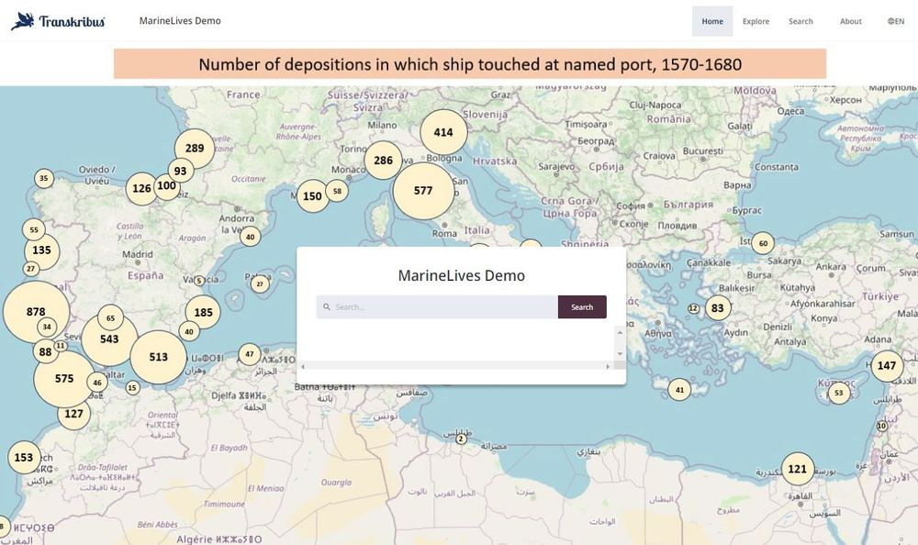

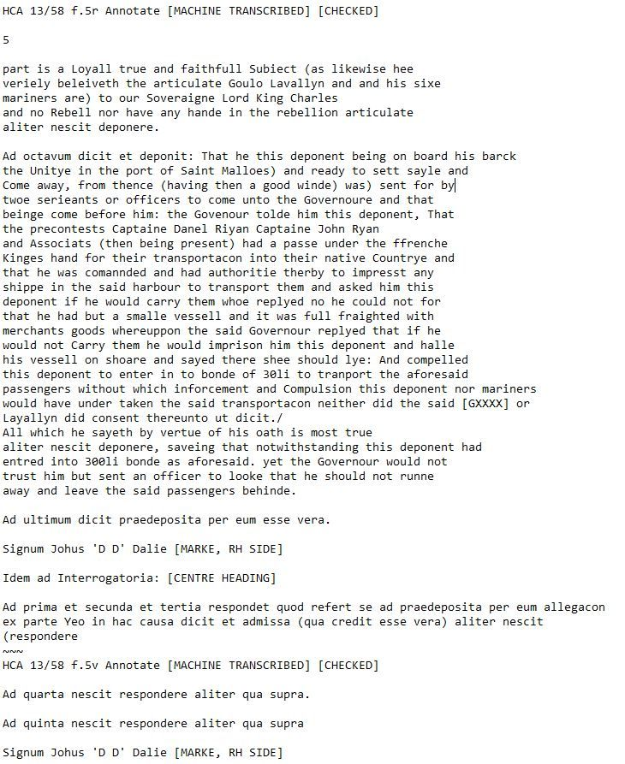

[[](https://bsky.app/profile/marinelives.bsky.social)](https://bsky.app/profile/marinelives.bsky.social)

[· 06/09/2024](https://bsky.app/profile/marinelives.bsky.social/post/3l3i5r2uk432a)

We are working on machine transcribing English High Court of Admiralty depositions. Volume HCA 13/58 [1642 & 43] available to Commons end next week. 1500 pages. Please repost this message if you want to support our work, and make a small donation [#skystorians](https://bsky.app/hashtag/skystorians) [www.gofundme.com/f/help-marin...](https://www.gofundme.com/f/help-marinelives-write-history)







1

4

[[](https://bsky.app/profile/marinelives.bsky.social)](https://bsky.app/profile/marinelives.bsky.social)

[· 06/09/2024](https://bsky.app/profile/marinelives.bsky.social/post/3l3i7lbt2pm2w)

Researching the Eastern Mediterranean currant trade in the C17th? Want to know about Zante. Very soon you will be able to search 5 million words and growing of English High Court of Admiralty depositions from 1570-1685 to help you [#Skystorians](https://bsky.app/hashtag/Skystorians)

[@amrcampop.bsky.social](https://bsky.app/profile/did:plc:7xswm5avhockpxo5enmxdcys)

[www.gofundme.com/f/help-marin...](https://www.gofundme.com/f/help-marinelives-write-history)

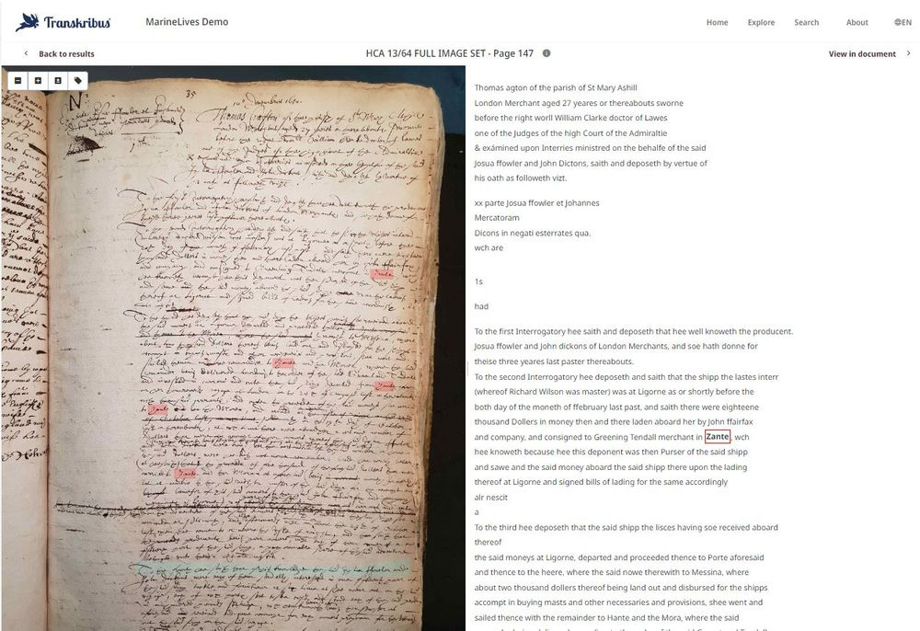

[[](https://bsky.app/profile/marinelives.bsky.social)](https://bsky.app/profile/marinelives.bsky.social)

[· 06/09/2024](https://bsky.app/profile/marinelives.bsky.social/post/3l3i5vjaemf24)

MarineLives is scaling up! 5 million words transcribed in the last 12 years. 25 million to be transcribed by end 2025. Please support us by reposting & considering a small donation

[@profelainechalus.bsky.social](https://bsky.app/profile/did:plc:w66sjdn6hhxcobbvpsmedorl)

[@timhitchcock.bsky.social](https://bsky.app/profile/did:plc:zazpgix5w4ldyytazeqzytmz)

[@plymprivateer.bsky.social](https://bsky.app/profile/did:plc:kfm7zs4ptqe5s4oo64b4jxxo)

[@earlymodernjohn.bsky.social](https://bsky.app/profile/did:plc:43lv3dcbbiofwrn3v2kkbf3p)

[[](https://bsky.app/profile/marinelives.bsky.social)](https://bsky.app/profile/marinelives.bsky.social)

[· 06/09/2024](https://bsky.app/profile/marinelives.bsky.social/post/3l3i5r2uk432a)

We are working on machine transcribing English High Court of Admiralty depositions. Volume HCA 13/58 [1642 & 43] available to Commons end next week. 1500 pages. Please repost this message if you want to support our work, and make a small donation #skystorians www.gofundme.com/f/help-marin...







1

[Reposted by you](https://bsky.app/profile/marinelives.bsky.social)

[[](https://bsky.app/profile/mpidr.bsky.social)](https://bsky.app/profile/mpidr.bsky.social)

[· 06/09/2024](https://bsky.app/profile/mpidr.bsky.social/post/3l3hv7gzejl2z)

📣Job Offer for Students!

[@mpidr.bsky.social](https://bsky.app/profile/did:plc:qfe5yhxqsnsiiq2id7z7qzde)

is seeking a Student Assistant for the Research Group Labor Demography. You should have a background in demography, economics, sociology, or a related field. Learn all: [www.demogr.mpg.de/en/career\_61...](https://www.demogr.mpg.de/en/career_6122/jobs_fellowships_1910/student_assistant_13338)



**4**

[[](https://bsky.app/profile/marinelives.bsky.social)](https://bsky.app/profile/marinelives.bsky.social)

[· 06/09/2024](https://bsky.app/profile/marinelives.bsky.social/post/3l3hs46hx222r)

Who can tell me if any group is working on training or fine tuning a LLM on Early Modern English (let's say roughly 1550 to 1800) using printed texts and high quality machine transcriptions? [#machinelearning](https://bsky.app/hashtag/machinelearning) [#AcademicSky](https://bsky.app/hashtag/AcademicSky) 🗃️ [#AI](https://bsky.app/hashtag/AI) We have 5 mill tokens and in one year will have ca, 30 mill tokens

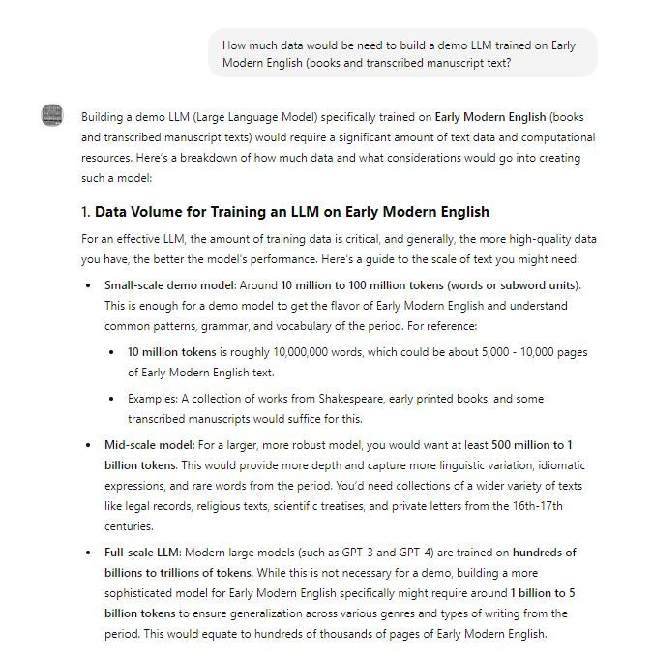

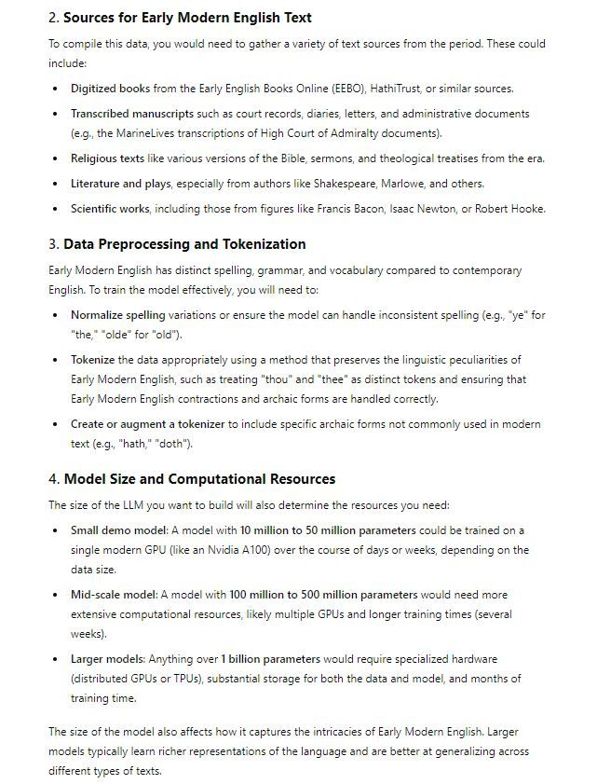

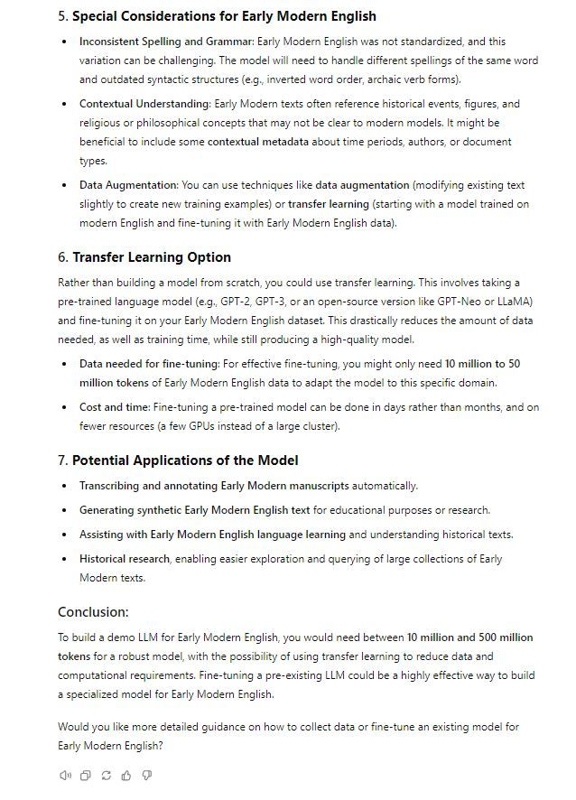

1

[[](https://bsky.app/profile/marinelives.bsky.social)](https://bsky.app/profile/marinelives.bsky.social)

[· 05/09/2024](https://bsky.app/profile/marinelives.bsky.social/post/3l3g5evni5h2d)

It costs 10 pence (15 cents) to produce this semi-diplomatic transcription of a page of High Court of Admiralty depositions from 1642 [Third image]. Maybe 5 to 10% of history undergraduates could read this. HTR by

[@transkribus.bsky.social](https://bsky.app/profile/did:plc:adbwqqtuasa27sf4ijch4zvt)

Cleanup by Aurelius-HTR. No human correction [#machinelearning](https://bsky.app/hashtag/machinelearning)

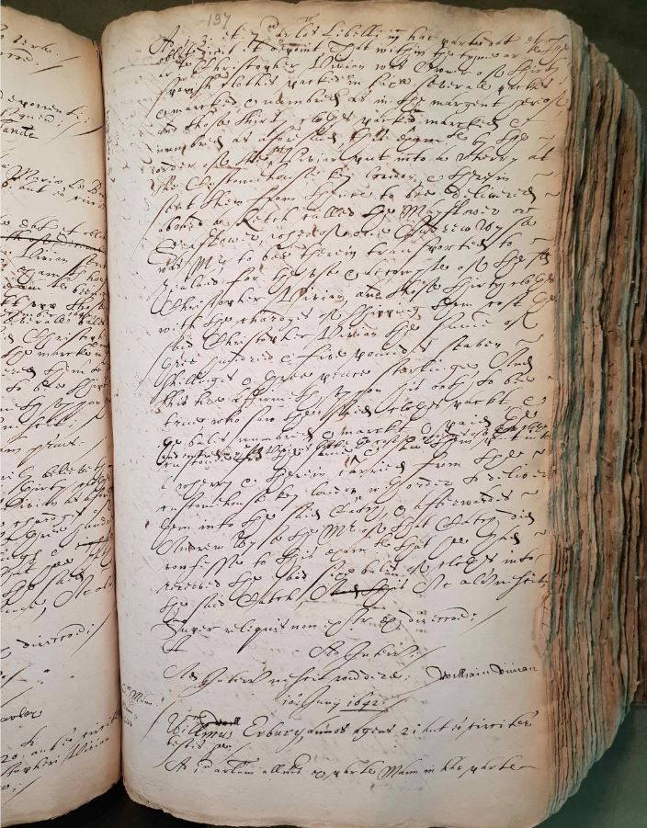

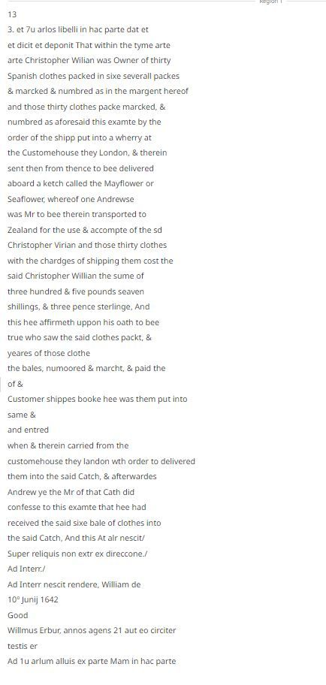

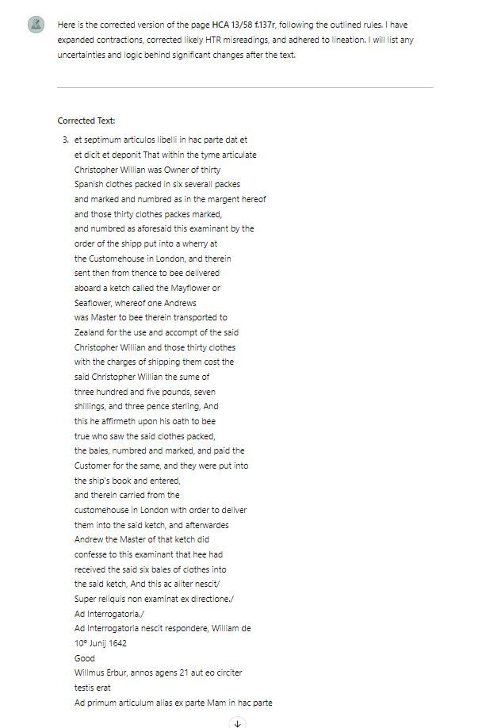

1

1

[View full thread](https://bsky.app/profile/did:plc:3haql47cl6jucf32mlqtre4p/post/3l3g5evni5h2d)

[[](https://bsky.app/profile/marinelives.bsky.social)](https://bsky.app/profile/marinelives.bsky.social)

[· 05/09/2024](https://bsky.app/profile/marinelives.bsky.social/post/3l3gap43oax24)

I pasted 5,000 words of English High Court of Admiralty depositions into Aurelius-HTR and asked for a spelling, grammatical, syntactical and stylistic analysis. I asked Aurelius-HTR to keep this analysis in its context as it corrects future HCA text for me [#machinelearning](https://bsky.app/hashtag/machinelearning) [#skystorians](https://bsky.app/hashtag/skystorians)

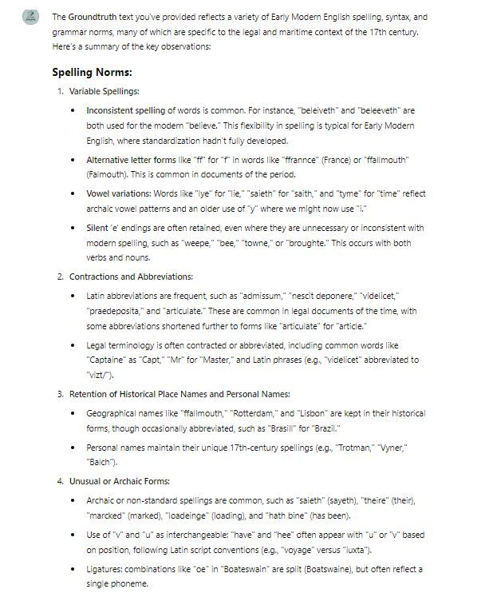

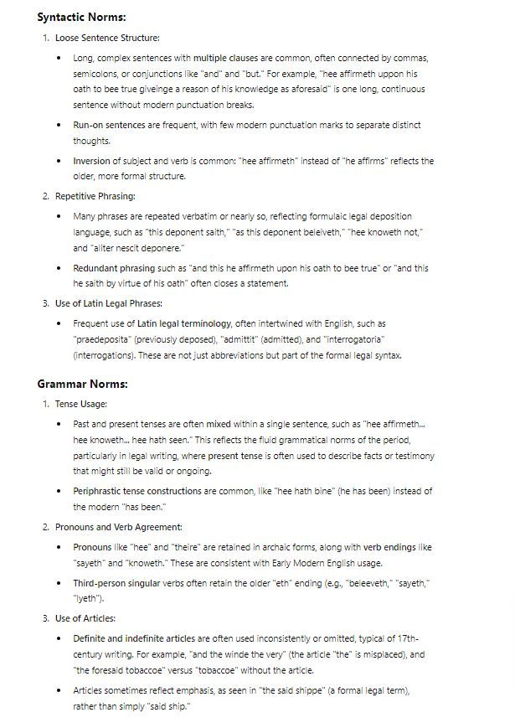

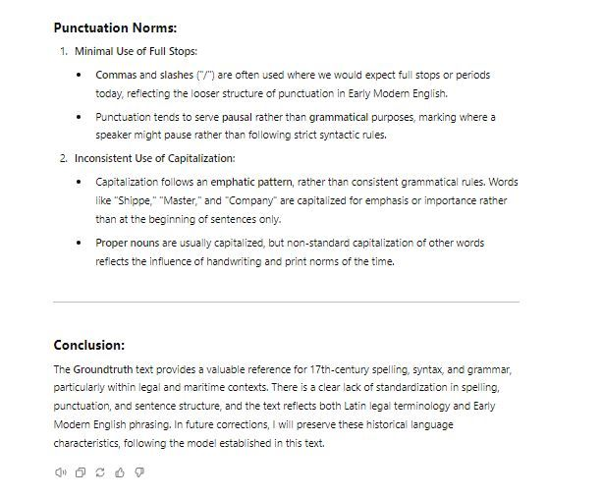

1

[[](https://bsky.app/profile/marinelives.bsky.social)](https://bsky.app/profile/marinelives.bsky.social)

[· 05/09/2024](https://bsky.app/profile/marinelives.bsky.social/post/3l3gbik6cpi2k)

The 5,000 words have helped. There is a fascinating tension between the GPT4o bot providing linguistic fluencey (and very acurately) but modernizing spelling and syntax, and my desire for a more formal semi-diplomatic transcription. I will get there! [#machinelearning](https://bsky.app/hashtag/machinelearning) [#skystorians](https://bsky.app/hashtag/skystorians)

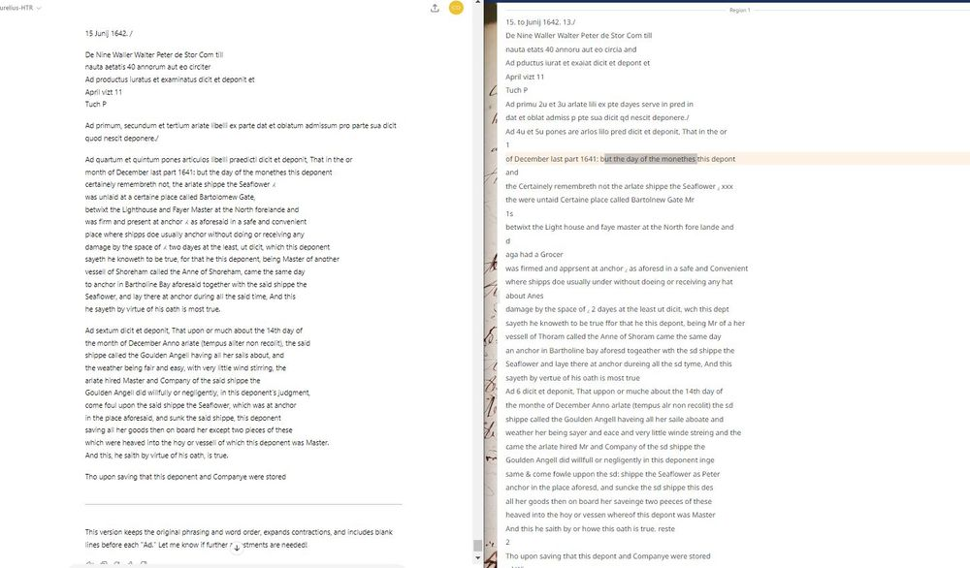

[[](https://bsky.app/profile/marinelives.bsky.social)](https://bsky.app/profile/marinelives.bsky.social)

[· 05/09/2024](https://bsky.app/profile/marinelives.bsky.social/post/3l3g6xcvdwv2v)

Hello [#Skystorians](https://bsky.app/hashtag/Skystorians) [#Historians](https://bsky.app/hashtag/Historians) [#Earlymodern](https://bsky.app/hashtag/Earlymodern) I'm still getting used to BlueSky feeds. Turns out [#Skyhistory](https://bsky.app/hashtag/Skyhistory) is not a thing. A three part post [bsky.app/profile/mari...](https://bsky.app/profile/marinelivesorg.bsky.social/post/3l3g5evni5h2d)

[[](https://bsky.app/profile/marinelives.bsky.social)](https://bsky.app/profile/marinelives.bsky.social)

[· 05/09/2024](https://bsky.app/profile/marinelives.bsky.social/post/3l3g5evni5h2d)

It costs 10 pence (15 cents) to produce this semi-diplomatic transcription of a page of High Court of Admiralty depositions from 1642 [Third image]. Maybe 5 to 10% of history undergraduates could read this. HTR by @transkribus.bsky.social Cleanup by Aurelius-HTR. No human correction #machinelearning







[[](https://bsky.app/profile/marinelives.bsky.social)](https://bsky.app/profile/marinelives.bsky.social)

[· 05/09/2024](https://bsky.app/profile/marinelives.bsky.social/post/3l3fc5gx7zu2p)

ChatGPT now has memory. I have multiple GPT4o agents and I presume the memories and preferences are stored by agent rather than user account, and that different users interacting with the same agent can build different interaction preferences? But does it remember upload files? [#AI](https://bsky.app/hashtag/AI) [#machinelearning](https://bsky.app/hashtag/machinelearning)

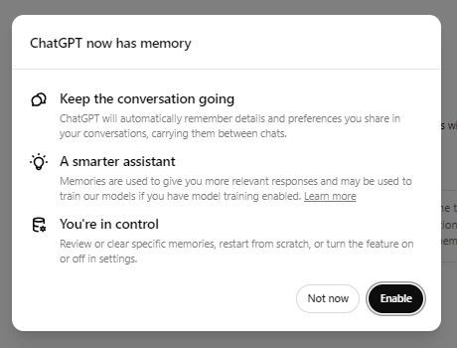

1

2

[View full thread](https://bsky.app/profile/did:plc:3haql47cl6jucf32mlqtre4p/post/3l3fc5gx7zu2p)

[[](https://bsky.app/profile/marinelives.bsky.social)](https://bsky.app/profile/marinelives.bsky.social)

[· 05/09/2024](https://bsky.app/profile/marinelives.bsky.social/post/3l3ftxpelau2d)

Part Eleven: Absolutely fascinating! The innate Latin language capabilities of GPT4o are correcting Latin where I have given no dictionary. Innate English language capabilities (constrained by my C17th English context) are doing a reasonable job of guessing EM English from bad HTR

[@tedunderwood.me](https://bsky.app/profile/did:plc:565ebob5f6hw33hjdkxty6qj)

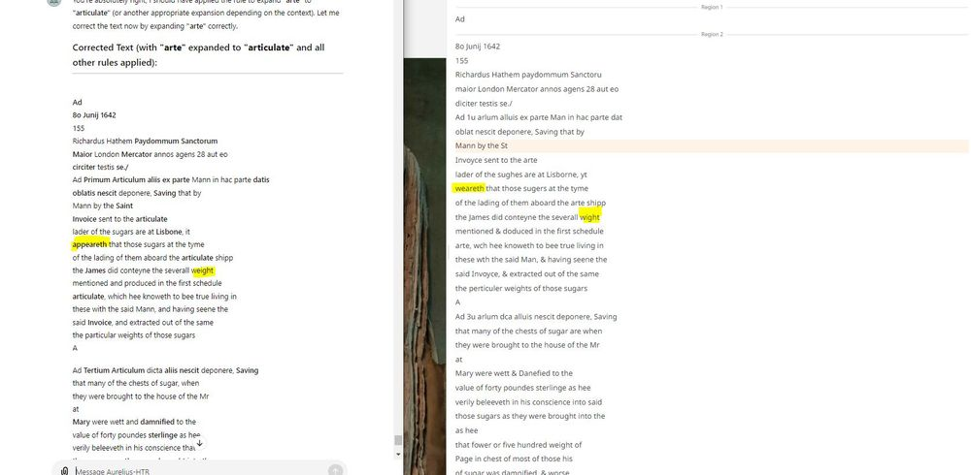

1

[[](https://bsky.app/profile/marinelives.bsky.social)](https://bsky.app/profile/marinelives.bsky.social)

[· 05/09/2024](https://bsky.app/profile/marinelives.bsky.social/post/3l3fvija3px26)

Part Twelve: looks like I need to use something like Notion to create a bespoke dictionary which Aurelius-HTR can access on the fly when it corrects C17th manuscript HTR. This is a major use case.

[@transkribus.bsky.social](https://bsky.app/profile/did:plc:adbwqqtuasa27sf4ijch4zvt)

, you need to get working on this [#machinelearning](https://bsky.app/hashtag/machinelearning)

[@tedunderwood.me](https://bsky.app/profile/did:plc:565ebob5f6hw33hjdkxty6qj)

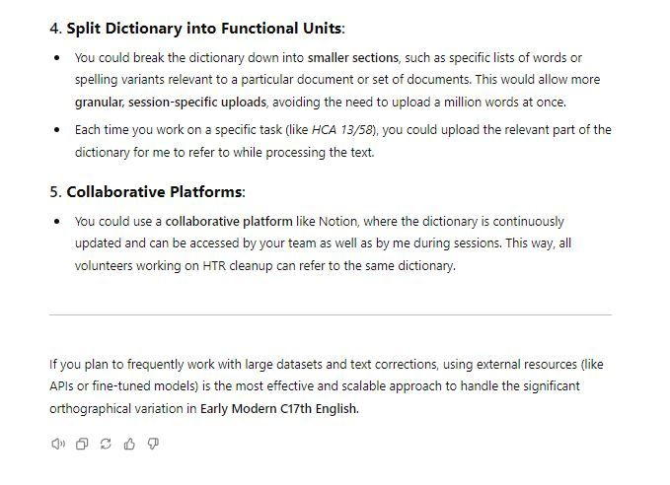

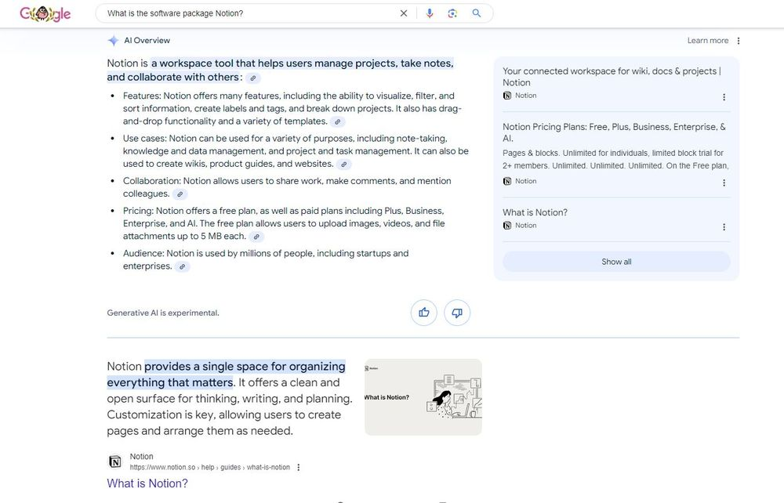

[[](https://bsky.app/profile/marinelives.bsky.social)](https://bsky.app/profile/marinelives.bsky.social)

[· 05/09/2024](https://bsky.app/profile/marinelives.bsky.social/post/3l3fnwkbsuw2q)

I am working on a solution to support ten or more volunteers to use Aurelius-HTR (tailored agent) to support process flow, rules, and knowledge resources to do post-HTR cleanup. I have 50,000 pages and 25 mill words.Here is the solution proposed [#machinelearning](https://bsky.app/hashtag/machinelearning) [#ai](https://bsky.app/hashtag/ai) [chatgpt.com/g/g-5RyFZvdj...](https://chatgpt.com/g/g-5RyFZvdjH-aurelius-htr)

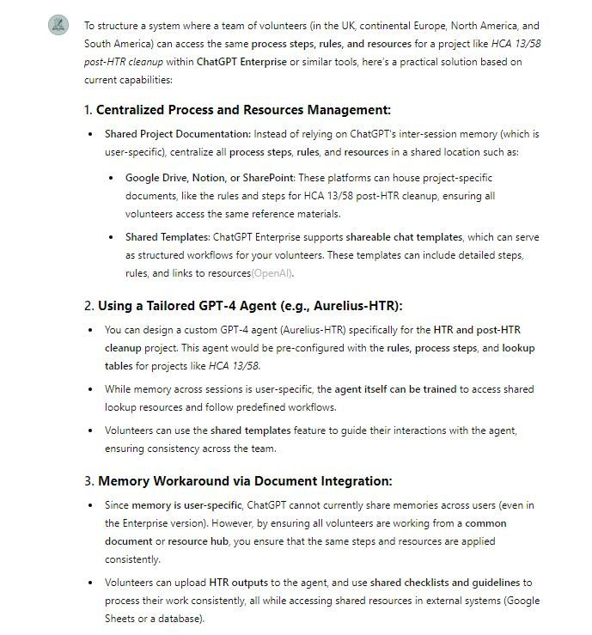

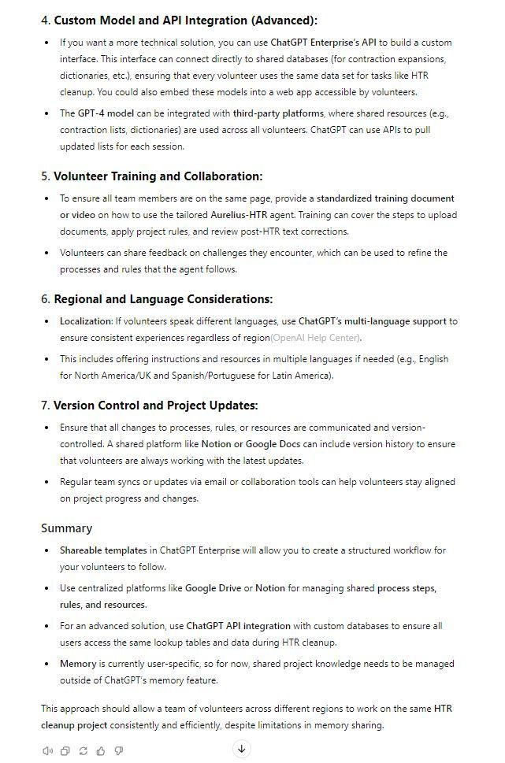

[[](https://bsky.app/profile/marinelives.bsky.social)](https://bsky.app/profile/marinelives.bsky.social)

[· 05/09/2024](https://bsky.app/profile/marinelives.bsky.social/post/3l3fikqagz72y)

I have been experimenting with a tailored GPT4o intelligent agent I have built named Aurelius-HTR. Using the new ChatGPT retained memory between session capability and defining process steps & rules, it is a superb tool to support volunteers clean up HTR [see pts 2 to 7]

[@timhitchcock.bsky.social](https://bsky.app/profile/did:plc:zazpgix5w4ldyytazeqzytmz)

[[](https://bsky.app/profile/marinelives.bsky.social)](https://bsky.app/profile/marinelives.bsky.social)

[· 05/09/2024](https://bsky.app/profile/marinelives.bsky.social/post/3l3fegrtbnq2p)

Part Two/ Here are some experiments using the memory feature in the context of cleaning up HTR output from @transkribus.bsky.social for the volume HCA 13/58 [the year 1642} which I am actively working on. Starting with some scoping questions to Aurelius-HTR

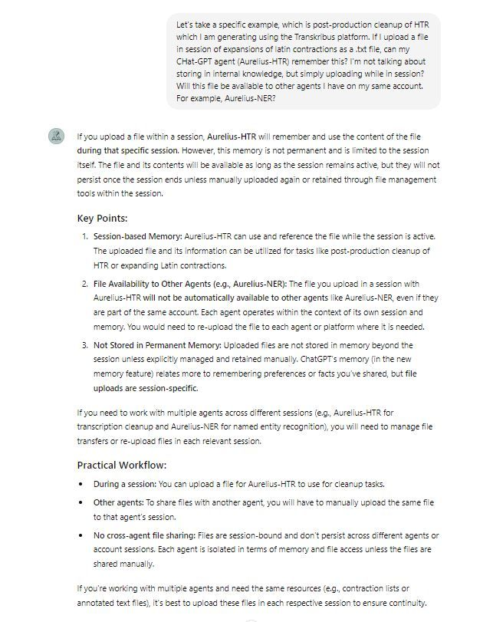

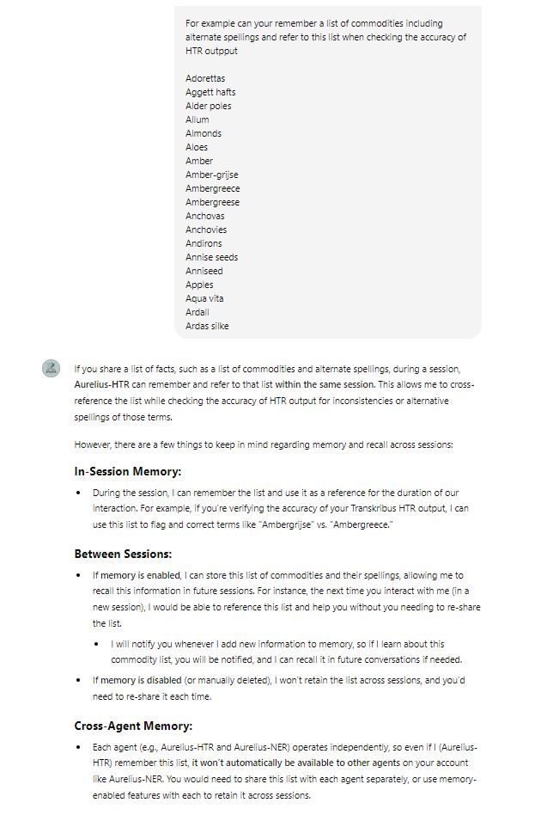

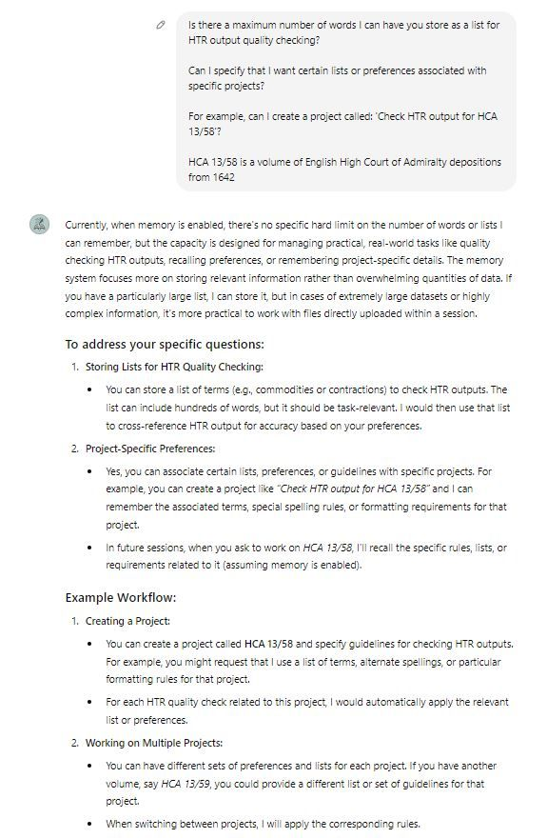

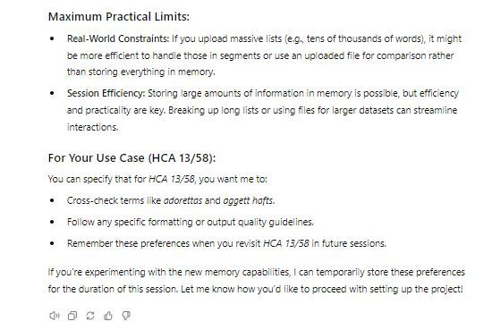

1

[[](https://bsky.app/profile/marinelives.bsky.social)](https://bsky.app/profile/marinelives.bsky.social)

[· 05/09/2024](https://bsky.app/profile/marinelives.bsky.social/post/3l3finzzjny2a)

This link should take you to parts one to seven of my original post [bsky.app/profile/mari...](https://bsky.app/profile/marinelivesorg.bsky.social/post/3l3fc5gx7zu2p)

[[](https://bsky.app/profile/marinelives.bsky.social)](https://bsky.app/profile/marinelives.bsky.social)

[· 05/09/2024](https://bsky.app/profile/marinelives.bsky.social/post/3l3fc5gx7zu2p)

ChatGPT now has memory. I have multiple GPT4o agents and I presume the memories and preferences are stored by agent rather than user account, and that different users interacting with the same agent can build different interaction preferences? But does it remember upload files? #AI #machinelearning



[[](https://bsky.app/profile/marinelives.bsky.social)](https://bsky.app/profile/marinelives.bsky.social)

[· 04/09/2024](https://bsky.app/profile/marinelives.bsky.social/post/3l3dbceqgj427)

Question to [#AI](https://bsky.app/hashtag/AI) & [#CompSci](https://bsky.app/hashtag/CompSci) experts. I want to improve a LLM's ability to machine correct HTR-output from

[@transkribus.bsky.social](https://bsky.app/profile/did:plc:adbwqqtuasa27sf4ijch4zvt)

Could I key log changes I hand make to correct HTR-output and then use this to fine-tune the LLM? What volume of data do I need?

[@tedunderwood.me](https://bsky.app/profile/did:plc:565ebob5f6hw33hjdkxty6qj)

[@tharsen.bsky.social](https://bsky.app/profile/did:plc:essd7vyz5rnwazahimzswjpr)

2

[[](https://bsky.app/profile/marinelives.bsky.social)](https://bsky.app/profile/marinelives.bsky.social)

[· 04/09/2024](https://bsky.app/profile/marinelives.bsky.social/post/3l3d5fg62up2v)

We are beginning to spend the £1240 [target £20k] we have raised to do quality machine transcription of 50,000 pages of English High Court of Admiralty depositions (1570 to 1685). Please donate if you can (£5 will buy compute time to process 50 pages!) [www.gofundme.com/f/help-marin...](https://www.gofundme.com/f/help-marinelives-write-history) [#skystorians](https://bsky.app/hashtag/skystorians)

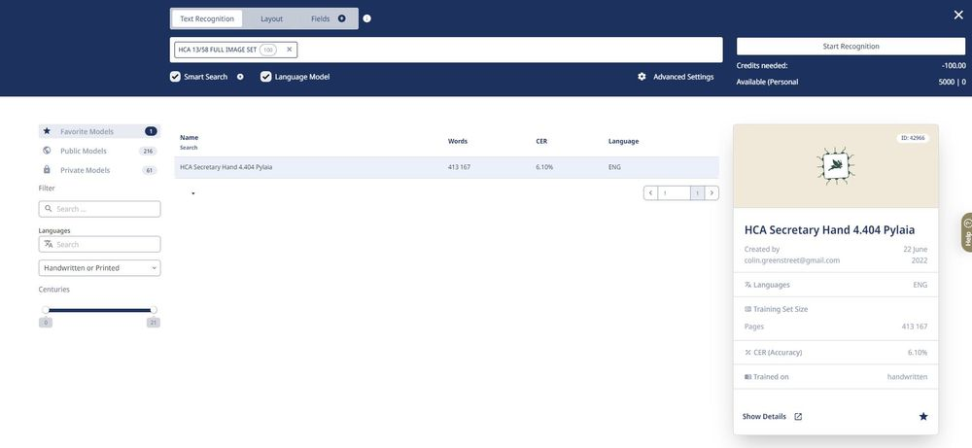

2

1

[View full thread](https://bsky.app/profile/did:plc:3haql47cl6jucf32mlqtre4p/post/3l3d5fg62up2v)

[[](https://bsky.app/profile/marinelives.bsky.social)](https://bsky.app/profile/marinelives.bsky.social)

[· 04/09/2024](https://bsky.app/profile/marinelives.bsky.social/post/3l3d5udjst42w)

Sample machine transcribed and checked page from HCA 13/58 [1642]

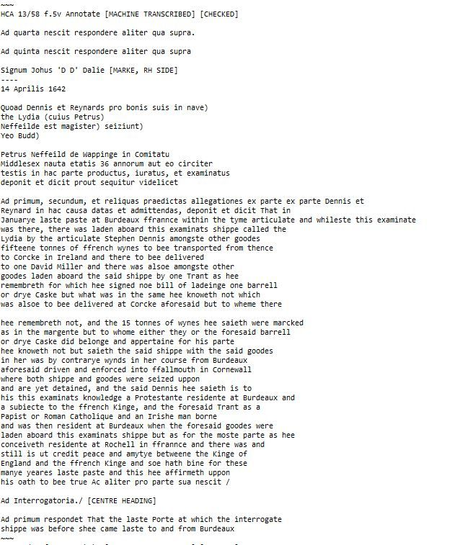

1

[[](https://bsky.app/profile/marinelives.bsky.social)](https://bsky.app/profile/marinelives.bsky.social)

[· 04/09/2024](https://bsky.app/profile/marinelives.bsky.social/post/3l3d66o5gmh2y)

Donor funds being put to work on another 100 pages (circa 50,000 words) of English High Court of Admiralty depositions from 1642

[@transkribus.bsky.social](https://bsky.app/profile/did:plc:adbwqqtuasa27sf4ijch4zvt)

[#skystorians](https://bsky.app/hashtag/skystorians) Please donate if you can. £5 will fund another 50 pages for the Commons. [www.gofundme.com/f/help-marin...](https://www.gofundme.com/f/help-marinelives-write-history)

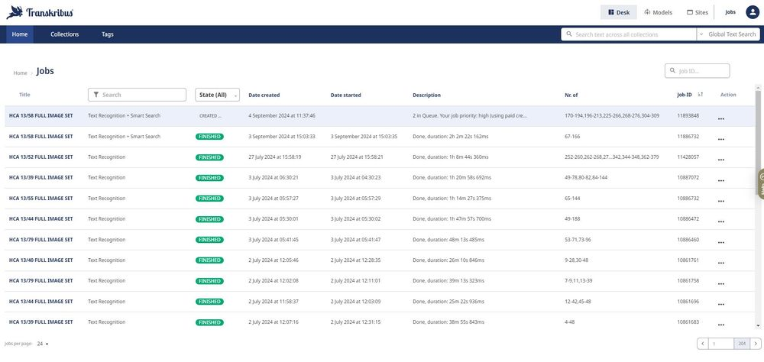

[[](https://bsky.app/profile/marinelives.bsky.social)](https://bsky.app/profile/marinelives.bsky.social)

[· 04/09/2024](https://bsky.app/profile/marinelives.bsky.social/post/3l3d3s3lu4o27)

Ping

[@camunicampop.bsky.social](https://bsky.app/profile/did:plc:l2wo64q7ceakio2cp54dzf5u)

[@amrcampop.bsky.social](https://bsky.app/profile/did:plc:7xswm5avhockpxo5enmxdcys)

[[](https://bsky.app/profile/marinelives.bsky.social)](https://bsky.app/profile/marinelives.bsky.social)

[· 03/09/2024](https://bsky.app/profile/marinelives.bsky.social/post/3l3awaokrzs2i)

If you are interested in exploring with an open mind the potential of LLM and other model based AI to support historical research, I have a range of tailored bots you may be interested and a range of tested use cases @tedunderwood.me @timhitchcock.bsky.social #historyGPT4usecase

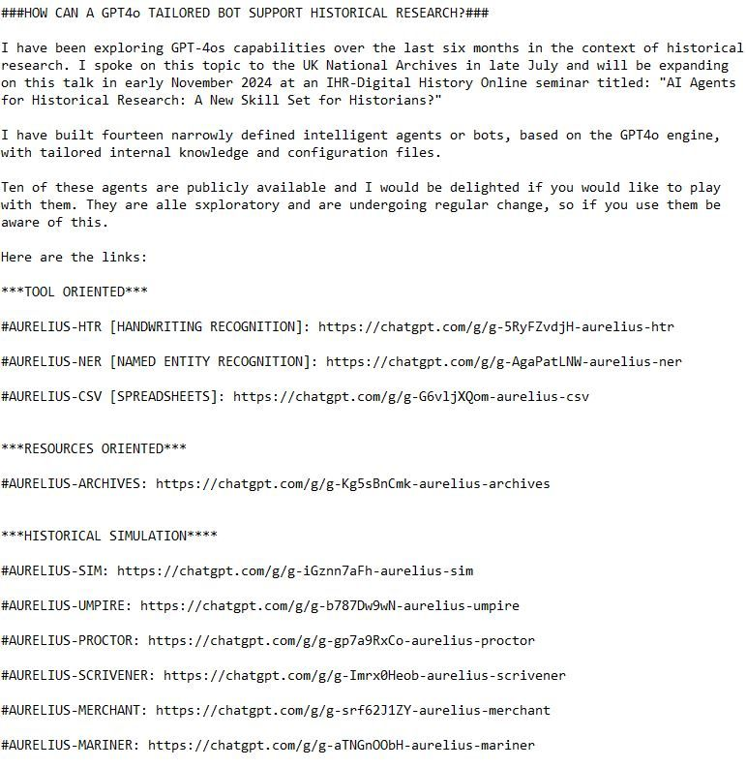

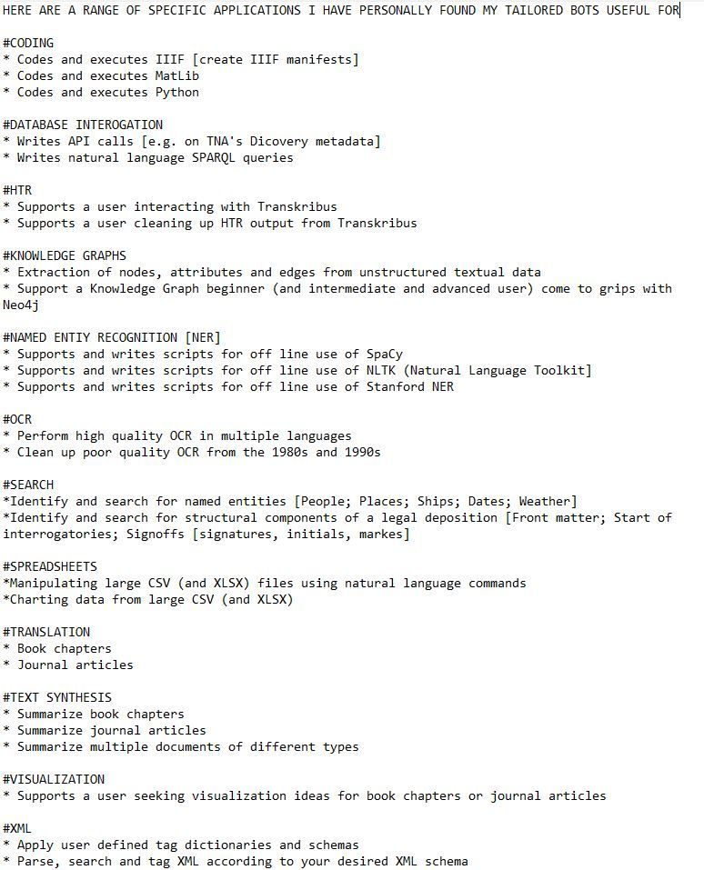

1

[Reposted by you](https://bsky.app/profile/marinelives.bsky.social)

[[](https://bsky.app/profile/amrcampop.bsky.social)](https://bsky.app/profile/amrcampop.bsky.social)

[· 04/09/2024](https://bsky.app/profile/amrcampop.bsky.social/post/3l3cztvpa2p22)

Replied to you

CamPop is now on BlueSky! Follow on

[@camunicampop.bsky.social](https://bsky.app/profile/did:plc:l2wo64q7ceakio2cp54dzf5u)

**[camunicampop.bsky.social](https://camunicampop.bsky.social/" \t "_blank)**

[camunicampop.bsky.social](https://camunicampop.bsky.social/" \t "_blank)

1

**1**

[[](https://bsky.app/profile/marinelives.bsky.social)](https://bsky.app/profile/marinelives.bsky.social)

[· 04/09/2024](https://bsky.app/profile/marinelives.bsky.social/post/3l3d2twvfns2d)

Ping

[@camunicampop.bsky.social](https://bsky.app/profile/did:plc:l2wo64q7ceakio2cp54dzf5u)

[@sharonhoward.bsky.social](https://bsky.app/profile/did:plc:3faeu5kcm7ecip4tc6wastff)

[[](https://bsky.app/profile/marinelives.bsky.social)](https://bsky.app/profile/marinelives.bsky.social)

[· 04/09/2024](https://bsky.app/profile/marinelives.bsky.social/post/3l3ctijhmfm2a)

The Aurelius Family of historical research agents come equipped with user manuals built into their internal knowledge. Chose whether you want a beginners, intermediate or advanced version. Here an example from Aurelius-HTR chatgpt.com/g/g-AgaPatLN... #historyGPT4usecase #skystorians

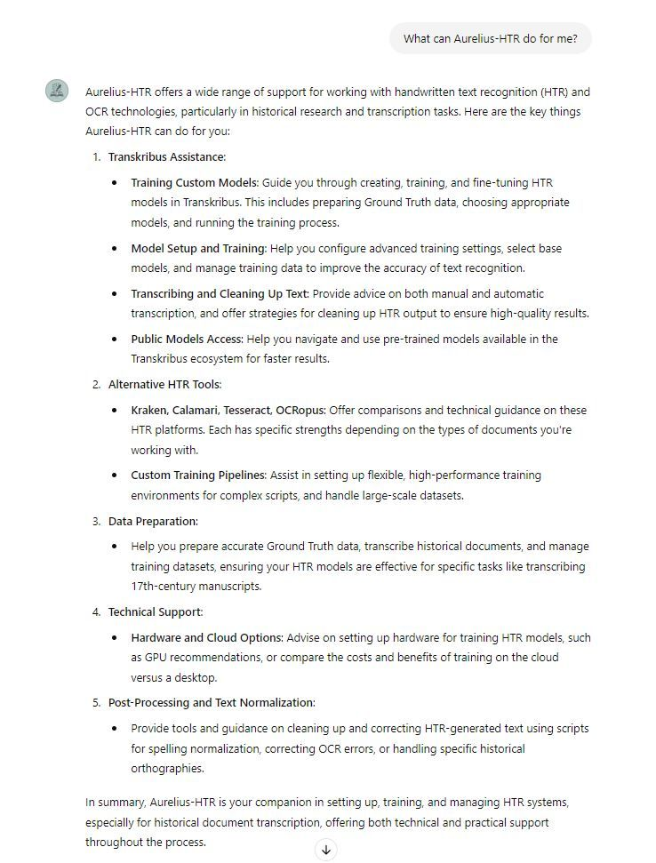

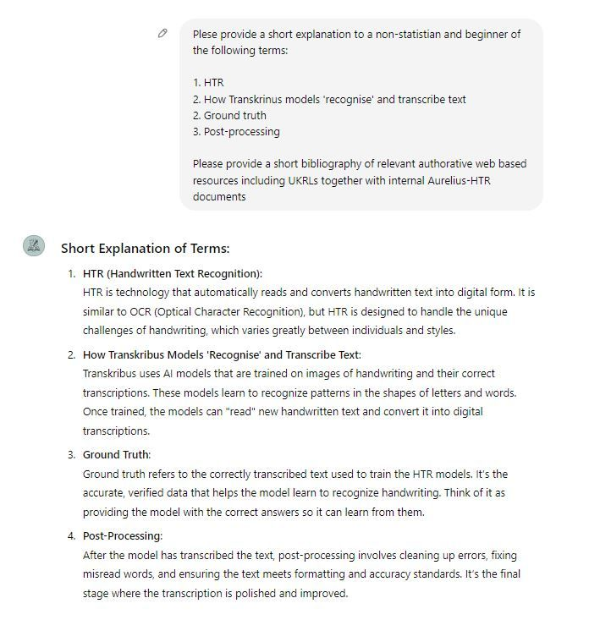

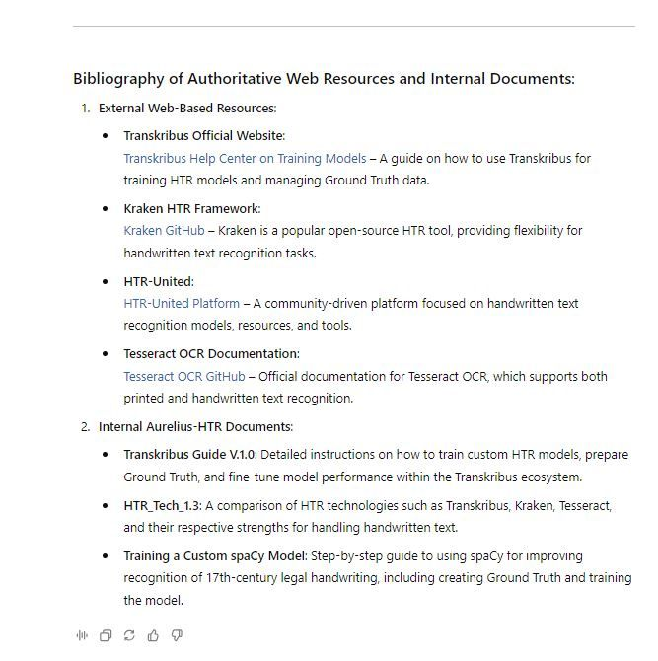

[[](https://bsky.app/profile/marinelives.bsky.social)](https://bsky.app/profile/marinelives.bsky.social)

[· 04/09/2024](https://bsky.app/profile/marinelives.bsky.social/post/3l3d2rwrbqa2s)

Ping

[@camunicampop.bsky.social](https://bsky.app/profile/did:plc:l2wo64q7ceakio2cp54dzf5u)

[@sharonhoward.bsky.social](https://bsky.app/profile/did:plc:3faeu5kcm7ecip4tc6wastff)

[[](https://bsky.app/profile/marinelives.bsky.social)](https://bsky.app/profile/marinelives.bsky.social)

[· 04/09/2024](https://bsky.app/profile/marinelives.bsky.social/post/3l3cslp2t6y2y)

Here is an example from two simple queries to Aurelius-NER asking for (1) What Aurelius-NER can do for me (2) A non-statisticians guide to basic terminology @axe99.bsky.social @cathamclarke.bsky.social @tedunderwood.me @tharsen.bsky.social @stuartdunn.bsky.social

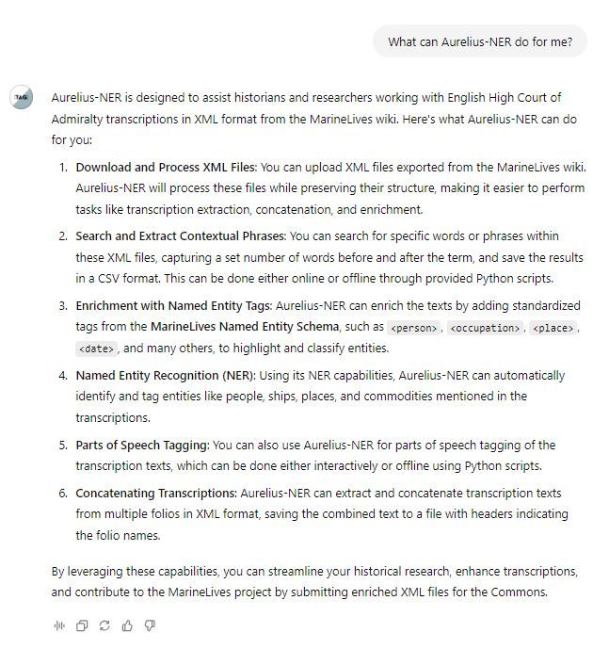

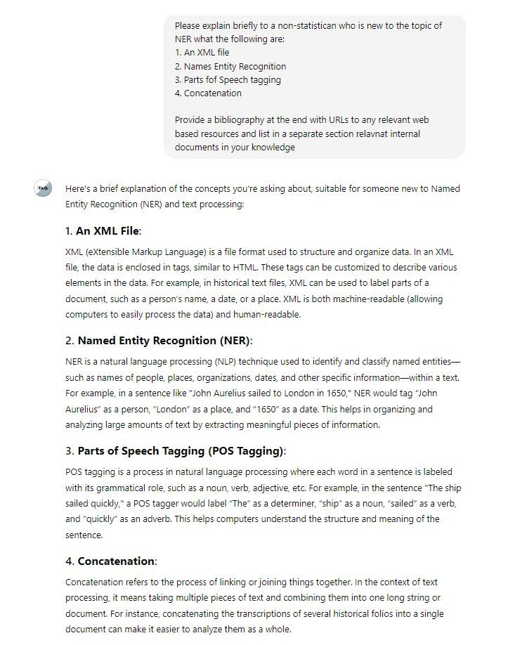

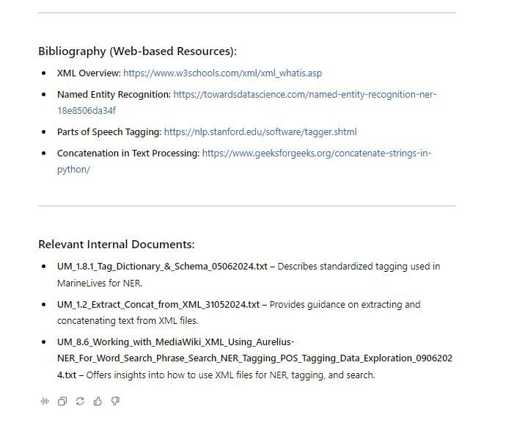

[[](https://bsky.app/profile/marinelives.bsky.social)](https://bsky.app/profile/marinelives.bsky.social)

[· 04/09/2024](https://bsky.app/profile/marinelives.bsky.social/post/3l3ctijhmfm2a)

The Aurelius Family of historical research agents come equipped with user manuals built into their internal knowledge. Chose whether you want a beginners, intermediate or advanced version. Here an example from Aurelius-HTR [chatgpt.com/g/g-AgaPatLN..](https://chatgpt.com/g/g-AgaPatLN..). [#historyGPT4usecase](https://bsky.app/hashtag/historyGPT4usecase) [#skystorians](https://bsky.app/hashtag/skystorians)







1

[[](https://bsky.app/profile/marinelives.bsky.social)](https://bsky.app/profile/marinelives.bsky.social)

[· 04/09/2024](https://bsky.app/profile/marinelives.bsky.social/post/3l3csfg577b25)

The Aurelius Family of historical research agents come equipped with use manuals built into their internal knowledge. Chose whether you want a beginners, intermediate or advanced version. Here an example from Aurelius-NER [chatgpt.com/g/g-AgaPatLN...](https://chatgpt.com/g/g-AgaPatLNW-aurelius-ner) [#historyGPT4usecase](https://bsky.app/hashtag/historyGPT4usecase) [#skystorians](https://bsky.app/hashtag/skystorians)







[[](https://bsky.app/profile/marinelives.bsky.social)](https://bsky.app/profile/marinelives.bsky.social)

[· 03/09/2024](https://bsky.app/profile/marinelives.bsky.social/post/3l3awaokrzs2i)

If you are interested in exploring with an open mind the potential of LLM and other model based AI to support historical research, I have a range of tailored bots you may be interested and a range of tested use cases

[@tedunderwood.me](https://bsky.app/profile/did:plc:565ebob5f6hw33hjdkxty6qj)

[@timhitchcock.bsky.social](https://bsky.app/profile/did:plc:zazpgix5w4ldyytazeqzytmz)

[#historyGPT4usecase](https://bsky.app/hashtag/historyGPT4usecase)





1

2

[[](https://bsky.app/profile/marinelives.bsky.social)](https://bsky.app/profile/marinelives.bsky.social)

[· 03/09/2024](https://bsky.app/profile/marinelives.bsky.social/post/3l3ap44neet2s)

I'm improving my latin [#hitoryGPT4usecase](https://bsky.app/hashtag/hitoryGPT4usecase) [chatgpt.com/g/g-5RyFZvdj...](https://chatgpt.com/g/g-5RyFZvdjH-aurelius-htr)

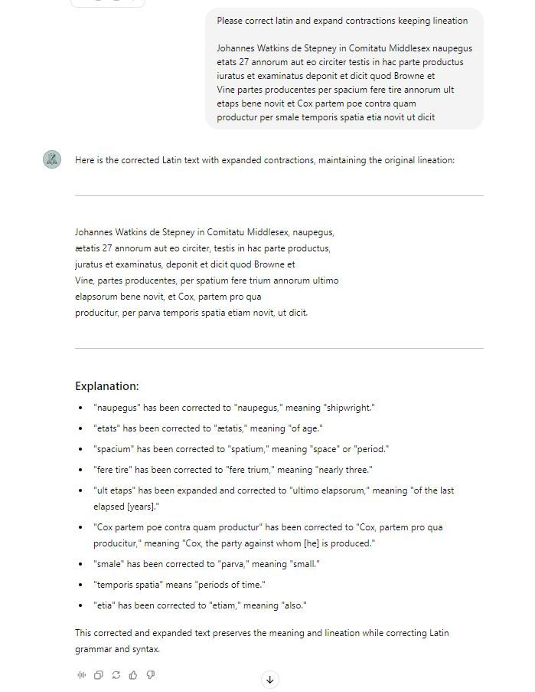

1

[[](https://bsky.app/profile/marinelives.bsky.social)](https://bsky.app/profile/marinelives.bsky.social)

[· 03/09/2024](https://bsky.app/profile/marinelives.bsky.social/post/3l3apmzjd4n2h)

I tweaked the GPT4o feedback and checked again. GPT4o is keen to insert punctuation, but I'm sticking to punctuation as in the original, with expansions of the Latin

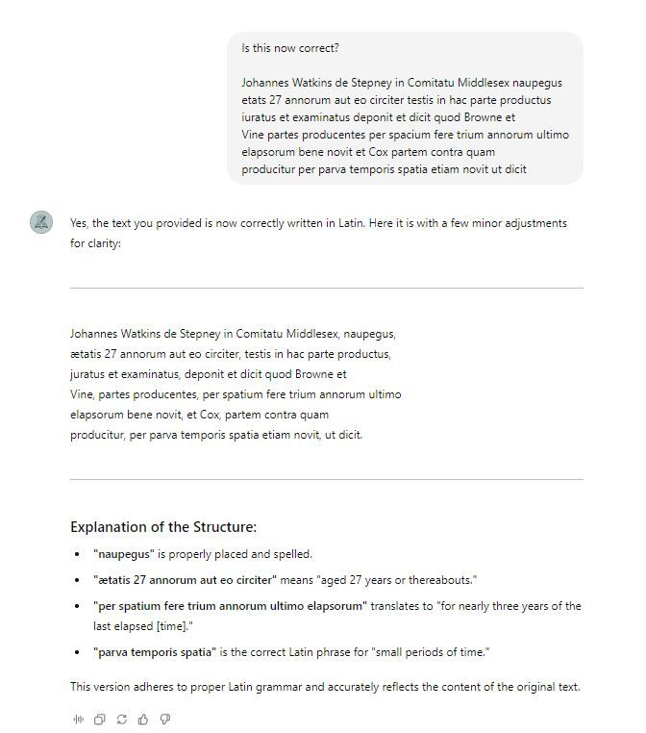

[[](https://bsky.app/profile/marinelives.bsky.social)](https://bsky.app/profile/marinelives.bsky.social)

[· 03/09/2024](https://bsky.app/profile/marinelives.bsky.social/post/3l3aideblwo2t)

I'm running an experiment to see if I can create a basic Knowledge Graph, supported by a GPT-4o bot. [#skystorians](https://bsky.app/hashtag/skystorians) [#historyGPT4usecase](https://bsky.app/hashtag/historyGPT4usecase) Part One

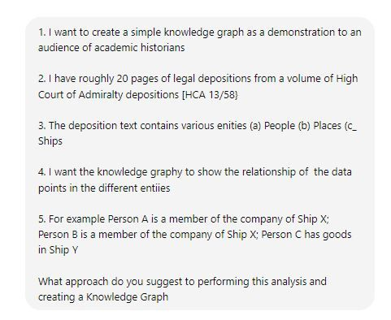

1

[View full thread](https://bsky.app/profile/did:plc:3haql47cl6jucf32mlqtre4p/post/3l3aideblwo2t)

[[](https://bsky.app/profile/marinelives.bsky.social)](https://bsky.app/profile/marinelives.bsky.social)

[· 03/09/2024](https://bsky.app/profile/marinelives.bsky.social/post/3l3ajezylex2b)

Part Seven: Building a demo English High Court of Admiralty Knowledge Graph - How would I make the demoKnowledge Graph interactive and capable of being interrogated? I asked GPT4o [#historyGPT4usecase](https://bsky.app/hashtag/historyGPT4usecase)

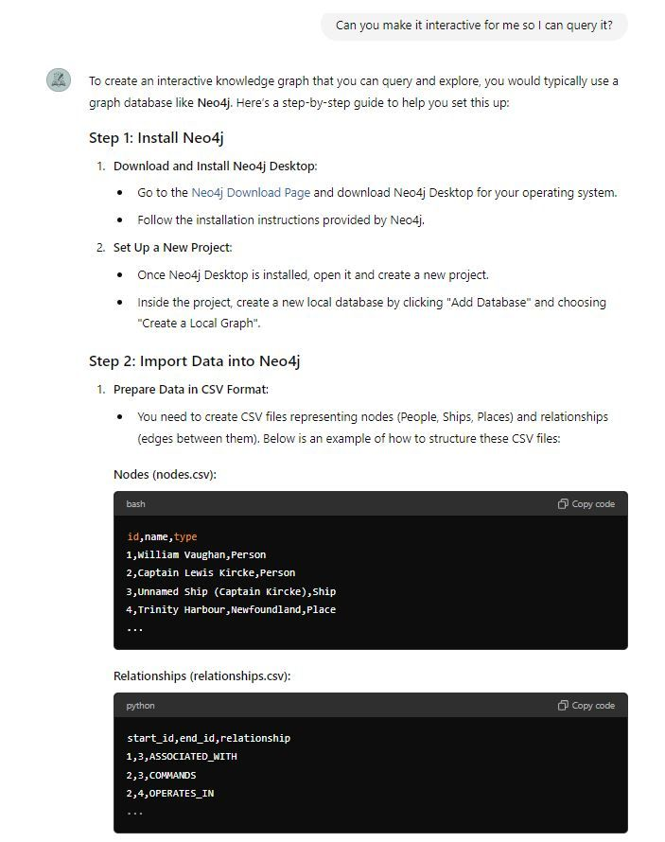

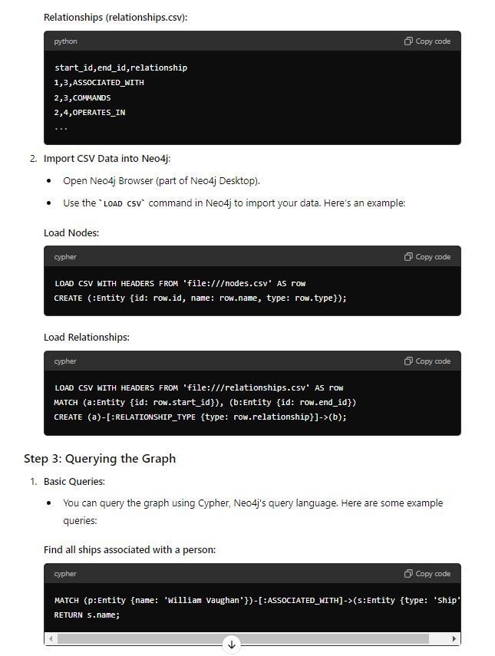

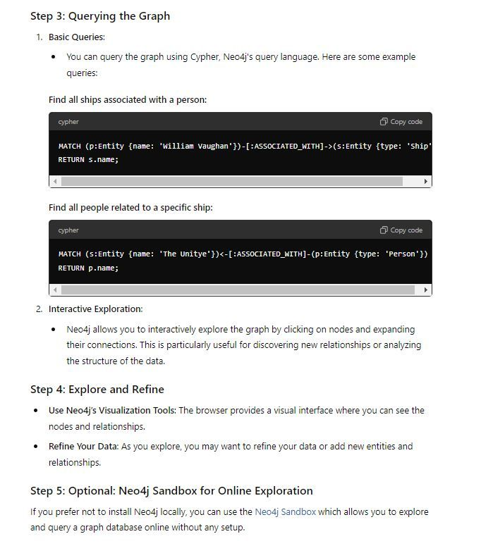

1

[[](https://bsky.app/profile/marinelives.bsky.social)](https://bsky.app/profile/marinelives.bsky.social)

[· 03/09/2024](https://bsky.app/profile/marinelives.bsky.social/post/3l3akglhxyw2x)

Part Eight Building a demo English High Court of Admiralty Knowledge Graph - I have created a free Neo4j account and asked GPT4o to create a downloadable csv file I can uploaded into Neo4j [#historyGPT4usecase](https://bsky.app/hashtag/historyGPT4usecase)

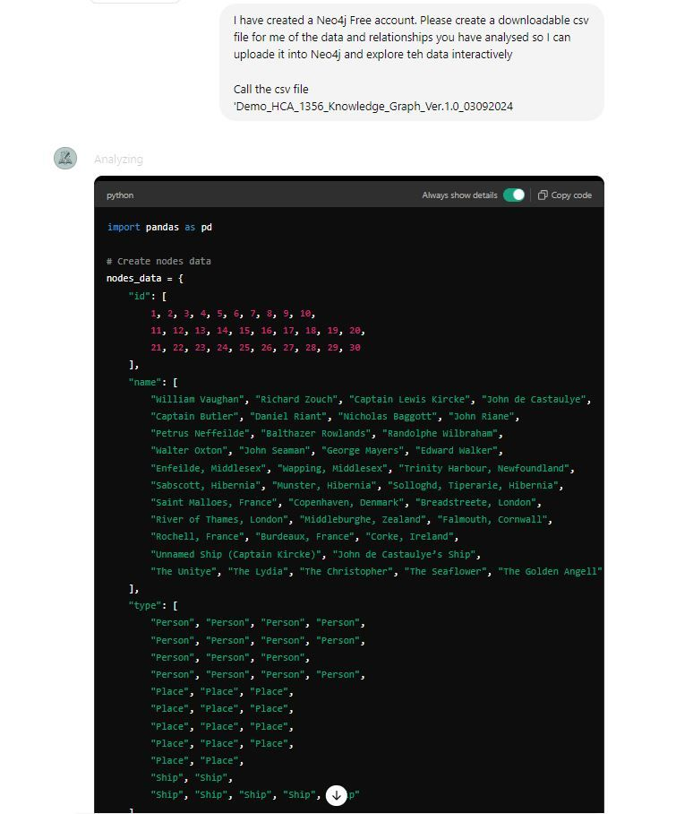

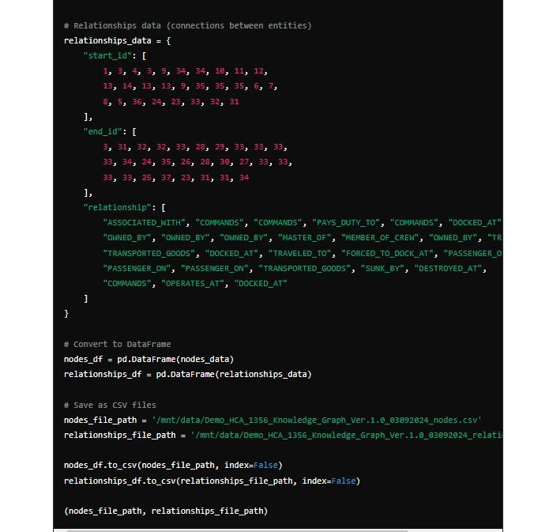

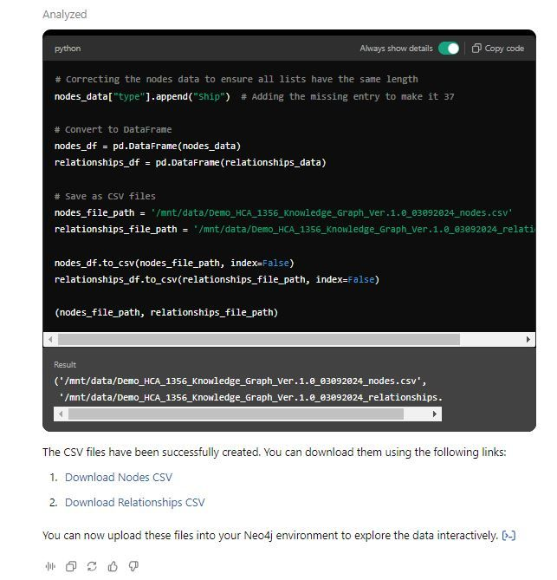

[[](https://bsky.app/profile/marinelives.bsky.social)](https://bsky.app/profile/marinelives.bsky.social)

[· 03/09/2024](https://bsky.app/profile/marinelives.bsky.social/post/3l3aewzp6gh27)

Can a GPT-4o bot reliably identify ship names in text which contains no semantic markup and provide reasoning for its choices? Yes. [#skystorians](https://bsky.app/hashtag/skystorians) [#historyGPT4usecase](https://bsky.app/hashtag/historyGPT4usecase)

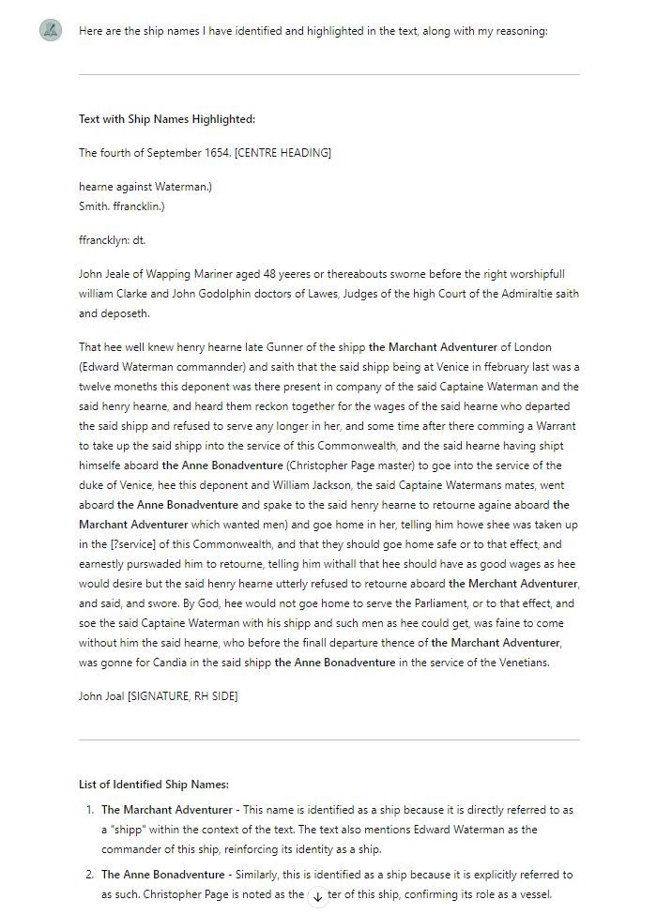

1

[[](https://bsky.app/profile/marinelives.bsky.social)](https://bsky.app/profile/marinelives.bsky.social)

[· 03/09/2024](https://bsky.app/profile/marinelives.bsky.social/post/3l3af6z24qd2w)

I'm using my tailored bot Aurelius-HTR, which also does an ace job on places [#skystorians](https://bsky.app/hashtag/skystorians) [#historyGPT4usecase](https://bsky.app/hashtag/historyGPT4usecase) [chatgpt.com/g/g-5RyFZvdj...](https://chatgpt.com/g/g-5RyFZvdjH-aurelius-htr)

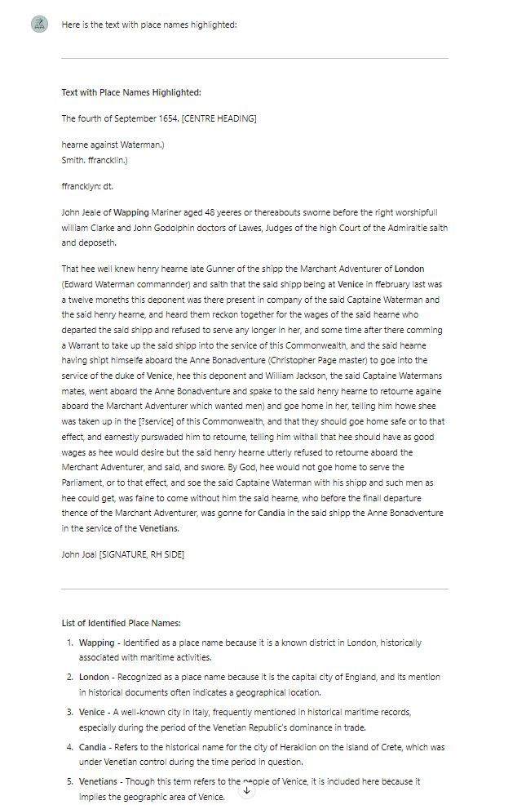

1

[[](https://bsky.app/profile/marinelives.bsky.social)](https://bsky.app/profile/marinelives.bsky.social)

[· 03/09/2024](https://bsky.app/profile/marinelives.bsky.social/post/3l37fxy3h2p2d)

Here's another use for a GPT4o bot in historical research. OCR, transcription and summarisation of secondary texts

[@axe99.bsky.social](https://bsky.app/profile/did:plc:lrbfv7e6zzpsaux7omucrvo3)

[@anterotesis.bsky.social](https://bsky.app/profile/did:plc:5ea6mwiru6wfle4qzsj5r7td)

[@tedunderwood.me](https://bsky.app/profile/did:plc:565ebob5f6hw33hjdkxty6qj)

See next post for results

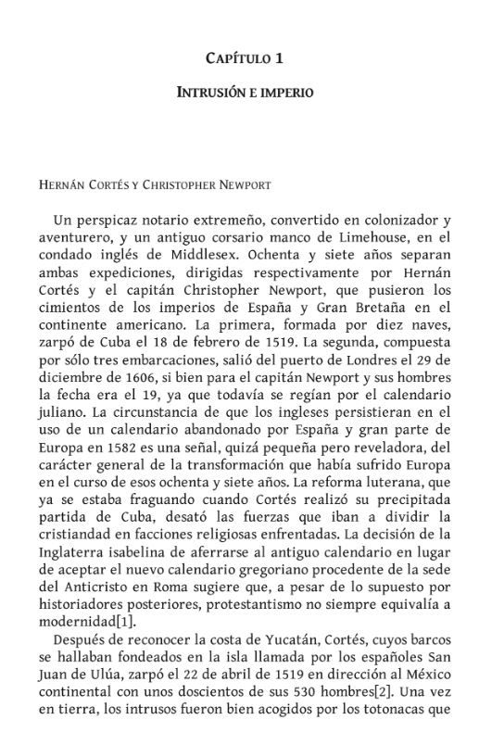

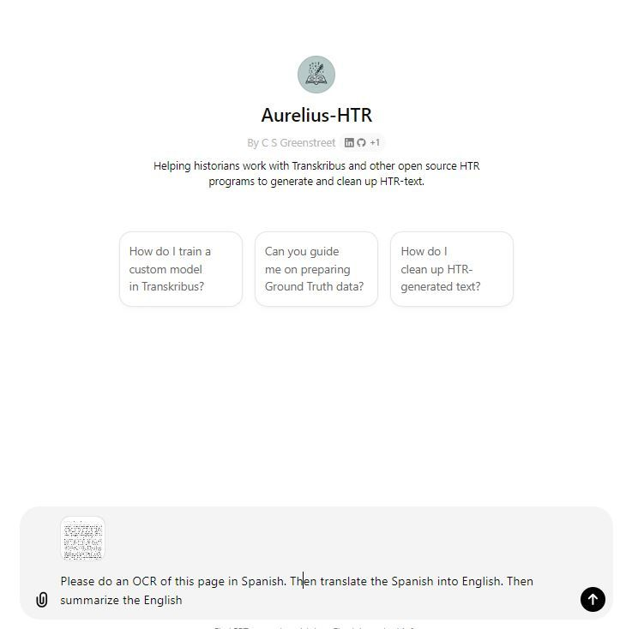

1

[[](https://bsky.app/profile/marinelives.bsky.social)](https://bsky.app/profile/marinelives.bsky.social)

[· 03/09/2024](https://bsky.app/profile/marinelives.bsky.social/post/3l37g7lgstk25)

Here are the results: First Spanish OCR, then English quick and dirty translation. Then a short summary [#historyGPT4usecase](https://bsky.app/hashtag/historyGPT4usecase) [#Skystorians](https://bsky.app/hashtag/Skystorians)

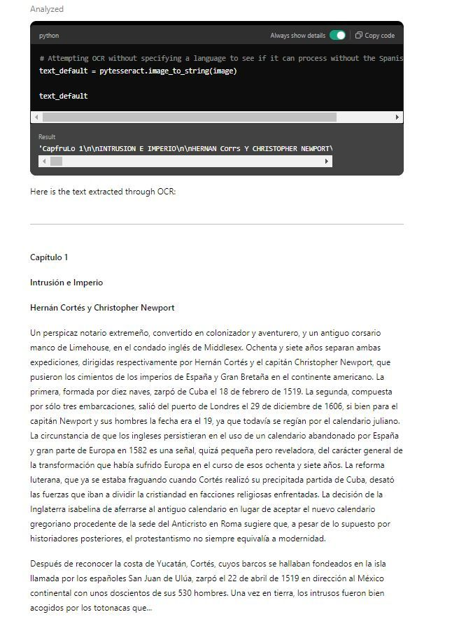

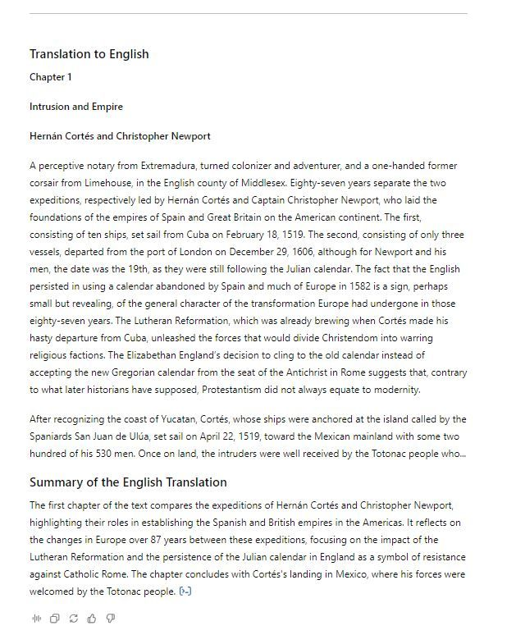

1

[[](https://bsky.app/profile/marinelives.bsky.social)](https://bsky.app/profile/marinelives.bsky.social)

[· 02/09/2024](https://bsky.app/profile/marinelives.bsky.social/post/3l37bh3gljk2b)

Ping

[@tedunderwood.me](https://bsky.app/profile/did:plc:565ebob5f6hw33hjdkxty6qj)

[[](https://bsky.app/profile/marinelives.bsky.social)](https://bsky.app/profile/marinelives.bsky.social)

[· 02/09/2024](https://bsky.app/profile/marinelives.bsky.social/post/3l3767dju332b)

Can you use a GPT-4o based bot to identify structureal and semantic components of a legal deposition? Yes, you can. Here Aurelius-HTR nails the name, occupation and age of a deponent. It also found the signature and start of the interrogatories. #historyGPT4usecase #skystorians

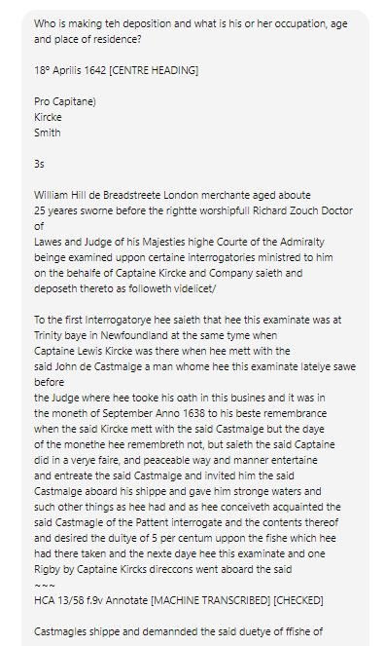

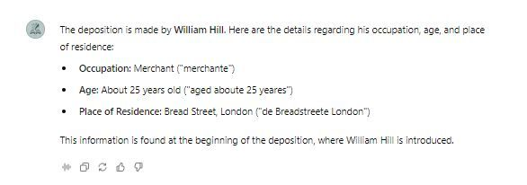

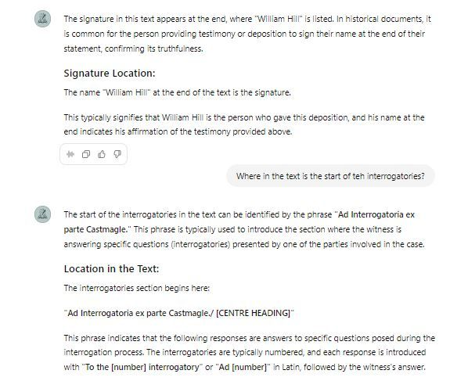

[[](https://bsky.app/profile/marinelives.bsky.social)](https://bsky.app/profile/marinelives.bsky.social)

[· 02/09/2024](https://bsky.app/profile/marinelives.bsky.social/post/3l376aomjwe2x)

Ping

[@tedmccormick.bsky.social](https://bsky.app/profile/did:plc:ymninynadpwv67q7hxiqy7h2)

[@mcculloughp.bsky.social](https://bsky.app/profile/did:plc:33m6asmu2bwmf4jkr7wvols4)

[@lsangha.bsky.social](https://bsky.app/profile/did:plc:sizujj7y6vouiq7mh2rdvv6k)

[@timhitchcock.bsky.social](https://bsky.app/profile/did:plc:zazpgix5w4ldyytazeqzytmz)

[[](https://bsky.app/profile/marinelives.bsky.social)](https://bsky.app/profile/marinelives.bsky.social)

[· 02/09/2024](https://bsky.app/profile/marinelives.bsky.social/post/3l3767dju332b)

Can you use a GPT-4o based bot to identify structureal and semantic components of a legal deposition? Yes, you can. Here Aurelius-HTR nails the name, occupation and age of a deponent. It also found the signature and start of the interrogatories. #historyGPT4usecase #skystorians







1

[[](https://bsky.app/profile/marinelives.bsky.social)](https://bsky.app/profile/marinelives.bsky.social)

[· 02/09/2024](https://bsky.app/profile/marinelives.bsky.social/post/3l376yfsolj2n)

So I decided to get more demanding and pasted in 4,000 words of text covering multiple depositions. I asked for the name, age, occupation and residence of the one or more deponents. The answer is right: 4 deponents, all data correctly extracted, including inference [#historyGPT4usecase](https://bsky.app/hashtag/historyGPT4usecase) [#skystorians](https://bsky.app/hashtag/skystorians)

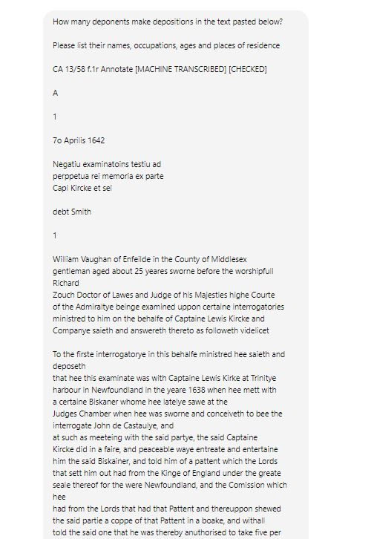

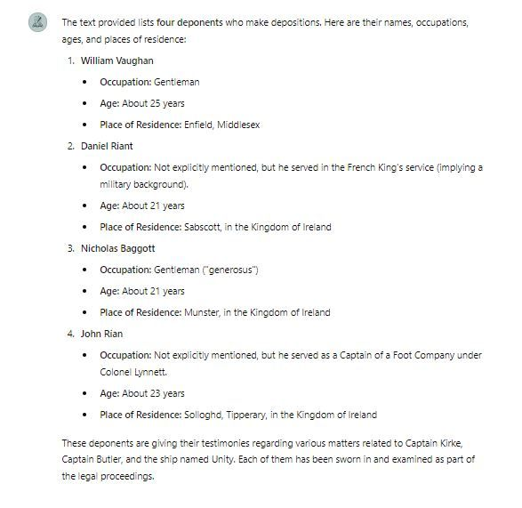

[[](https://bsky.app/profile/marinelives.bsky.social)](https://bsky.app/profile/marinelives.bsky.social)

[· 02/09/2024](https://bsky.app/profile/marinelives.bsky.social/post/3l376myaezz2l)

The fact that a GPT-4o bot without any fine tuning can identify structural components of a legal deposition is big news for historical search. It means that transcribed documents can be searched for structure and semantics without prior markup for certain attributes

[@anterotesis.bsky.social](https://bsky.app/profile/did:plc:5ea6mwiru6wfle4qzsj5r7td)

[[](https://bsky.app/profile/marinelives.bsky.social)](https://bsky.app/profile/marinelives.bsky.social)

[· 02/09/2024](https://bsky.app/profile/marinelives.bsky.social/post/3l3767dju332b)

Can you use a GPT-4o based bot to identify structureal and semantic components of a legal deposition? Yes, you can. Here Aurelius-HTR nails the name, occupation and age of a deponent. It also found the signature and start of the interrogatories. #historyGPT4usecase #skystorians







[[](https://bsky.app/profile/marinelives.bsky.social)](https://bsky.app/profile/marinelives.bsky.social)

[· 02/09/2024](https://bsky.app/profile/marinelives.bsky.social/post/3l3767dju332b)

Can you use a GPT-4o based bot to identify structureal and semantic components of a legal deposition? Yes, you can. Here Aurelius-HTR nails the name, occupation and age of a deponent. It also found the signature and start of the interrogatories. [#historyGPT4usecase](https://bsky.app/hashtag/historyGPT4usecase) [#skystorians](https://bsky.app/hashtag/skystorians)







4

[[](https://bsky.app/profile/marinelives.bsky.social)](https://bsky.app/profile/marinelives.bsky.social)

[· 02/09/2024](https://bsky.app/profile/marinelives.bsky.social/post/3l36zain4h72h)

MarineLives hosts 30,000 images of English High Court of Admiralty depositions on Transkribus. Let us know if you would like access for research purposes. Happy to give you access [#historians](https://bsky.app/hashtag/historians) [#skystorians](https://bsky.app/hashtag/skystorians)

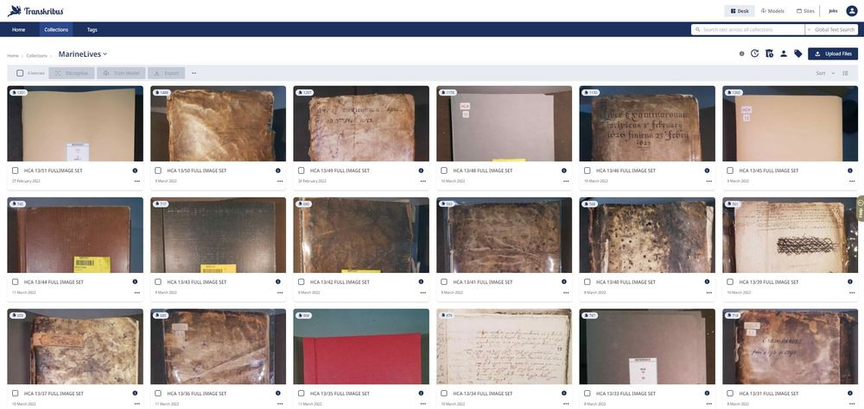

1

5

[[](https://bsky.app/profile/marinelives.bsky.social)](https://bsky.app/profile/marinelives.bsky.social)

[· 02/09/2024](https://bsky.app/profile/marinelives.bsky.social/post/3l36rvip7yq2w)

Ping

[@axe99.bsky.social](https://bsky.app/profile/did:plc:lrbfv7e6zzpsaux7omucrvo3)

[[](https://bsky.app/profile/marinelives.bsky.social)](https://bsky.app/profile/marinelives.bsky.social)

[· 02/09/2024](https://bsky.app/profile/marinelives.bsky.social/post/3l36rswgwyc2x)

My Latin tuition by Aurelius-HTR is moving on. I think I am getting to grips with this!! My Latin teacher Phil Hiscock (1969-72) would be intrigued #skystorians #historyGPTusecase

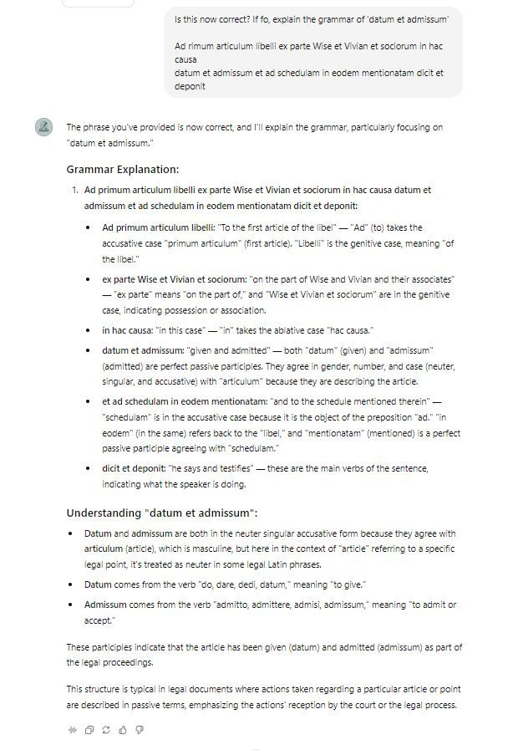

[[](https://bsky.app/profile/marinelives.bsky.social)](https://bsky.app/profile/marinelives.bsky.social)

[· 02/09/2024](https://bsky.app/profile/marinelives.bsky.social/post/3l364bfofyo25)

Second of a series of posts showing specific use cases for tailored GPT-4o agents to support historical research

[@cathamclarke.bsky.social](https://bsky.app/profile/did:plc:imn5zuyki7dqgziteqzfmlrw)

[@drsezzer.bsky.social](https://bsky.app/profile/did:plc:flqcrjbvyenfsmvvpw6nf2kj)

[@tharsen.bsky.social](https://bsky.app/profile/did:plc:essd7vyz5rnwazahimzswjpr)

[ky.social](https://ky.social/)

[@timhitchcock.bsky.social](https://bsky.app/profile/did:plc:zazpgix5w4ldyytazeqzytmz)

[y.social](https://y.social/) [#historians](https://bsky.app/hashtag/historians) [#historyGPT4usecase](https://bsky.app/hashtag/historyGPT4usecase)

[@gilliansmac.bsky.social](https://bsky.app/profile/did:plc:aiztlooc3nkwss3yyeyvgvid)

[[](https://bsky.app/profile/marinelives.bsky.social)](https://bsky.app/profile/marinelives.bsky.social)

[· 02/09/2024](https://bsky.app/profile/marinelives.bsky.social/post/3l363ll2b5k2y)

I thought I would start to improve my understanding of Latin grammar so that I can better hand correct machine transcribed High Court of Admiralty depositions

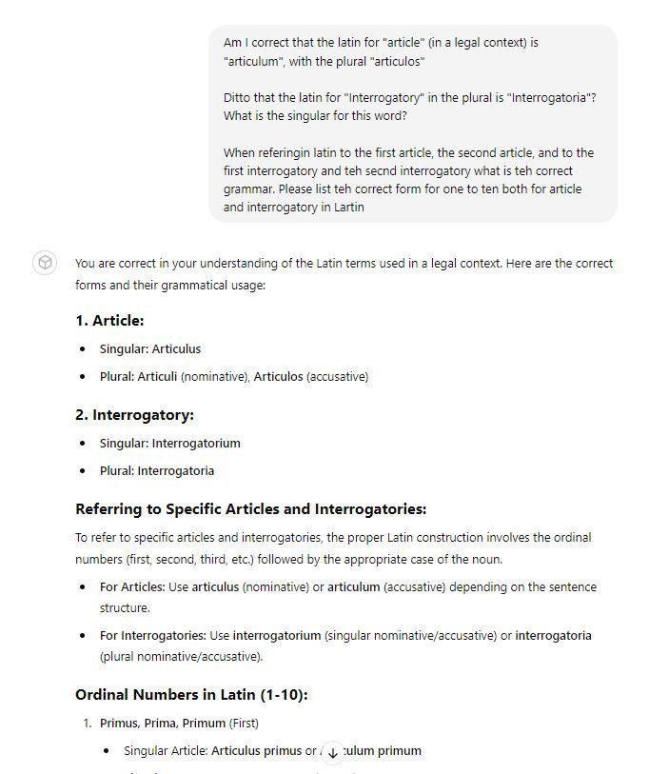

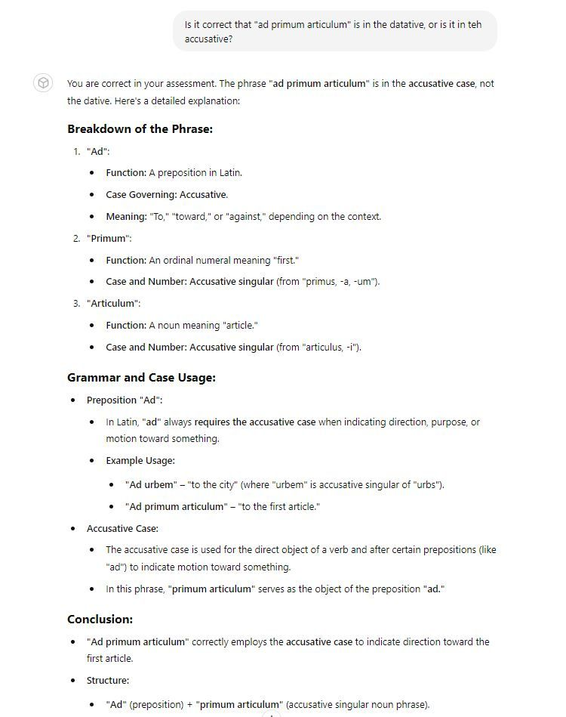

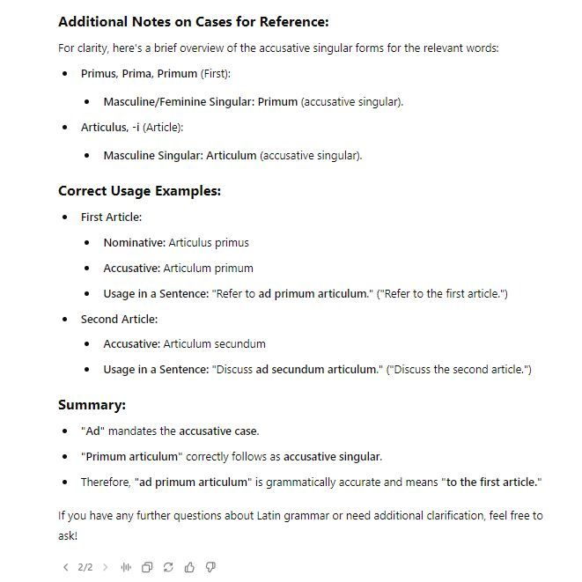

1

[[](https://bsky.app/profile/marinelives.bsky.social)](https://bsky.app/profile/marinelives.bsky.social)

[· 02/09/2024](https://bsky.app/profile/marinelives.bsky.social/post/3l36rswgwyc2x)

My Latin tuition by Aurelius-HTR is moving on. I think I am getting to grips with this!! My Latin teacher Phil Hiscock (1969-72) would be intrigued [#skystorians](https://bsky.app/hashtag/skystorians) [#historyGPTusecase](https://bsky.app/hashtag/historyGPTusecase)



1

1

[[](https://bsky.app/profile/marinelives.bsky.social)](https://bsky.app/profile/marinelives.bsky.social)

[· 02/09/2024](https://bsky.app/profile/marinelives.bsky.social/post/3l36mlu2kkk23)

I want to improve Aurelius-HTRs ability to deal with C16th and C17th legal latin. Would love more texts to work on, or use cases [#skystorians](https://bsky.app/hashtag/skystorians) have. Including vocabulary and phrase lists [#historyGPT4usecase](https://bsky.app/hashtag/historyGPT4usecase) [#latinlanguage](https://bsky.app/hashtag/latinlanguage) [#earlymodern](https://bsky.app/hashtag/earlymodern)

[[](https://bsky.app/profile/marinelives.bsky.social)](https://bsky.app/profile/marinelives.bsky.social)

[· 02/09/2024](https://bsky.app/profile/marinelives.bsky.social/post/3l36md6siy42s)

I'm working with Aurelius-HTR GPT-4o tailored bot to improve my pretty bad hand correction of C17th Latin. I asked Aurelius to highlight typical mistakes in my work and to create a checklist for volunteers. #historyGPT4usecase #skystorians chatgpt.com/g/g-5RyFZvdj...

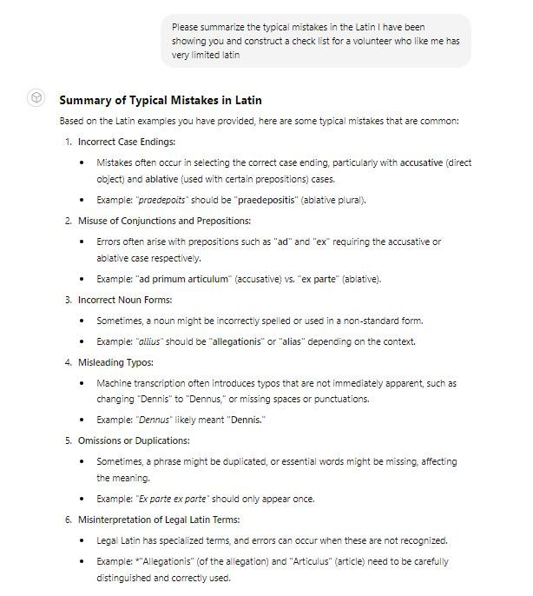

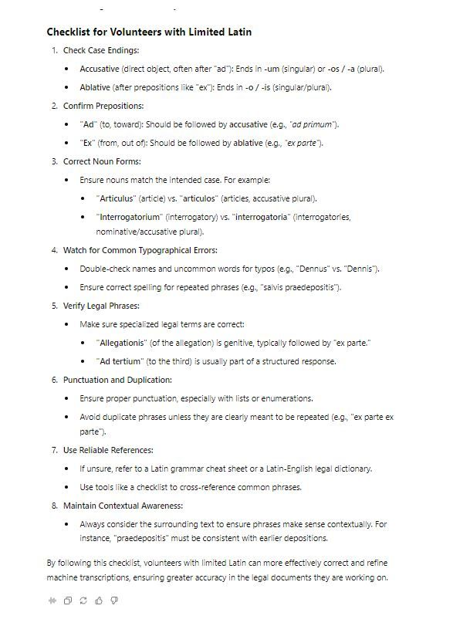

[[](https://bsky.app/profile/marinelives.bsky.social)](https://bsky.app/profile/marinelives.bsky.social)

[· 02/09/2024](https://bsky.app/profile/marinelives.bsky.social/post/3l36md6siy42s)

I'm working with Aurelius-HTR GPT-4o tailored bot to improve my pretty bad hand correction of C17th Latin. I asked Aurelius to highlight typical mistakes in my work and to create a checklist for volunteers. [#historyGPT4usecase](https://bsky.app/hashtag/historyGPT4usecase) [#skystorians](https://bsky.app/hashtag/skystorians) [chatgpt.com/g/g-5RyFZvdj...](https://chatgpt.com/g/g-5RyFZvdjH-aurelius-htr)





1

[[](https://bsky.app/profile/marinelives.bsky.social)](https://bsky.app/profile/marinelives.bsky.social)

[· 02/09/2024](https://bsky.app/profile/marinelives.bsky.social/post/3l35yuh7zmy2h)

Here is an example of how an historian can work with a GPT-4o bot which has been tailored to be conscious of C17th context. I am using it to parse multiple depositions from the same case and summarize key facts. The summary is accurate [#historians](https://bsky.app/hashtag/historians) [#historyGPT4usecase](https://bsky.app/hashtag/historyGPT4usecase)

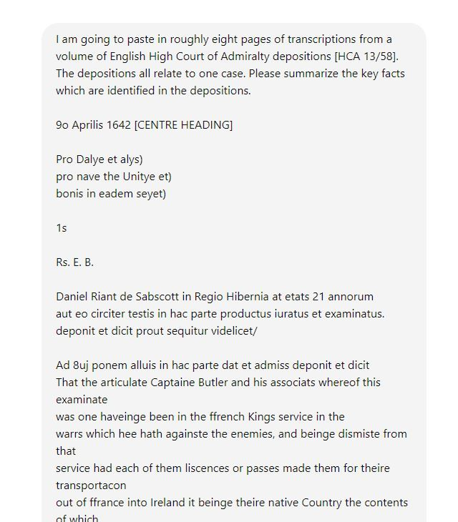

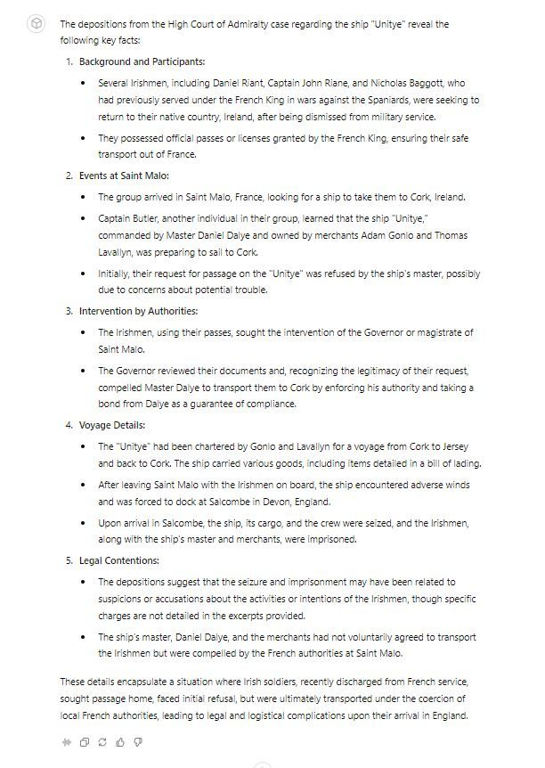

1

1

[View full thread](https://bsky.app/profile/did:plc:3haql47cl6jucf32mlqtre4p/post/3l35yuh7zmy2h)

[[](https://bsky.app/profile/marinelives.bsky.social)](https://bsky.app/profile/marinelives.bsky.social)

[· 02/09/2024](https://bsky.app/profile/marinelives.bsky.social/post/3l362g5t5d42k)

I then pasted a further part of the deposition of the master of the Unity and asked the GPT-4o agent [called Aurelius-Merchant] whether there were additional facts which supported, expanded or contradicted the previous summary. How well would your students do? [#historians](https://bsky.app/hashtag/historians) [#historyGPT4usecase](https://bsky.app/hashtag/historyGPT4usecase)

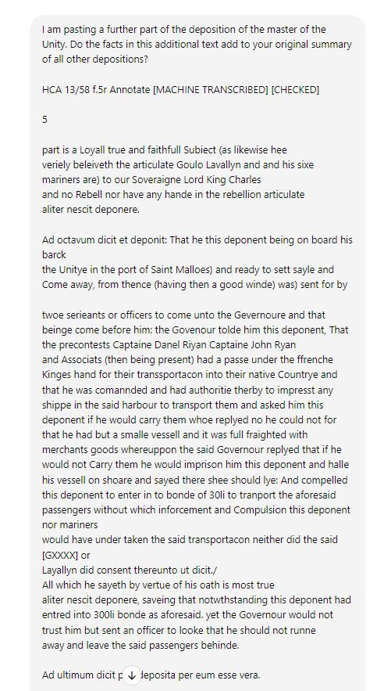

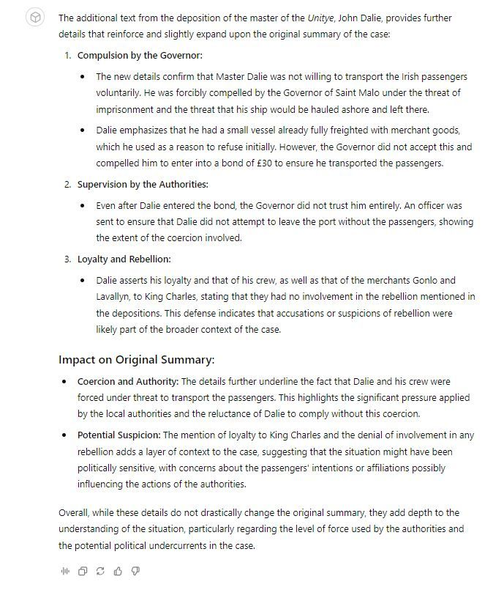

1

[[](https://bsky.app/profile/marinelives.bsky.social)](https://bsky.app/profile/marinelives.bsky.social)

[· 02/09/2024](https://bsky.app/profile/marinelives.bsky.social/post/3l36m52eetb2k)

I'm now working with Aurelius-HTR in "the wild" and asking for Latin assistance as I get on hand correcting machine transcriptions by

[@transkribus.bsky.social](https://bsky.app/profile/did:plc:adbwqqtuasa27sf4ijch4zvt)

[#hostoryGPT4usecase](https://bsky.app/hashtag/hostoryGPT4usecase) [chatgpt.com/g/g-5RyFZvdj...](https://chatgpt.com/g/g-5RyFZvdjH-aurelius-htr)

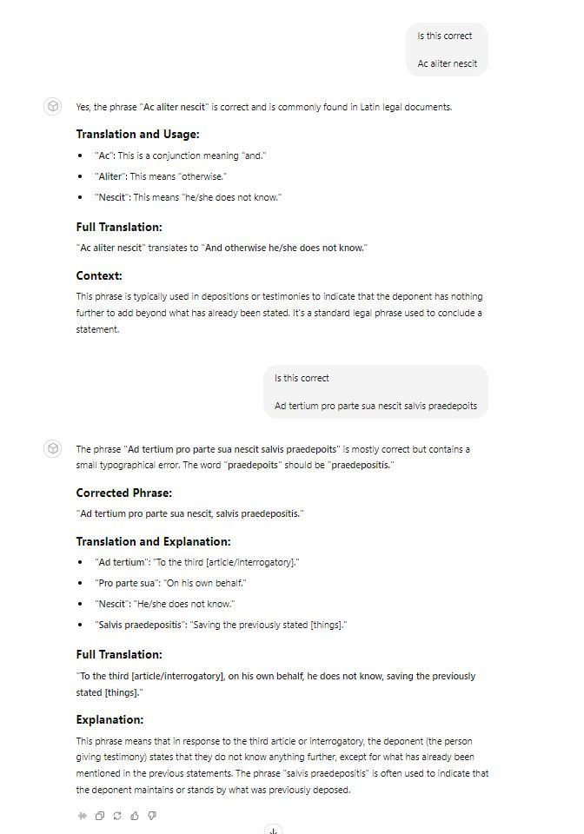

[[](https://bsky.app/profile/marinelives.bsky.social)](https://bsky.app/profile/marinelives.bsky.social)

[· 02/09/2024](https://bsky.app/profile/marinelives.bsky.social/post/3l3646lm6if26)

[[](https://bsky.app/profile/marinelives.bsky.social)](https://bsky.app/profile/marinelives.bsky.social)

[· 02/09/2024](https://bsky.app/profile/marinelives.bsky.social/post/3l362x5ty5a2b)

My Latin is pretty rusty. I asked a tailored GPT-4o agent Aurelius-Merchant to extract all the Latin phrases in the 3000 words of text pasted in and to comment on their accuracy. Extraction broardly right. Comment from Latinists? #historians #historyGPT4usecase chatgpt.com/g/g-srf62J1Z...

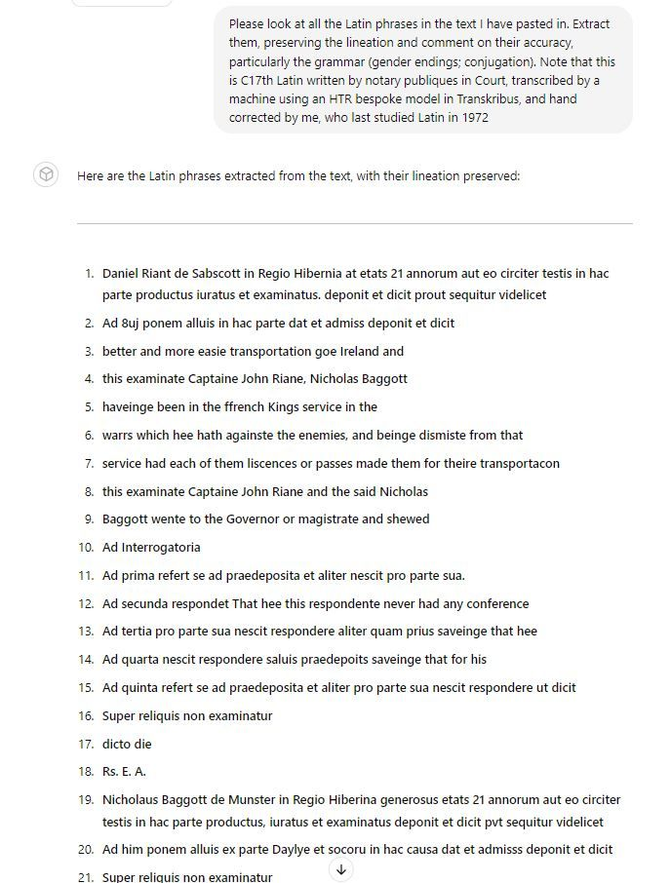

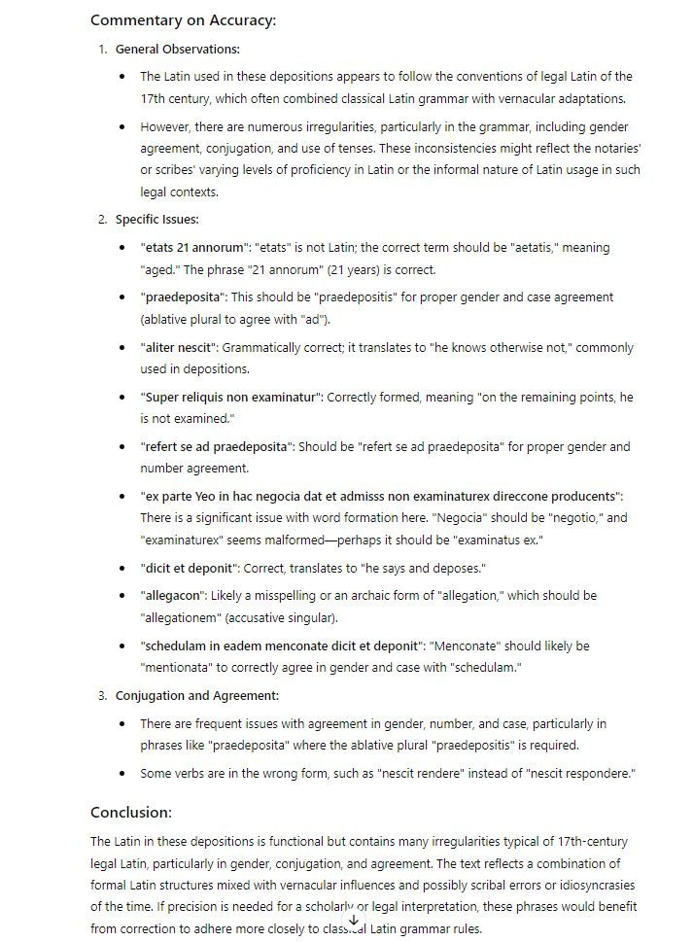

[[](https://bsky.app/profile/marinelives.bsky.social)](https://bsky.app/profile/marinelives.bsky.social)

[· 02/09/2024](https://bsky.app/profile/marinelives.bsky.social/post/3l362x5ty5a2b)

My Latin is pretty rusty. I asked a tailored GPT-4o agent Aurelius-Merchant to extract all the Latin phrases in the 3000 words of text pasted in and to comment on their accuracy. Extraction broardly right. Comment from Latinists? [#historians](https://bsky.app/hashtag/historians) [#historyGPT4usecase](https://bsky.app/hashtag/historyGPT4usecase) [chatgpt.com/g/g-srf62J1Z...](https://chatgpt.com/g/g-srf62J1ZY-aurelius-merchant)





1

2

[[](https://bsky.app/profile/marinelives.bsky.social)](https://bsky.app/profile/marinelives.bsky.social)

[· 02/09/2024](https://bsky.app/profile/marinelives.bsky.social/post/3l363ll2b5k2y)

I thought I would start to improve my understanding of Latin grammar so that I can better hand correct machine transcribed High Court of Admiralty depositions







1

1

[[](https://bsky.app/profile/marinelives.bsky.social)](https://bsky.app/profile/marinelives.bsky.social)

[· 02/09/2024](https://bsky.app/profile/marinelives.bsky.social/post/3l363yuyqwz2d)

And finally I have my answer to the gender of Interrogatory and how to handle the numerous references in High Court of Admiralty depositions to Interrogatories

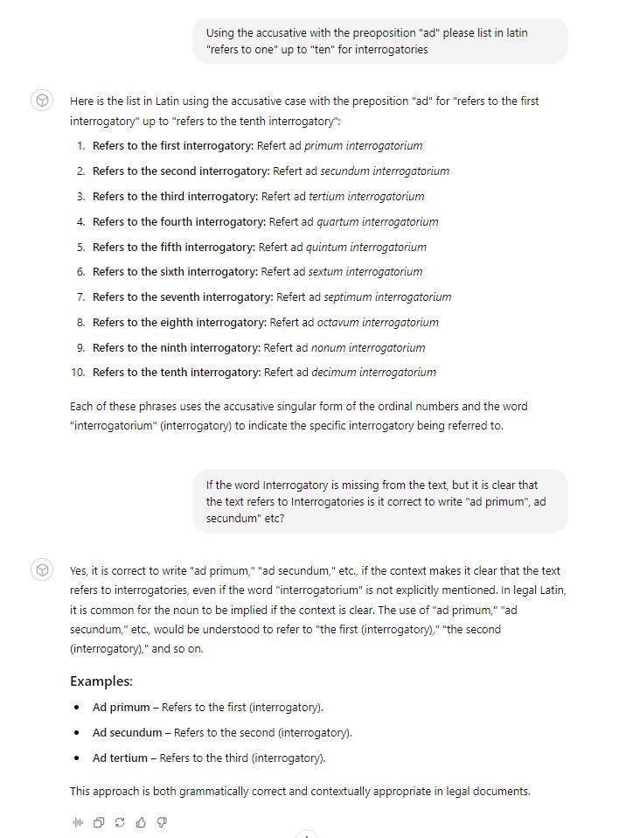

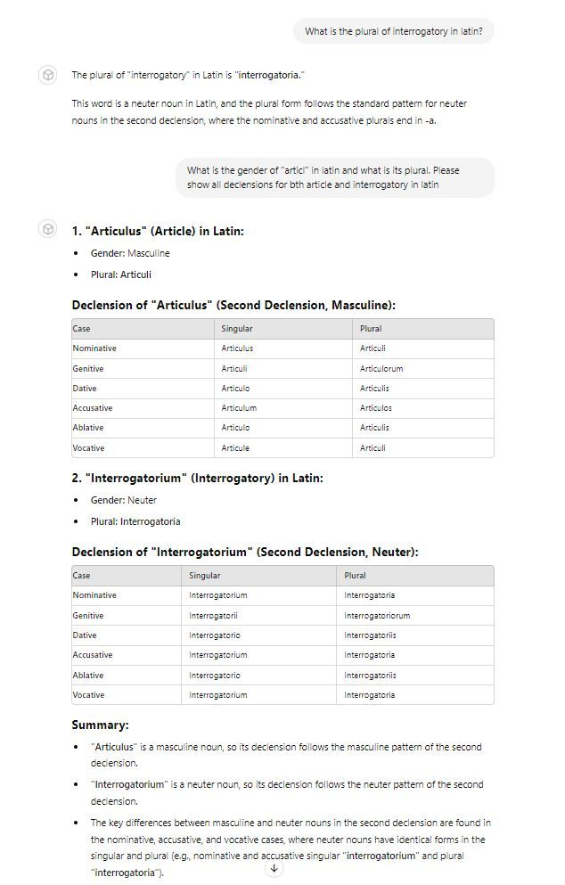

1

[[](https://bsky.app/profile/marinelives.bsky.social)](https://bsky.app/profile/marinelives.bsky.social)

[· 02/09/2024](https://bsky.app/profile/marinelives.bsky.social/post/3l35z223c722s)

First of a series of posts showing specific use cases for tailored GPT-4o agents to support historical research

[@cathamclarke.bsky.social](https://bsky.app/profile/did:plc:imn5zuyki7dqgziteqzfmlrw)

[@drsezzer.bsky.social](https://bsky.app/profile/did:plc:flqcrjbvyenfsmvvpw6nf2kj)

[@tharsen.bsky.social](https://bsky.app/profile/did:plc:essd7vyz5rnwazahimzswjpr)

[@gilliansmac.bsky.social](https://bsky.app/profile/did:plc:aiztlooc3nkwss3yyeyvgvid)

[@timhitchcock.bsky.social](https://bsky.app/profile/did:plc:zazpgix5w4ldyytazeqzytmz)

[[](https://bsky.app/profile/marinelives.bsky.social)](https://bsky.app/profile/marinelives.bsky.social)

[· 02/09/2024](https://bsky.app/profile/marinelives.bsky.social/post/3l35yuh7zmy2h)

Here is an example of how an historian can work with a GPT-4o bot which has been tailored to be conscious of C17th context. I am using it to parse multiple depositions from the same case and summarize key facts. The summary is accurate #historians #historyGPT4usecase





[Reposted by you](https://bsky.app/profile/marinelives.bsky.social)

[[](https://bsky.app/profile/jdp.extropian.net)](https://bsky.app/profile/jdp.extropian.net)

[· 01/09/2024](https://bsky.app/profile/jdp.extropian.net/post/3l33ldatmdx2x)

Replied to

[John David Pressman](https://bsky.app/profile/jdp.extropian.net)

I thought this was a good non-hype case study of someone using LLMs for historical research dealing with their parts and still getting value out of it. [www.theverge.com/24068716/ai-...](https://www.theverge.com/24068716/ai-historians-academia-llm-chatgpt)

[[](https://www.theverge.com/24068716/ai-historians-academia-llm-chatgpt)](https://www.theverge.com/24068716/ai-historians-academia-llm-chatgpt" \t "_blank)

**[What AI can do for historians](https://www.theverge.com/24068716/ai-historians-academia-llm-chatgpt" \t "_blank)**

[It turns out that large language models make surprisingly good research assistants for historians. Can the future of AI help reconstruct the past?](https://www.theverge.com/24068716/ai-historians-academia-llm-chatgpt" \t "_blank)

[www.theverge.com](https://www.theverge.com/24068716/ai-historians-academia-llm-chatgpt" \t "_blank)

2

**1**

[[](https://bsky.app/profile/marinelives.bsky.social)](https://bsky.app/profile/marinelives.bsky.social)

[· 31/08/2024](https://bsky.app/profile/marinelives.bsky.social/post/3l2zmq43anx25)

I have a request to all [#historians](https://bsky.app/hashtag/historians). I am giving a talk in early November at an IHR digital seminar about the potential use of LLMs to support historical reserach. I would like your use cases. How could LLMs help you and your students research history (warts and all)?



4

7

[[](https://bsky.app/profile/marinelives.bsky.social)](https://bsky.app/profile/marinelives.bsky.social)

[· 31/08/2024](https://bsky.app/profile/marinelives.bsky.social/post/3l2zg6da5yk2k)

I have invented a new parlour game! I have created an intelligent agent (Aurelius-Merchant) designed to think like a C17th merchant, with knowledge of Early Modern commodities and geography. Let's see if it can guess ports by their commodities? Yes it is Smyrna [chatgpt.com/g/g-srf62J1Z...](https://chatgpt.com/g/g-srf62J1ZY-aurelius-merchant) PART ONE

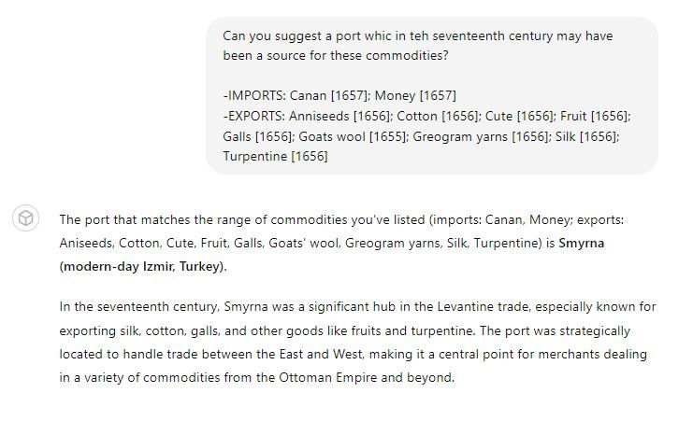

1

1

[View full thread](https://bsky.app/profile/did:plc:3haql47cl6jucf32mlqtre4p/post/3l2zg6da5yk2k)

[[](https://bsky.app/profile/marinelives.bsky.social)](https://bsky.app/profile/marinelives.bsky.social)

[· 31/08/2024](https://bsky.app/profile/marinelives.bsky.social/post/3l2zj5266wx2h)

I decided to test Aurelius-Merchant on its knowledge of C17th Materials Handling (it has a large file in internal knowledge). The answer was pretty good and made me think before broadly agreeing. Again, how would your students have answered this?

[@thiagokrause.bsky.social](https://bsky.app/profile/did:plc:m6ub6fozxlo3gzqn2rayoiwy)

[@timhitchcock.bsky.social](https://bsky.app/profile/did:plc:zazpgix5w4ldyytazeqzytmz)

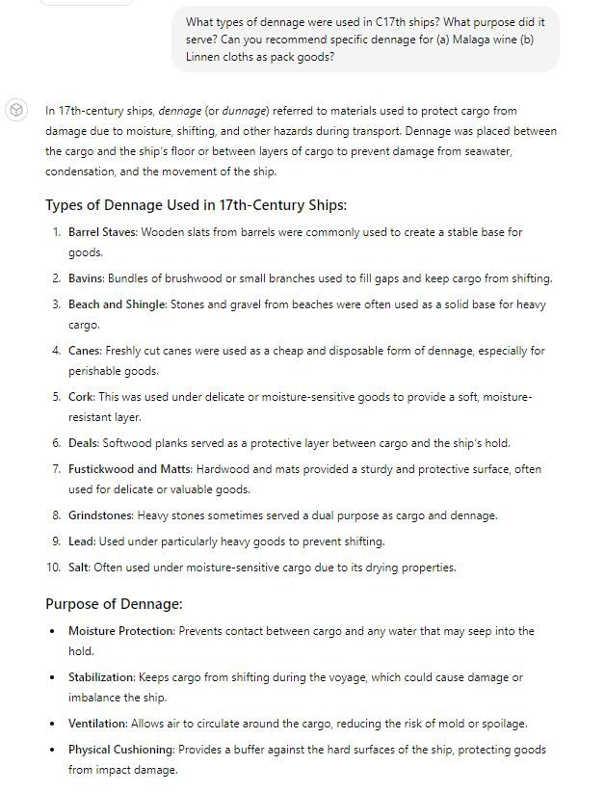

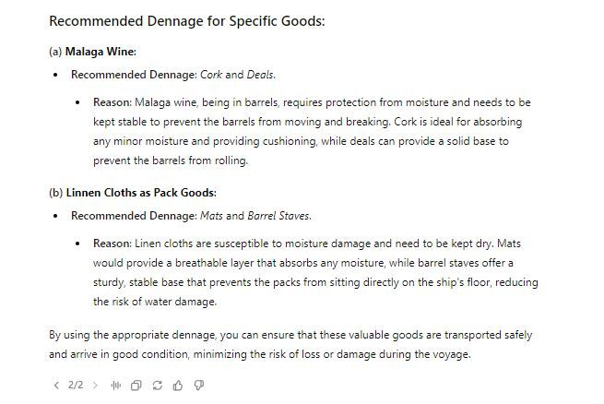

1

[[](https://bsky.app/profile/marinelives.bsky.social)](https://bsky.app/profile/marinelives.bsky.social)

[· 31/08/2024](https://bsky.app/profile/marinelives.bsky.social/post/3l2zjorcvfx25)

I asked Aurelius-Merchant how best to transport pepper by ship in the C17th. The bot correctly referenced its internal knowledge, but failed to give me an acaedemic source (though the quotes are correct)

[@thiagokrause.bsky.social](https://bsky.app/profile/did:plc:m6ub6fozxlo3gzqn2rayoiwy)

[@timhitchcock.bsky.social](https://bsky.app/profile/did:plc:zazpgix5w4ldyytazeqzytmz)

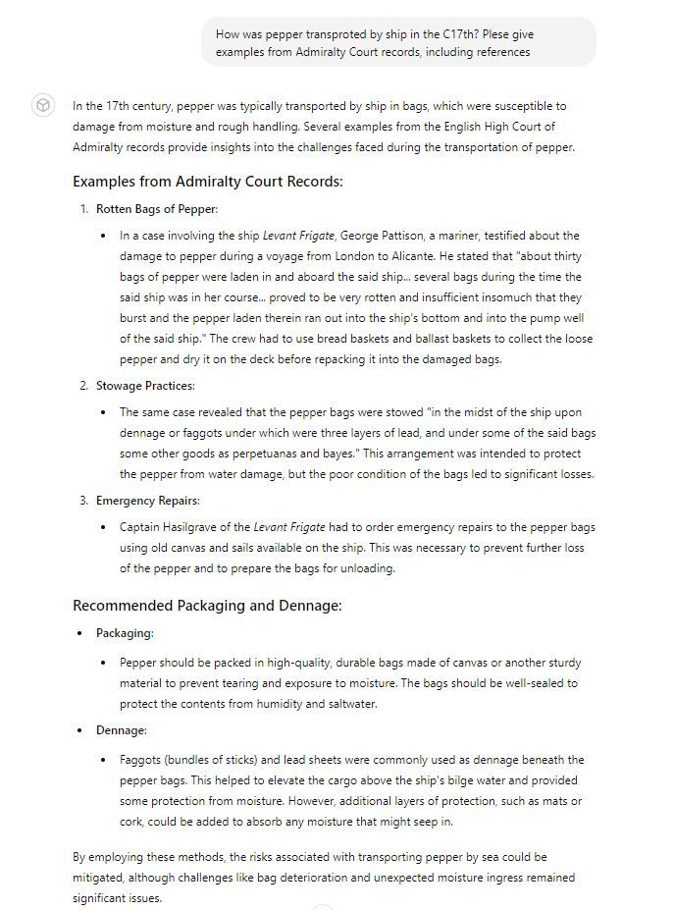

[[](https://bsky.app/profile/marinelives.bsky.social)](https://bsky.app/profile/marinelives.bsky.social)

[· 31/08/2024](https://bsky.app/profile/marinelives.bsky.social/post/3l2zi2pkoga2n)

How would your students perform with this parlour game? The teaching for me would be to work with students to improve Aurelius-Merchant

[@roperlou.bsky.social](https://bsky.app/profile/did:plc:6ot4sikmpkjq5sfbxk4n24sm)

[@lauragowing.bsky.social](https://bsky.app/profile/did:plc:odnvfulslh72dthd22pxblpo)

[@profelainechalus.bsky.social](https://bsky.app/profile/did:plc:w66sjdn6hhxcobbvpsmedorl)

[@plymprivateer.bsky.social](https://bsky.app/profile/did:plc:kfm7zs4ptqe5s4oo64b4jxxo)

[@fdonoff.bsky.social](https://bsky.app/profile/did:plc:jsjmis3fwd5amsflgkgxuzfr)

[@thiagokrause.bsky.social](https://bsky.app/profile/did:plc:m6ub6fozxlo3gzqn2rayoiwy)

[[](https://bsky.app/profile/marinelives.bsky.social)](https://bsky.app/profile/marinelives.bsky.social)

[· 31/08/2024](https://bsky.app/profile/marinelives.bsky.social/post/3l2zg6da5yk2k)

I have invented a new parlour game! I have created an intelligent agent (Aurelius-Merchant) designed to think like a C17th merchant, with knowledge of Early Modern commodities and geography. Let's see if it can guess ports by their commodities? Yes it is Smyrna chatgpt.com/g/g-srf62J1Z... PART ONE



1

[[](https://bsky.app/profile/marinelives.bsky.social)](https://bsky.app/profile/marinelives.bsky.social)

[· 31/08/2024](https://bsky.app/profile/marinelives.bsky.social/post/3l2ynclffc62f)

Start of a datamining exercise looking at import and export of commodities by Early Modern ports in 100+ years of English High Court of Admiralty data, 1570 to 1680 [#earlymodern](https://bsky.app/hashtag/earlymodern)

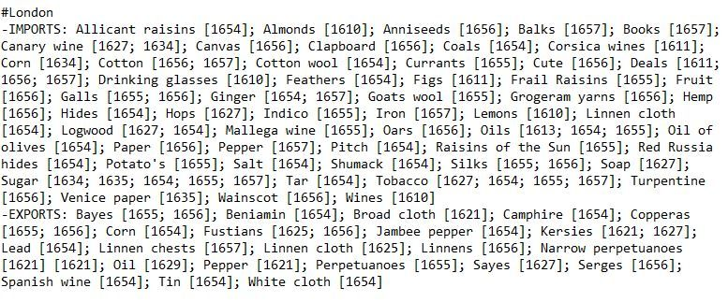

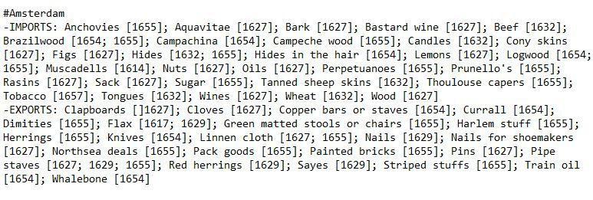

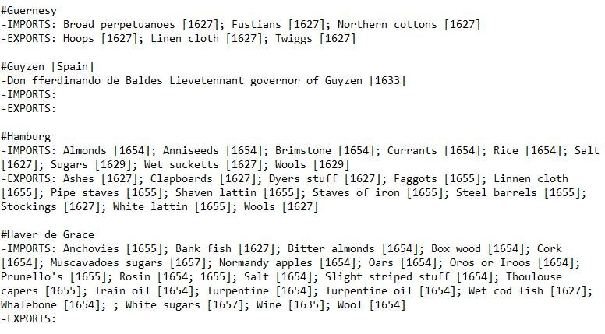

1

[[](https://bsky.app/profile/marinelives.bsky.social)](https://bsky.app/profile/marinelives.bsky.social)

[· 31/08/2024](https://bsky.app/profile/marinelives.bsky.social/post/3l2ynjil5l22w)

This will assist in modelling trading patterns (e.g. salt for use in fishery indsutries; export of fish of all sorts into Mediterranean; export of textiles and exchange for goods from Spanish & Portuguese overseas dominions)

1

[[](https://bsky.app/profile/marinelives.bsky.social)](https://bsky.app/profile/marinelives.bsky.social)

[· 30/08/2024](https://bsky.app/profile/marinelives.bsky.social/post/3l2wscuod7423)

John Marshall. 26 years of age. Mariner of Leith. Depsoing in the High Court of Admiralty in late 1613 on a storm which lasted 5 days "Tossed and tumpled upp and downe with the tempest and waves of the sea which continually overraked the shipp" [#earlymodern](https://bsky.app/hashtag/earlymodern) [#navalhistory](https://bsky.app/hashtag/navalhistory) [#oldweather](https://bsky.app/hashtag/oldweather)

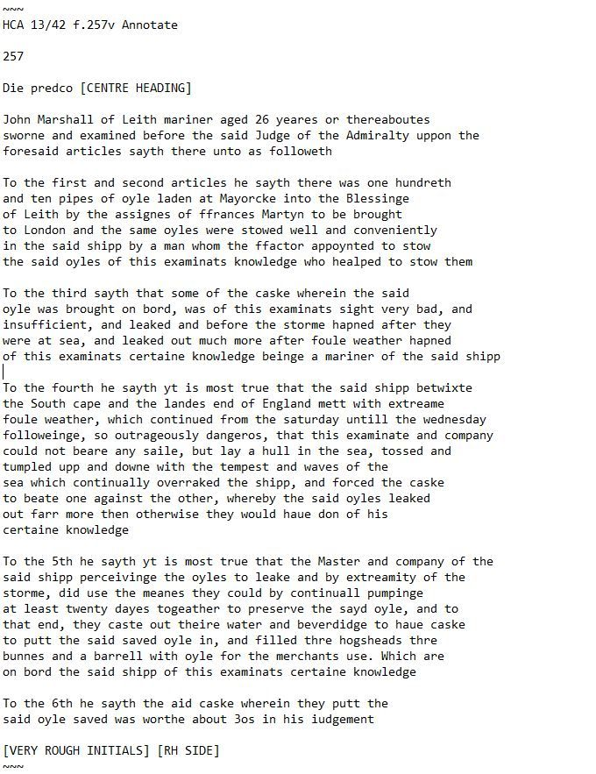

1

[[](https://bsky.app/profile/marinelives.bsky.social)](https://bsky.app/profile/marinelives.bsky.social)

[· 29/08/2024](https://bsky.app/profile/marinelives.bsky.social/post/3l2unew6l7n2t)

Nice piece of historical data analysis looking at mortality bills in the mid-C17th

[[](https://bsky.app/profile/jasonheppler.org)](https://bsky.app/profile/jasonheppler.org)

[· 29/08/2024](https://bsky.app/profile/jasonheppler.org/post/3l2ummzi7ja2c)

For the Death by Numbers project, our graduate student Hernán Adasme analyzes and visualizes plague spikes in London between 1638 and 1647: deathbynumbers.org/2024/08/28/a...

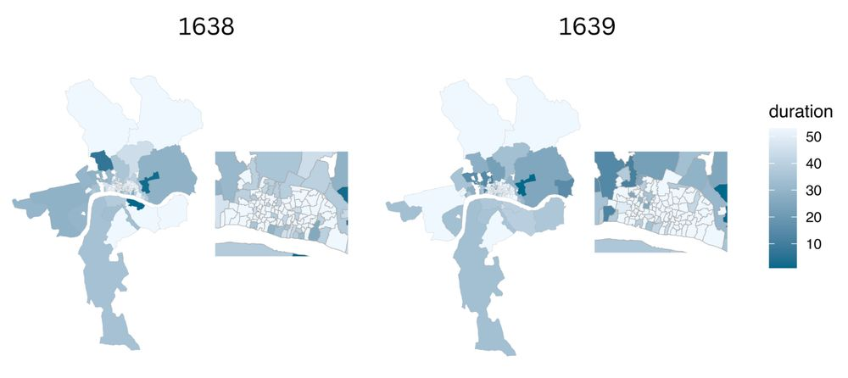

[[](https://bsky.app/profile/marinelives.bsky.social)](https://bsky.app/profile/marinelives.bsky.social)

[· 29/08/2024](https://bsky.app/profile/marinelives.bsky.social/post/3l2uiwapi5q2m)

Master of a ship sailed from Algiers to the Shetland Islands with the intent of enslaving Christians (1627). Something of a surprise? [#historians](https://bsky.app/hashtag/historians) [#early,modern](https://bsky.app/hashtag/early%2Cmodern) [#navalhistory](https://bsky.app/hashtag/navalhistory)

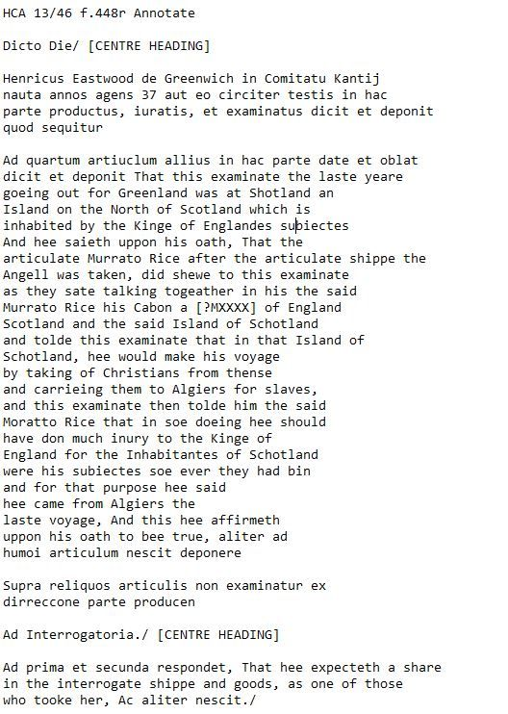

1

2

[[](https://bsky.app/profile/marinelives.bsky.social)](https://bsky.app/profile/marinelives.bsky.social)

[· 29/08/2024](https://bsky.app/profile/marinelives.bsky.social/post/3l2ujdo5mao2w)

The ship of Algiers was of a decent size (estimated by an English mariner at between 200 and 300 tons, with 20 or 22 guns). The mariner was named Henry Eastwood and was surgeon on board the ship which seized the ship of Algiers

[[](https://bsky.app/profile/marinelives.bsky.social)](https://bsky.app/profile/marinelives.bsky.social)

[· 28/08/2024](https://bsky.app/profile/marinelives.bsky.social/post/3l2s6tmkld62w)

An amazing migratory story [www.theguardian.com/environment/...](https://www.theguardian.com/environment/article/2024/aug/28/northern-bald-ibis-bird-back-from-extinction-now-scientists-in-a-glider-are-teaching-it-to-migrate-aoe)

[[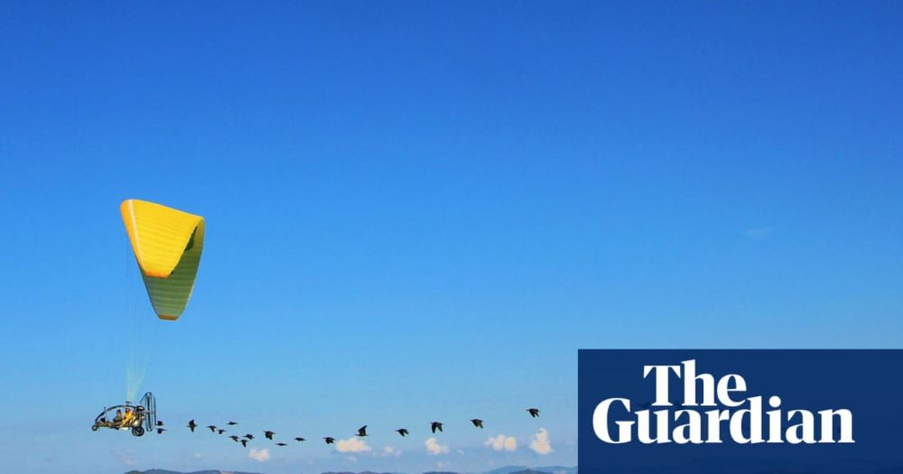](https://www.theguardian.com/environment/article/2024/aug/28/northern-bald-ibis-bird-back-from-extinction-now-scientists-in-a-glider-are-teaching-it-to-migrate-aoe)](https://www.theguardian.com/environment/article/2024/aug/28/northern-bald-ibis-bird-back-from-extinction-now-scientists-in-a-glider-are-teaching-it-to-migrate-aoe" \t "_blank)

**[This bird came back from extinction - now scientists in a glider are teaching it to migrate](https://www.theguardian.com/environment/article/2024/aug/28/northern-bald-ibis-bird-back-from-extinction-now-scientists-in-a-glider-are-teaching-it-to-migrate-aoe" \t "_blank)**

[Extinct in central Europe for 300 years, 36 northern bald ibis are following an ultralight aircraft on their long-forgotten migration route from Austria to Spain](https://www.theguardian.com/environment/article/2024/aug/28/northern-bald-ibis-bird-back-from-extinction-now-scientists-in-a-glider-are-teaching-it-to-migrate-aoe" \t "_blank)

[www.theguardian.com](https://www.theguardian.com/environment/article/2024/aug/28/northern-bald-ibis-bird-back-from-extinction-now-scientists-in-a-glider-are-teaching-it-to-migrate-aoe" \t "_blank)

[[](https://bsky.app/profile/marinelives.bsky.social)](https://bsky.app/profile/marinelives.bsky.social)

[· 28/08/2024](https://bsky.app/profile/marinelives.bsky.social/post/3l2rymtnuok2z)

A little exercise to see if I can drum up interest in LLM-based support for historical research? I am posting 10 different language versions of the same page. Let me know if your doctoral candidates could read these without AI? Starting with the English language original

[@timhitchcock.bsky.social](https://bsky.app/profile/did:plc:zazpgix5w4ldyytazeqzytmz)

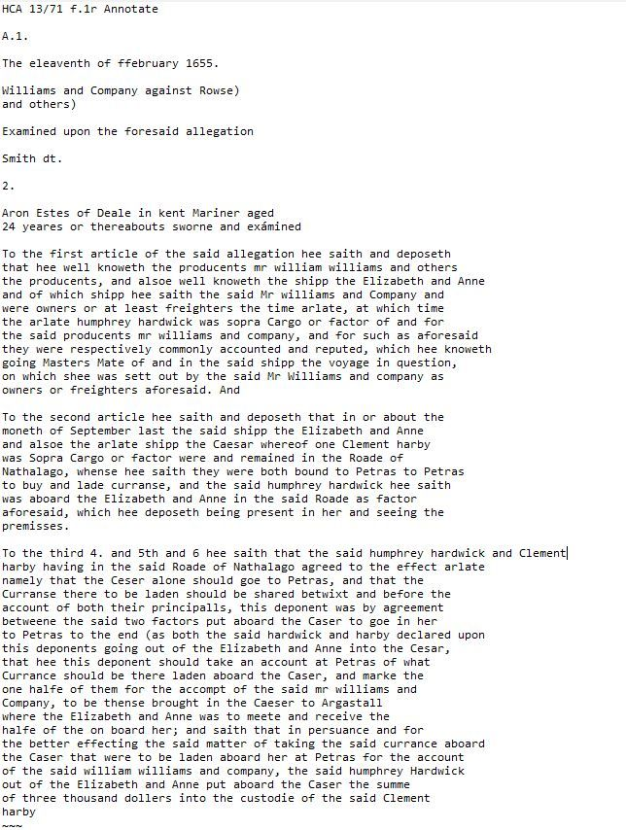

1

[View full thread](https://bsky.app/profile/did:plc:3haql47cl6jucf32mlqtre4p/post/3l2rymtnuok2z)

[[](https://bsky.app/profile/marinelives.bsky.social)](https://bsky.app/profile/marinelives.bsky.social)

[· 28/08/2024](https://bsky.app/profile/marinelives.bsky.social/post/3l2rzecwdno2w)

I tried Egyptian hieroglyphs, but got a NO. But here is ancient Greek

[@timhitchcock.bsky.social](https://bsky.app/profile/did:plc:zazpgix5w4ldyytazeqzytmz)

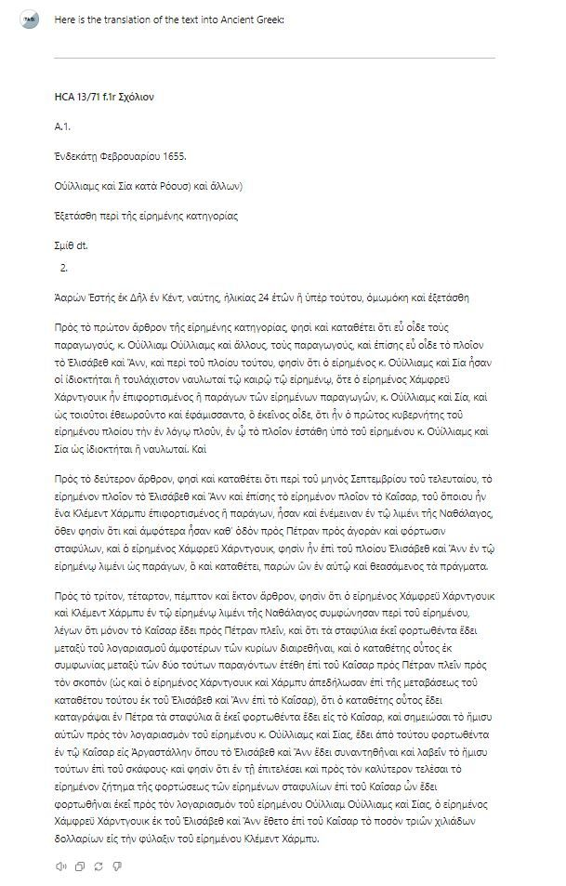

1

[[](https://bsky.app/profile/marinelives.bsky.social)](https://bsky.app/profile/marinelives.bsky.social)

[· 28/08/2024](https://bsky.app/profile/marinelives.bsky.social/post/3l2rziy3krc23)

And finally a Namibian language

[@timhitchcock.bsky.social](https://bsky.app/profile/did:plc:zazpgix5w4ldyytazeqzytmz)

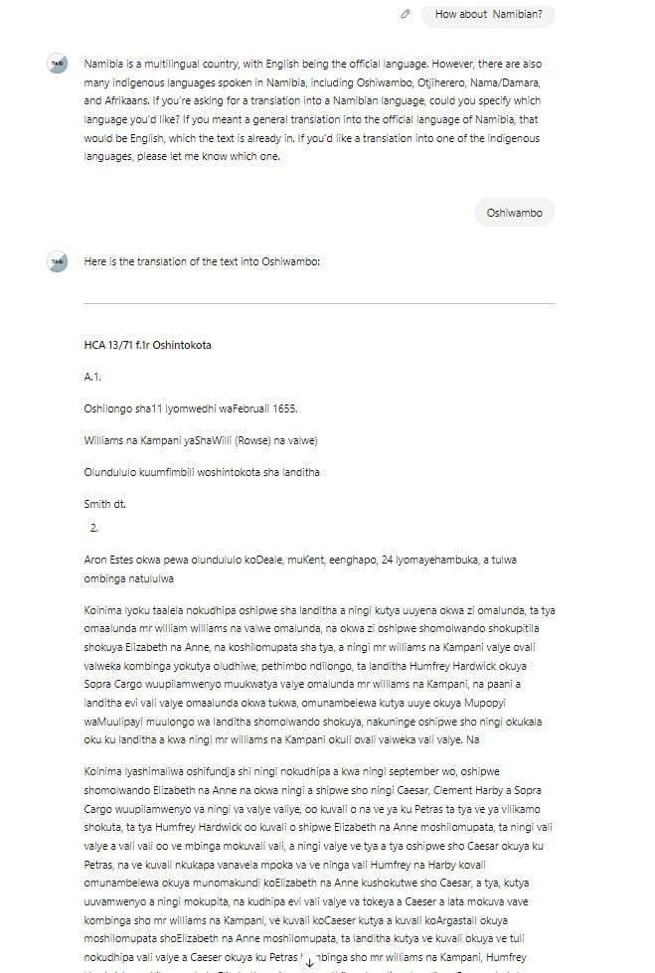

[[](https://bsky.app/profile/marinelives.bsky.social)](https://bsky.app/profile/marinelives.bsky.social)

[· 28/08/2024](https://bsky.app/profile/marinelives.bsky.social/post/3l2rpi4cgvi2t)

[@ihr.bsky.social](https://bsky.app/profile/did:plc:msb74n73t2heaaacburngrwh)

[@bho.bsky.social](https://bsky.app/profile/did:plc:2ocpvkq5gioh4kf7p57wjxyo)

[@globalmarhist.bsky.social](https://bsky.app/profile/did:plc:lhfkueyeqbuguem4u3kqdnyr)

[@tedmccormick.bsky.social](https://bsky.app/profile/did:plc:ymninynadpwv67q7hxiqy7h2)

[@tedunderwood.me](https://bsky.app/profile/did:plc:565ebob5f6hw33hjdkxty6qj)

[@warhammerofficial.bsky.social](https://bsky.app/profile/did:plc:4mk3qzxju2vn5tr6fxzogqd6)

[[](https://bsky.app/profile/marinelives.bsky.social)](https://bsky.app/profile/marinelives.bsky.social)

[· 28/08/2024](https://bsky.app/profile/marinelives.bsky.social/post/3l2rogpcubk2k)

Who would be interested in playing a multi agent/multi human game I am devising to simulate international investment in the C17th - either for pure interest, or as a teaching exercise with your students? #historians #earlymodern #navalhistory Link to one of the agents chatgpt.com/g/g-iGznn7aF...

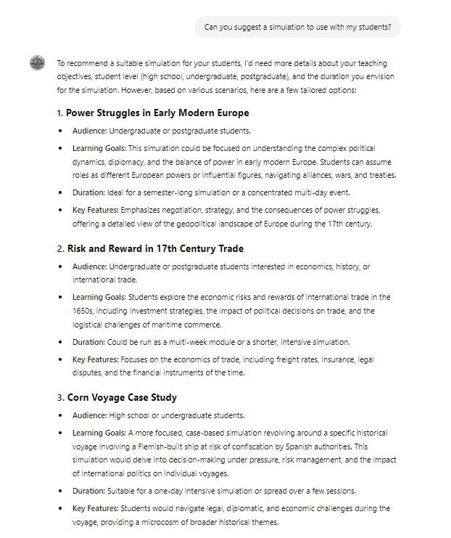

1

[[](https://bsky.app/profile/marinelives.bsky.social)](https://bsky.app/profile/marinelives.bsky.social)

[· 28/08/2024](https://bsky.app/profile/marinelives.bsky.social/post/3l2rogpcubk2k)

Who would be interested in playing a multi agent/multi human game I am devising to simulate international investment in the C17th - either for pure interest, or as a teaching exercise with your students? [#historians](https://bsky.app/hashtag/historians) [#earlymodern](https://bsky.app/hashtag/earlymodern) [#navalhistory](https://bsky.app/hashtag/navalhistory) Link to one of the agents [chatgpt.com/g/g-iGznn7aF...](https://chatgpt.com/g/g-iGznn7aFh-aurelius-sim)



1

2

[View full thread](https://bsky.app/profile/did:plc:3haql47cl6jucf32mlqtre4p/post/3l2rogpcubk2k)

[[](https://bsky.app/profile/marinelives.bsky.social)](https://bsky.app/profile/marinelives.bsky.social)

[· 28/08/2024](https://bsky.app/profile/marinelives.bsky.social/post/3l2rottndcs2p)

Part 5: Does the simulation need an Umpire. Here is what Aurelius-SIM suggests, but why not consult Aurelius-Umpire to see what he/she/it can do? [chatgpt.com/g/g-b787Dw9w...](https://chatgpt.com/g/g-b787Dw9wN-aurelius-umpire) [#historians](https://bsky.app/hashtag/historians) [#earlymodern](https://bsky.app/hashtag/earlymodern) [#navalhistory](https://bsky.app/hashtag/navalhistory) [#economists](https://bsky.app/hashtag/economists)

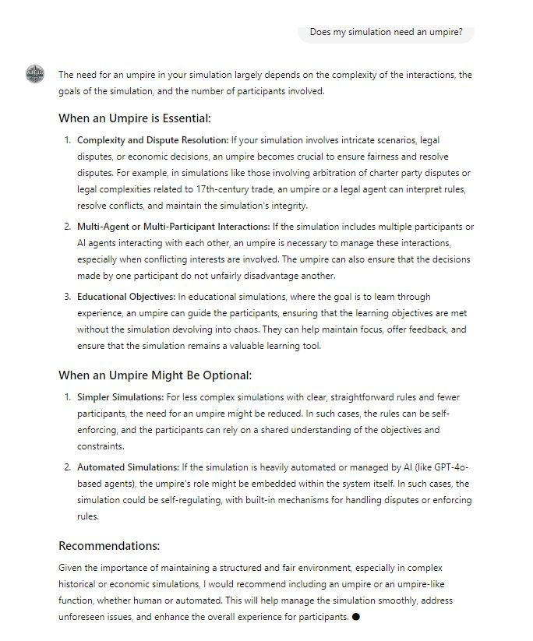

1

[[](https://bsky.app/profile/marinelives.bsky.social)](https://bsky.app/profile/marinelives.bsky.social)

[· 28/08/2024](https://bsky.app/profile/marinelives.bsky.social/post/3l2rp5z4pck2d)

Part 6: Introducing Aurelius-Merchant. Knows all about commodities and trading places. Can suggest potential commodity and geographic based trading strategies [#historians](https://bsky.app/hashtag/historians) [#earlymodern](https://bsky.app/hashtag/earlymodern) [#navalhistory](https://bsky.app/hashtag/navalhistory) [#economists](https://bsky.app/hashtag/economists) here is the link: [chatgpt.com/g/g-srf62J1Z...](https://chatgpt.com/g/g-srf62J1ZY-aurelius-merchant)

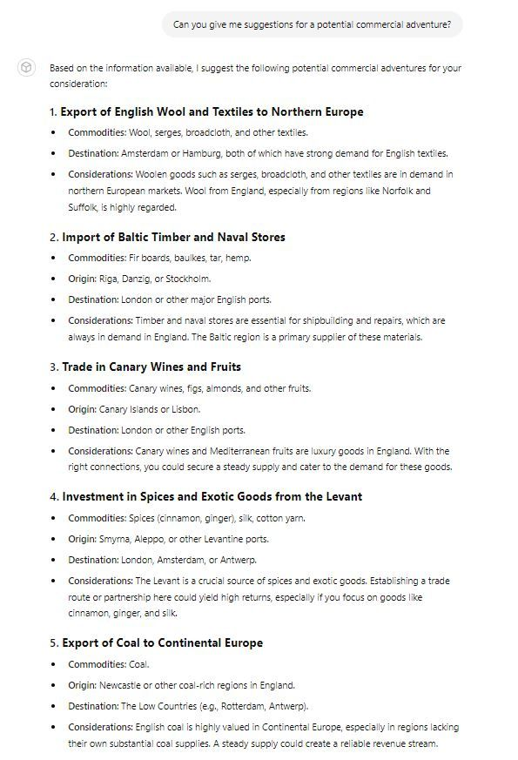

1

[[](https://bsky.app/profile/marinelives.bsky.social)](https://bsky.app/profile/marinelives.bsky.social)

[· 28/08/2024](https://bsky.app/profile/marinelives.bsky.social/post/3l2rlundfgs2f)

[@jonathanhealey.bsky.social](https://bsky.app/profile/did:plc:dd45swi4g3u3wo7kn34v7gmr)

[[](https://bsky.app/profile/marinelives.bsky.social)](https://bsky.app/profile/marinelives.bsky.social)

[· 28/08/2024](https://bsky.app/profile/marinelives.bsky.social/post/3l2rlrp3mkk2k)

Somewhat humbling to read that a 31 year old French mariner living in Saint Mallo's [1627] spent 14 months learning English at Lyme in Dorset around about the years 1606 and 1607 [HCA 13/46 f.386r] @earlymodernjohn.bsky.social @ilcs.bsky.social @mediumaevum.bsky.social @mcculloughp.bsky.social

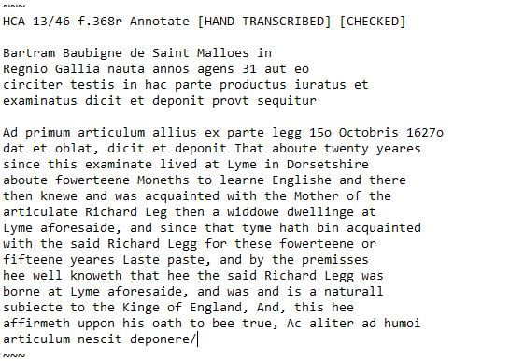

[[](https://bsky.app/profile/marinelives.bsky.social)](https://bsky.app/profile/marinelives.bsky.social)

[· 28/08/2024](https://bsky.app/profile/marinelives.bsky.social/post/3l2rlrp3mkk2k)

Somewhat humbling to read that a 31 year old French mariner living in Saint Mallo's [1627] spent 14 months learning English at Lyme in Dorset around about the years 1606 and 1607 [HCA 13/46 f.386r]

[@earlymodernjohn.bsky.social](https://bsky.app/profile/did:plc:43lv3dcbbiofwrn3v2kkbf3p)

[@ilcs.bsky.social](https://bsky.app/profile/did:plc:2wuygrdolpfn2tmsyt6zupfy)

[@mediumaevum.bsky.social](https://bsky.app/profile/did:plc:daqtalmj6l4m7bei6ikjcli3)

[@mcculloughp.bsky.social](https://bsky.app/profile/did:plc:33m6asmu2bwmf4jkr7wvols4)



1

[[](https://bsky.app/profile/marinelives.bsky.social)](https://bsky.app/profile/marinelives.bsky.social)

[· 28/08/2024](https://bsky.app/profile/marinelives.bsky.social/post/3l2rbnhg24s2p)

Would love to chat with an historical geographer interested in 1H C17th. I am data mining 30 mill words of High Court of Admiralty records 1570 to 1685 to build up an import/export table of commodities by European ports, and would be interested in discussing. [#historians](https://bsky.app/hashtag/historians)

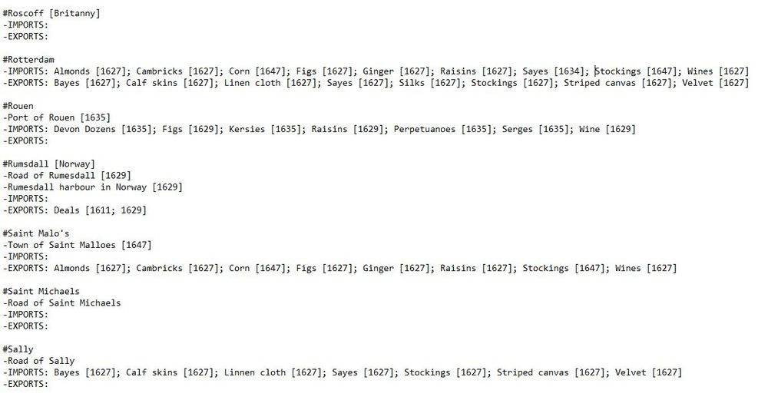

1

6

[[](https://bsky.app/profile/marinelives.bsky.social)](https://bsky.app/profile/marinelives.bsky.social)

[· 28/08/2024](https://bsky.app/profile/marinelives.bsky.social/post/3l2rbyesbpc2w)

I'm looking at the patterns of different ports and port networks to see (1) Range of commodities [#, commodity type] (2) Whether exported commodities are themselves imported [entrepot] (3) Whether import/export patterns can be used to characterize places

1

[[](https://bsky.app/profile/marinelives.bsky.social)](https://bsky.app/profile/marinelives.bsky.social)

[· 28/08/2024](https://bsky.app/profile/marinelives.bsky.social/post/3l2rbzx7lok2w)

Even after very early days work interesting commodity patterns emerging between London, Roterdam, and Amsetrdam in early C17th with Barbary coast, which imports a huge range of goods

2

[[](https://bsky.app/profile/marinelives.bsky.social)](https://bsky.app/profile/marinelives.bsky.social)

[· 28/08/2024](https://bsky.app/profile/marinelives.bsky.social/post/3l2rahjaxdl2e)

Good morning [#historians](https://bsky.app/hashtag/historians) [#economists](https://bsky.app/hashtag/economists) Does any one have a starter pack for [#economichistory](https://bsky.app/hashtag/economichistory)?

3

[Reposted by you](https://bsky.app/profile/marinelives.bsky.social)

[[](https://bsky.app/profile/mediumaevum.bsky.social)](https://bsky.app/profile/mediumaevum.bsky.social)

[· 27/08/2024](https://bsky.app/profile/mediumaevum.bsky.social/post/3l2pdt6dczm2v)

Hello Bluesky! The Society for the Study of Medieval Literatures and Languages are delighted to be joining you here. Follow us to stay up to date with our latest Medium Ævum journal issues and monographs, our conferences and meetings, and our annual Medium Ævum Essay Prize.



**ALT**

**16**

[[](https://bsky.app/profile/marinelives.bsky.social)](https://bsky.app/profile/marinelives.bsky.social)

[· 27/08/2024](https://bsky.app/profile/marinelives.bsky.social/post/3l2oz2d3m4f2f)

Can any [#historians](https://bsky.app/hashtag/historians) identify which book this front wrapper of an Admiralty Court deposition book is part? The deposition book is from 1591

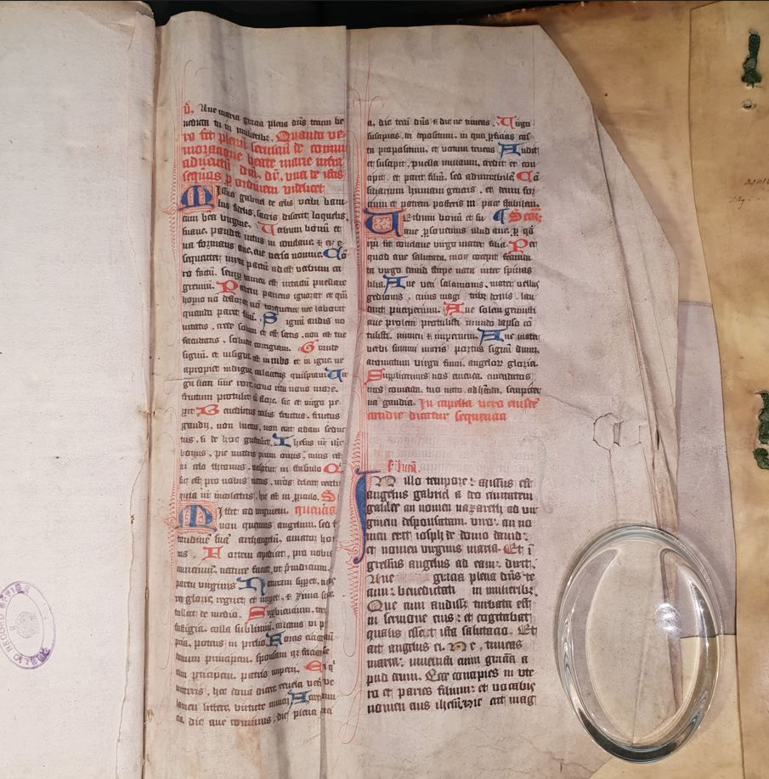

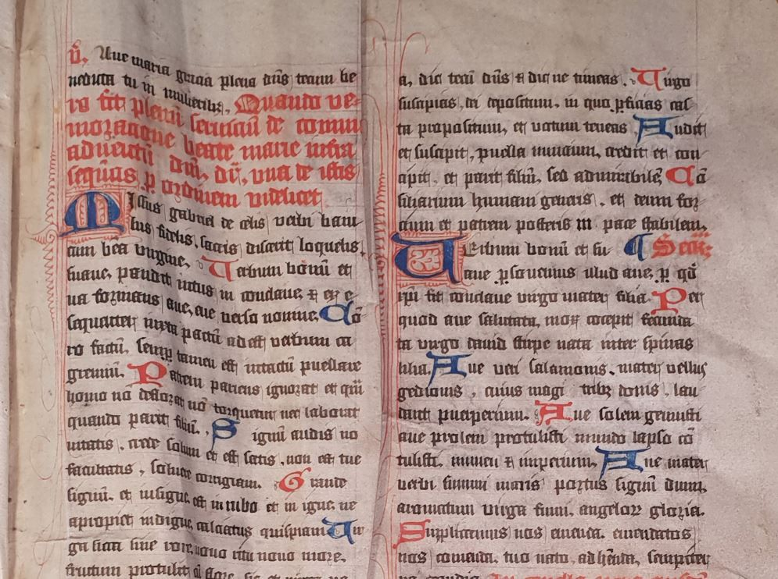

5

13

[[](https://bsky.app/profile/marinelives.bsky.social)](https://bsky.app/profile/marinelives.bsky.social)

[· 27/08/2024](https://bsky.app/profile/marinelives.bsky.social/post/3l2ozkr6usv2h)

There are four pages incorporated in the binding. They appear to be handwritten and illuminated

[[](https://bsky.app/profile/marinelives.bsky.social)](https://bsky.app/profile/marinelives.bsky.social)

[· 27/08/2024](https://bsky.app/profile/marinelives.bsky.social/post/3l2oxv3hqhj2w)

Hi [#historians](https://bsky.app/hashtag/historians) [#earlymodern](https://bsky.app/hashtag/earlymodern) Has any wone prepared a starter pack for Early Modern historians?

1

[[](https://bsky.app/profile/marinelives.bsky.social)](https://bsky.app/profile/marinelives.bsky.social)

[· 26/08/2024](https://bsky.app/profile/marinelives.bsky.social/post/3l2n6fnv4kj24)

647 biographies of C17th mariners and merchants who typically don't feature in the ODNB. Check out Ambrose Pmeroy (owner of lighters) and George Margetts (ropemaker, member of the ironmongers livery company) [www.marinelives.org/wiki/Categor...](http://www.marinelives.org/wiki/Category:Semantic_biography)

**[Category:Semantic biography - MarineLives](http://www.marinelives.org/wiki/Category:Semantic_biography" \t "_blank)**

[www.marinelives.org](http://www.marinelives.org/wiki/Category:Semantic_biography" \t "_blank)

4

[[](https://bsky.app/profile/marinelives.bsky.social)](https://bsky.app/profile/marinelives.bsky.social)

[· 26/08/2024](https://bsky.app/profile/marinelives.bsky.social/post/3l2n4mmspld2r)

That will teach me. I thought my hashtag [#cannibalism](https://bsky.app/hashtag/cannibalism) would be a first for BlueSky. Nope. It is a genre. But I think my post is the first combine earing people (mid-C17th) with [#earlymodern](https://bsky.app/hashtag/earlymodern)

[[](https://bsky.app/profile/marinelives.bsky.social)](https://bsky.app/profile/marinelives.bsky.social)

[· 26/08/2024](https://bsky.app/profile/marinelives.bsky.social/post/3l2n4bjd53q2o)

Cannibal Tales: From "The humple petition of Priscilla Lockier and Sara Spurgeon" [1650] [HCA 15/5 f.99] With a link to a blog article on the same: www.marinelives.org/wiki/Tools:\_... #earlymodern #cannibalism #skystorian

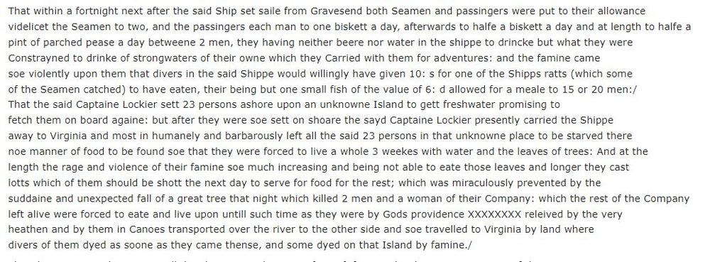

1

[[](https://bsky.app/profile/marinelives.bsky.social)](https://bsky.app/profile/marinelives.bsky.social)

[· 26/08/2024](https://bsky.app/profile/marinelives.bsky.social/post/3l2n4bjd53q2o)

Cannibal Tales: From "The humple petition of Priscilla Lockier and Sara Spurgeon" [1650] [HCA 15/5 f.99] With a link to a blog article on the same: [www.marinelives.org/wiki/Tools:\_...](http://www.marinelives.org/wiki/Tools:_Cannibal_tales) [#earlymodern](https://bsky.app/hashtag/earlymodern) [#cannibalism](https://bsky.app/hashtag/cannibalism) [#skystorian](https://bsky.app/hashtag/skystorian)



1

1

[[](https://bsky.app/profile/marinelives.bsky.social)](https://bsky.app/profile/marinelives.bsky.social)

[· 26/08/2024](https://bsky.app/profile/marinelives.bsky.social/post/3l2n4dx52vk2v)

The petition mentioning the enforced cannibalism of the husbands of two mariners wives . The English High Court of Admiralty is never boring. [www.marinelives.org/wiki/Tools:\_...](http://www.marinelives.org/wiki/Tools:_Cannibal_tales)

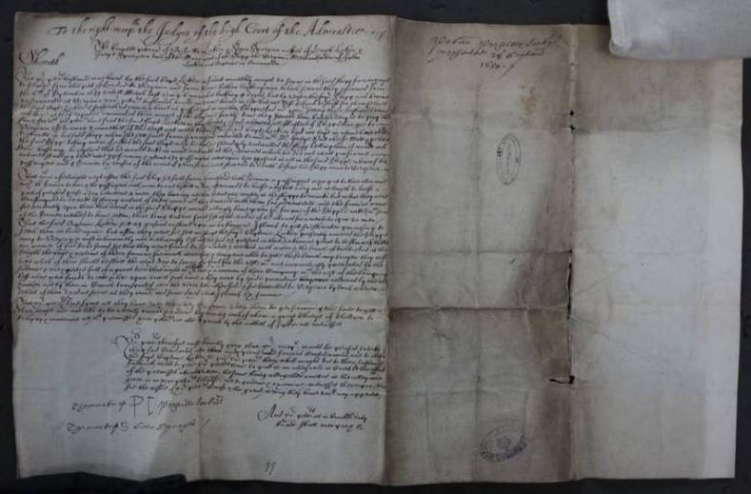

1

[[](https://bsky.app/profile/marinelives.bsky.social)](https://bsky.app/profile/marinelives.bsky.social)

[· 26/08/2024](https://bsky.app/profile/marinelives.bsky.social/post/3l2n4gz62py2b)

The voyage to Virginia involving alleged canibalism became quite notorious. Morale of the story? Make sure your ship's master has plenty of victuals.

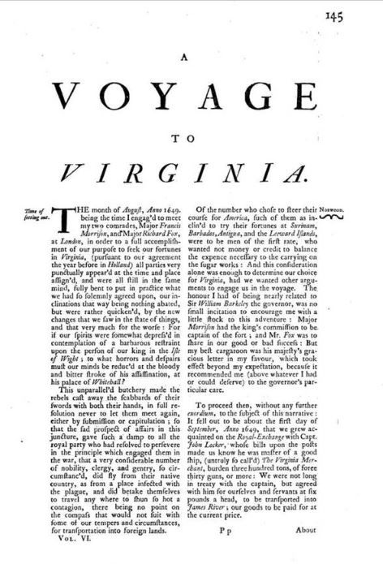

[[](https://bsky.app/profile/marinelives.bsky.social)](https://bsky.app/profile/marinelives.bsky.social)

[· 26/08/2024](https://bsky.app/profile/marinelives.bsky.social/post/3l2msbmxxpq2b)

Forty eight year old draper, Edward Thompson, was the 'linguist' for a voyage from London to Saphia in Barbary in 1608 because "he had the Moriscoe tongue" [#earlymodern](https://bsky.app/hashtag/earlymodern)

[@earlymodernjohn.bsky.social](https://bsky.app/profile/did:plc:43lv3dcbbiofwrn3v2kkbf3p)

[HCA 13/41 f.2v]

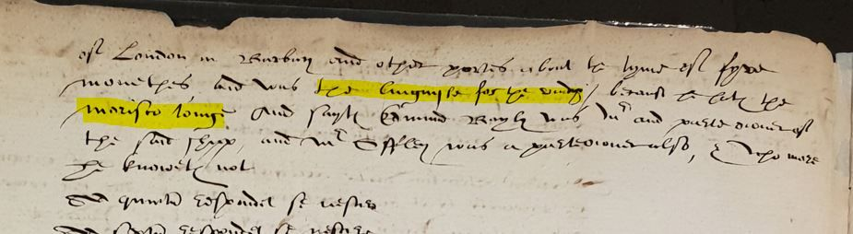

3

[Reposted by you](https://bsky.app/profile/marinelives.bsky.social)

[[](https://bsky.app/profile/binnig.bsky.social)](https://bsky.app/profile/binnig.bsky.social)

[· 24/08/2024](https://bsky.app/profile/binnig.bsky.social/post/3l2ioh2bimq23)

Replied to

[Scott 🦇Cave🦇](https://bsky.app/profile/hellabarnes.bsky.social)

Think bigger.

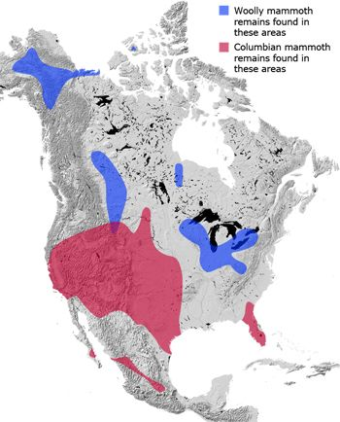

**ALT**

1

**1**

[[](https://bsky.app/profile/marinelives.bsky.social)](https://bsky.app/profile/marinelives.bsky.social)

[· 24/08/2024](https://bsky.app/profile/marinelives.bsky.social/post/3l2hjucsbt22p)

At the Globe Theatre last night. Much ado about nothing. Wonderful. Got me thinking about C17th taverns and victualling houses. I have a list! [#earlymodern](https://bsky.app/hashtag/earlymodern) [#c17](https://bsky.app/hashtag/c17) [#skystorian](https://bsky.app/hashtag/skystorian) [www.marinelives.org/wiki/Inns,\_T...](http://www.marinelives.org/wiki/Inns,_Taverns,_and_Victualling_Houses)

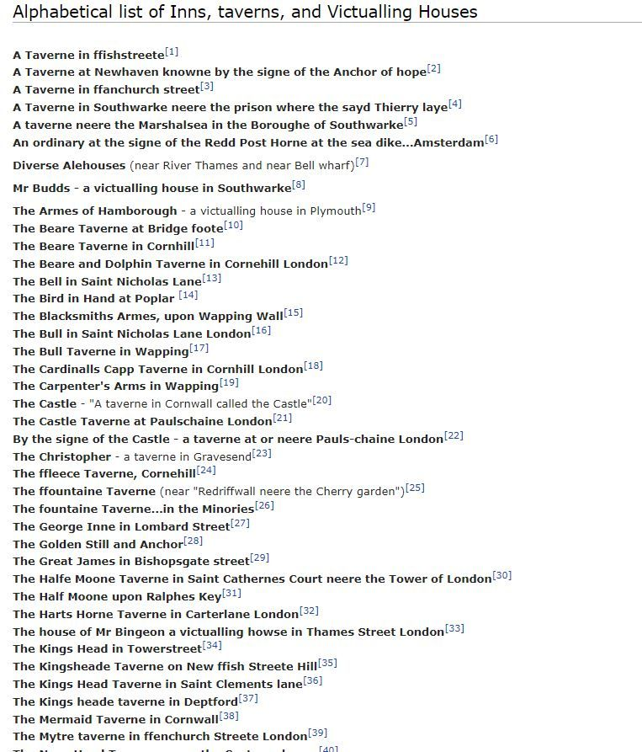

3

1

[[](https://bsky.app/profile/marinelives.bsky.social)](https://bsky.app/profile/marinelives.bsky.social)

[· 24/08/2024](https://bsky.app/profile/marinelives.bsky.social/post/3l2hjwpdugl2w)

The Mermaide Taverne; The Golden Stilla nd Anchor; The Great James. Such a shame I can't visit them [#earlymdern](https://bsky.app/hashtag/earlymdern) [#ca7](https://bsky.app/hashtag/ca7) [#skystorian](https://bsky.app/hashtag/skystorian) [www.marinelives.org/wiki/Inns,\_T...](http://www.marinelives.org/wiki/Inns,_Taverns,_and_Victualling_Houses)

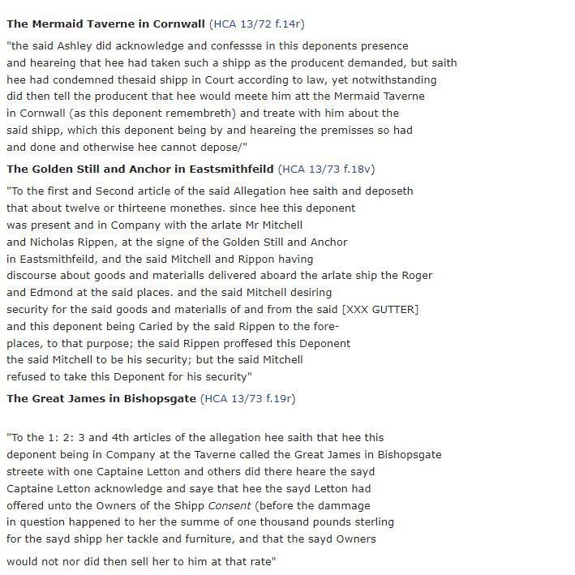

[[](https://bsky.app/profile/marinelives.bsky.social)](https://bsky.app/profile/marinelives.bsky.social)

[· 24/08/2024](https://bsky.app/profile/marinelives.bsky.social/post/3l2hjmuhyns2r)

Who's up for a bit of Early Modern invective and ill behaviour? I have a list! [#earlymodern](https://bsky.app/hashtag/earlymodern) [#c17](https://bsky.app/hashtag/c17) [#skystorian](https://bsky.app/hashtag/skystorian) [www.marinelives.org/wiki/Bad\_beh...](http://www.marinelives.org/wiki/Bad_behaviour_%26_Invective)

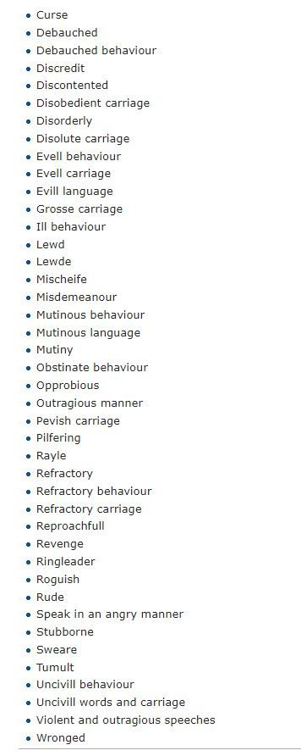

1

[[](https://bsky.app/profile/marinelives.bsky.social)](https://bsky.app/profile/marinelives.bsky.social)

[· 24/08/2024](https://bsky.app/profile/marinelives.bsky.social/post/3l2hfb3ddpt2g)

1/5 Five part post on women and investment activities in C17th. All data drawn from a MarineLives article on the same [#earlymodern](https://bsky.app/hashtag/earlymodern) [#skyhistorian](https://bsky.app/hashtag/skyhistorian) [www.marinelives.org/wiki/Women%2...](http://www.marinelives.org/wiki/Women%27s_investment_activities_and_record_keeping)

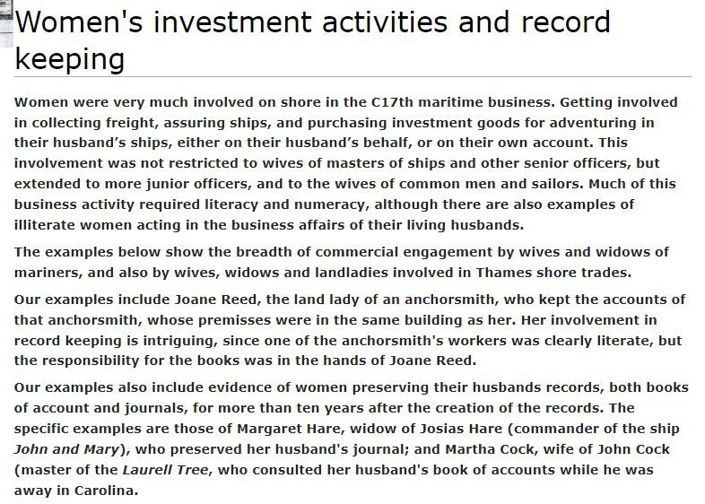

1

5

[[](https://bsky.app/profile/marinelives.bsky.social)](https://bsky.app/profile/marinelives.bsky.social)

[· 24/08/2024](https://bsky.app/profile/marinelives.bsky.social/post/3l2hfdrkfrr2a)

2/5 Nineteen separate examples of women in C17th England involved in investmebt activities [#earlymodern](https://bsky.app/hashtag/earlymodern) [#skystorian](https://bsky.app/hashtag/skystorian) [www.marinelives.org/wiki/Women%2...](http://www.marinelives.org/wiki/Women%27s_investment_activities_and_record_keeping)

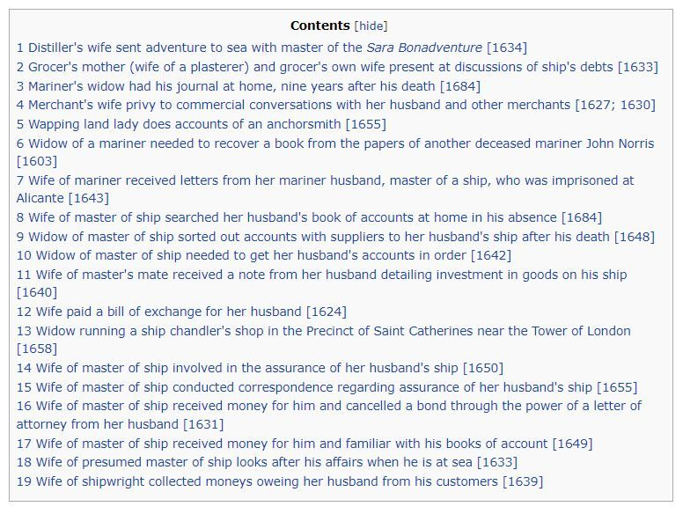

1

[[](https://bsky.app/profile/marinelives.bsky.social)](https://bsky.app/profile/marinelives.bsky.social)

[· 24/08/2024](https://bsky.app/profile/marinelives.bsky.social/post/3l2hffn2x232h)

3/5 Grocer's mother and grocer's wife present at discussion of debts [#earlymodern](https://bsky.app/hashtag/earlymodern) [#skystorian](https://bsky.app/hashtag/skystorian) [www.marinelives.org/wiki/Women%2...](http://www.marinelives.org/wiki/Women%27s_investment_activities_and_record_keeping)

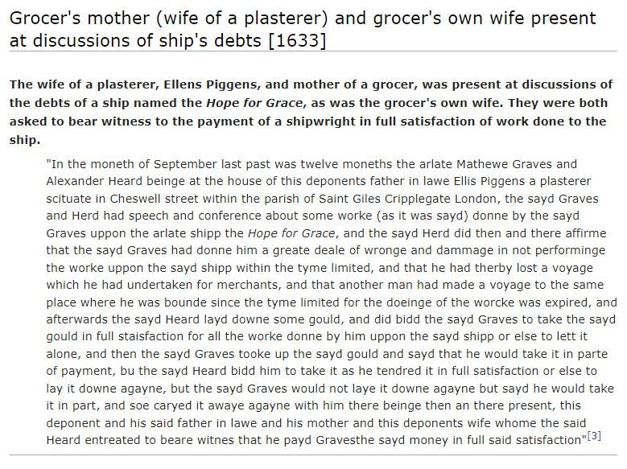

1

[[](https://bsky.app/profile/marinelives.bsky.social)](https://bsky.app/profile/marinelives.bsky.social)

[· 23/08/2024](https://bsky.app/profile/marinelives.bsky.social/post/3l2esbz4vqd2c)

Calling [#palaeographers](https://bsky.app/hashtag/palaeographers) [#palaeography](https://bsky.app/hashtag/palaeography) Any idea what appears to be "polvina sawsages" laden (together with a case of silk and a barrel of capers) at Leghorne (Livorno) in Tuscany in 1609? [#earlymodern](https://bsky.app/hashtag/earlymodern) [#skystorians](https://bsky.app/hashtag/skystorians)

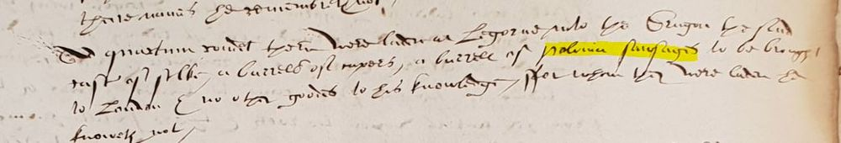

2

4

[[](https://bsky.app/profile/marinelives.bsky.social)](https://bsky.app/profile/marinelives.bsky.social)

[· 23/08/2024](https://bsky.app/profile/marinelives.bsky.social/post/3l2erwujazy2o)

A very generous gift from Jen Gutman has taken us to £1190 raised to create a high quality machine transcription of 50,000 mages of English High Court of Admiralty depositions (1570 to 1689) [www.gofundme.com/f/help-marin...](https://www.gofundme.com/f/help-marinelives-write-history) [#earlymodern](https://bsky.app/hashtag/earlymodern) [#skystorians](https://bsky.app/hashtag/skystorians)

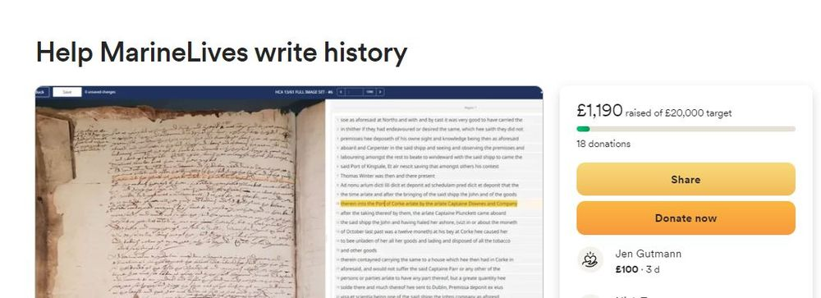

3

[Reposted by you](https://bsky.app/profile/marinelives.bsky.social)

[[](https://bsky.app/profile/pressgazette.co.uk)](https://bsky.app/profile/pressgazette.co.uk)

[· 22/08/2024](https://bsky.app/profile/pressgazette.co.uk/post/3l2cci2l4l22n)

Bluesky may still be a relative minnow among the social media giants, but several news publishers appear to see potential in the microblogging platform. Press Gazette spoke to publishers (and news feed maintainer

[@aendra.com](https://bsky.app/profile/did:plc:kkf4naxqmweop7dv4l2iqqf5)

) to hear how it's working out: [pressgazette.co.uk/platforms/pl...](https://pressgazette.co.uk/platforms/platform-profiles/platform-profile-news-publishers-bluesky-twitter-alternative/)

[[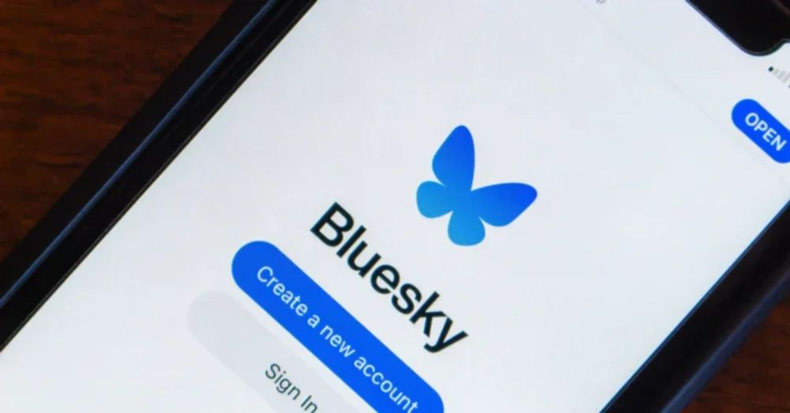](https://pressgazette.co.uk/platforms/platform-profiles/platform-profile-news-publishers-bluesky-twitter-alternative/)](https://pressgazette.co.uk/platforms/platform-profiles/platform-profile-news-publishers-bluesky-twitter-alternative/" \t "_blank)

**[Twitter alternative? News publishers see potential in Bluesky](https://pressgazette.co.uk/platforms/platform-profiles/platform-profile-news-publishers-bluesky-twitter-alternative/" \t "_blank)**

[Twitter alternative Bluesky may still be a minnow among the social media giants, but news publishers appear to see potential in the platform.](https://pressgazette.co.uk/platforms/platform-profiles/platform-profile-news-publishers-bluesky-twitter-alternative/" \t "_blank)

[pressgazette.co.uk](https://pressgazette.co.uk/platforms/platform-profiles/platform-profile-news-publishers-bluesky-twitter-alternative/" \t "_blank)

20

**179**

[[](https://bsky.app/profile/marinelives.bsky.social)](https://bsky.app/profile/marinelives.bsky.social)

[· 22/08/2024](https://bsky.app/profile/marinelives.bsky.social/post/3l2csbvm4422s)

London lighters and London Bridge has a history of accidents. Two case studies (1635; 1641) . Part One [#earlymodern](https://bsky.app/hashtag/earlymodern)

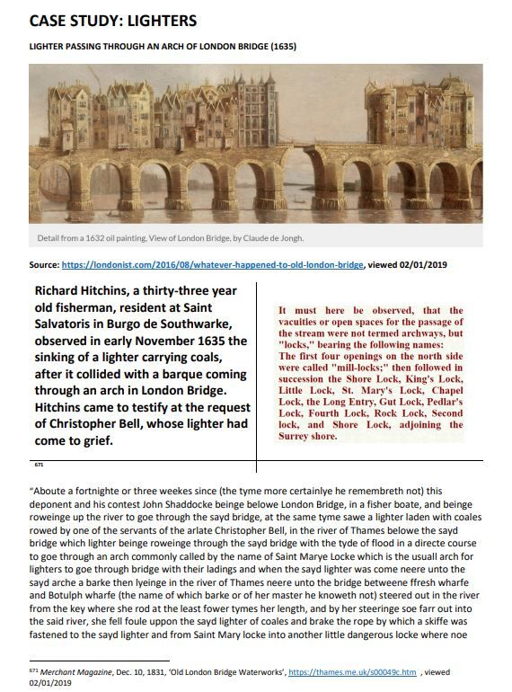

1

3

[View full thread](https://bsky.app/profile/did:plc:3haql47cl6jucf32mlqtre4p/post/3l2csbvm4422s)

[[](https://bsky.app/profile/marinelives.bsky.social)](https://bsky.app/profile/marinelives.bsky.social)

[· 22/08/2024](https://bsky.app/profile/marinelives.bsky.social/post/3l2csfgi34c2x)

Part Four. London lighters and London Bridge [#earlymodern](https://bsky.app/hashtag/earlymodern)

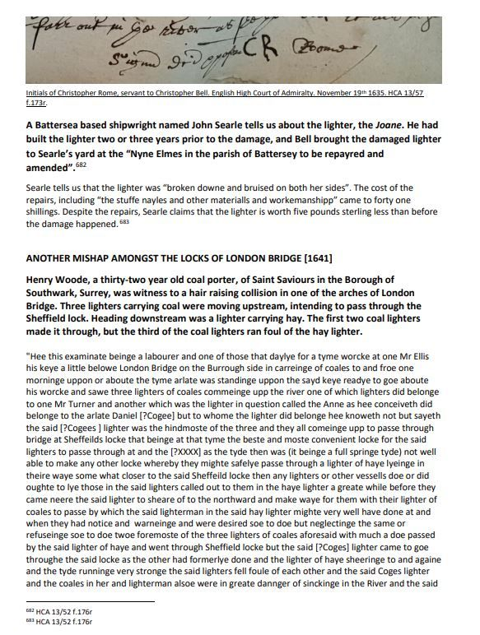

1

[[](https://bsky.app/profile/marinelives.bsky.social)](https://bsky.app/profile/marinelives.bsky.social)

[· 22/08/2024](https://bsky.app/profile/marinelives.bsky.social/post/3l2csfzkvyc24)

Part Five. London lighters and London Bridge [#earlymodern](https://bsky.app/hashtag/earlymodern)

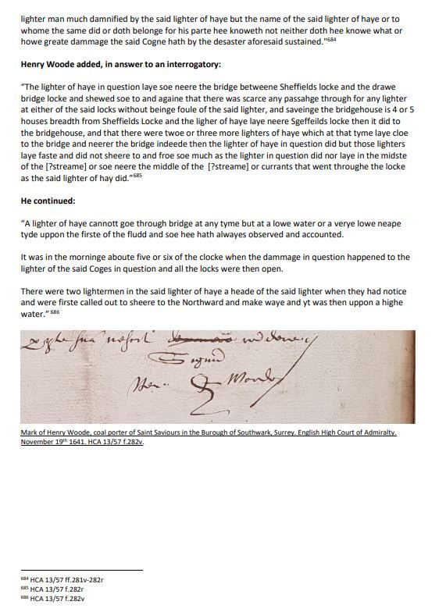

1

[[](https://bsky.app/profile/marinelives.bsky.social)](https://bsky.app/profile/marinelives.bsky.social)

[· 22/08/2024](https://bsky.app/profile/marinelives.bsky.social/post/3l2cs2addx22r)

I love [#materialhistory](https://bsky.app/hashtag/materialhistory). Here a case study from the late C16th of Venetian glass in London [#earlymodern](https://bsky.app/hashtag/earlymodern)

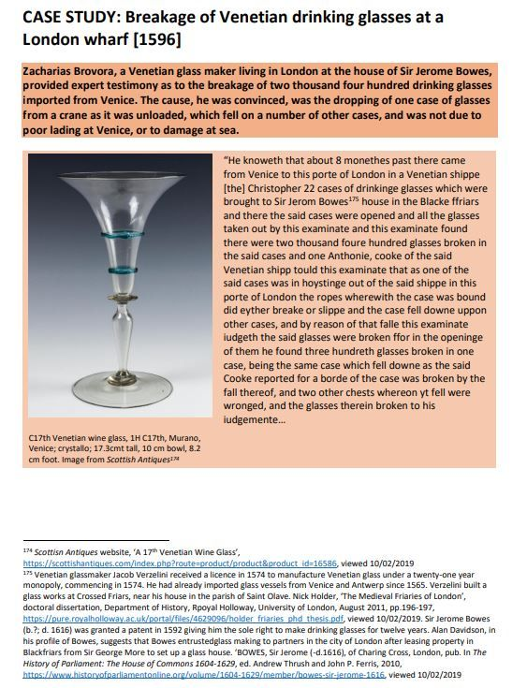

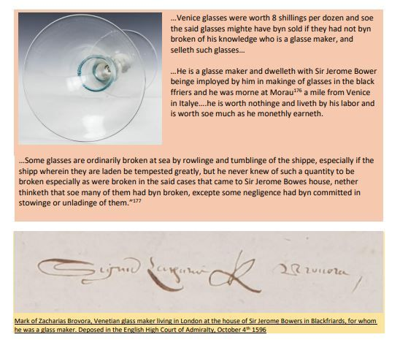

[[](https://bsky.app/profile/marinelives.bsky.social)](https://bsky.app/profile/marinelives.bsky.social)

[· 20/08/2024](https://bsky.app/profile/marinelives.bsky.social/post/3l254pdhbas26)

Imagine we could map the geographic scope of mariners letters (sent and received) in the late C16th and 1H C17th? Source is the SOLM-2024 database of English High Court of Admiralty depositions [#skystorians](https://bsky.app/hashtag/skystorians) [#earlymodern](https://bsky.app/hashtag/earlymodern)

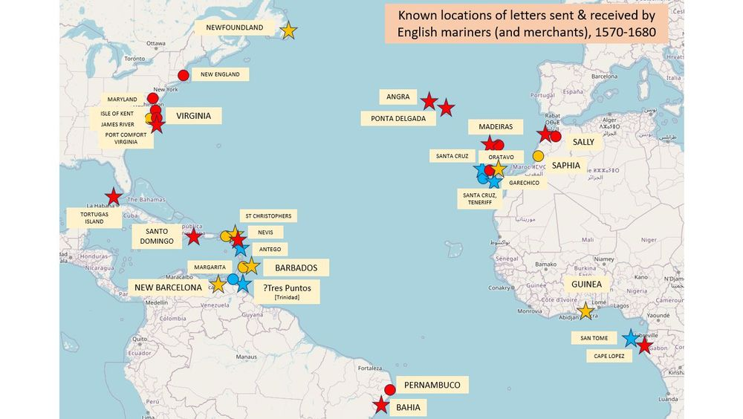

2

5

[[](https://bsky.app/profile/marinelives.bsky.social)](https://bsky.app/profile/marinelives.bsky.social)

[· 20/08/2024](https://bsky.app/profile/marinelives.bsky.social/post/3l25jiidugc26)

KEY:

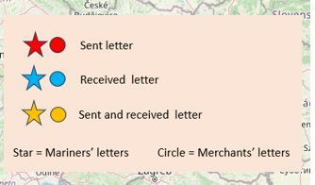

[[](https://bsky.app/profile/marinelives.bsky.social)](https://bsky.app/profile/marinelives.bsky.social)

[· 20/08/2024](https://bsky.app/profile/marinelives.bsky.social/post/3l254owpjdu25)

Imagine we could map the geographic scope of mariners letters (sent and received) in the late C16th and 1H C17th? Source is the SOLM-2024 database of English High Court of Admiralty depositions [#skystorians](https://bsky.app/hashtag/skystorians) [#earlymodern](https://bsky.app/hashtag/earlymodern)

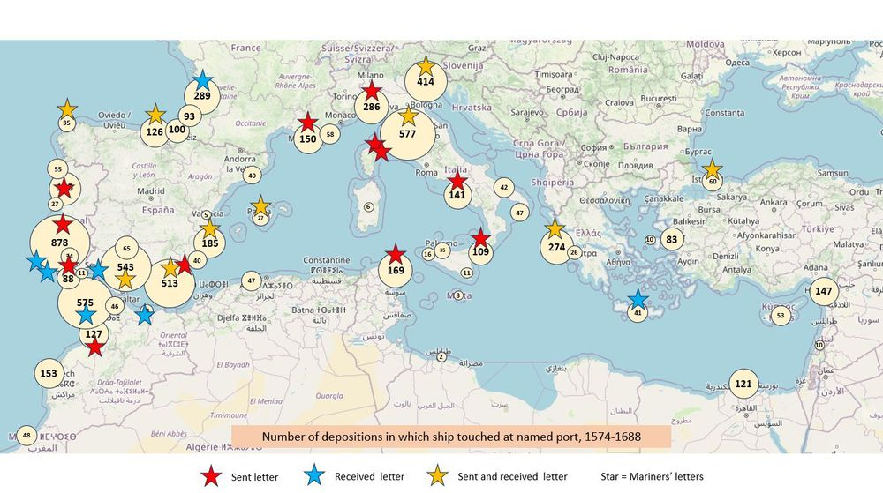

1

[[](https://bsky.app/profile/marinelives.bsky.social)](https://bsky.app/profile/marinelives.bsky.social)

[· 20/08/2024](https://bsky.app/profile/marinelives.bsky.social/post/3l254ndfrcb2q)

Imagine we could map the geographic scope of mariners letters (sent and received) in the late C16th and 1H C17th? Source is the SOLM-2024 database of English High Court of Admiralty depositions [#skystorians](https://bsky.app/hashtag/skystorians) [#earlymodern](https://bsky.app/hashtag/earlymodern)

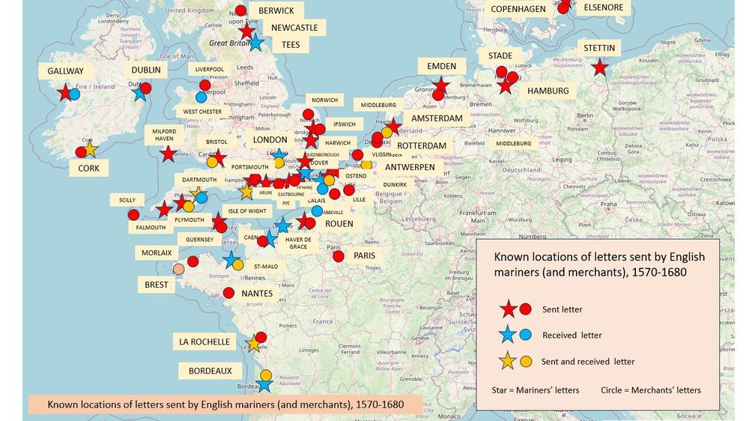

[[](https://bsky.app/profile/marinelives.bsky.social)](https://bsky.app/profile/marinelives.bsky.social)

[· 19/08/2024](https://bsky.app/profile/marinelives.bsky.social/post/3l23f6mv6wp27)

I am organising a one hour on-line seminar to discuss finetuning of LLMs for historical research. Plese let me know if you are interested. Early September.

[@bschmidt.bsky.social](https://bsky.app/profile/did:plc:r36govxkk4hmrcqlrjmbrjtl)

[@timhitchcock.bsky.social](https://bsky.app/profile/did:plc:zazpgix5w4ldyytazeqzytmz)

[@anterotesis.bsky.social](https://bsky.app/profile/did:plc:5ea6mwiru6wfle4qzsj5r7td)



1

2

[[](https://bsky.app/profile/marinelives.bsky.social)](https://bsky.app/profile/marinelives.bsky.social)

[· 19/08/2024](https://bsky.app/profile/marinelives.bsky.social/post/3l23boqhhkp27)

Location of Early Modern Mariners living in Devon (a key county). The source is the MarienLives SOLM-2024 database, which dras on English High Court of Admiralty depositions (HCA 13/ series) [#skystorians](https://bsky.app/hashtag/skystorians) [#earlymodern](https://bsky.app/hashtag/earlymodern) [#c16](https://bsky.app/hashtag/c16) [#c17](https://bsky.app/hashtag/c17)

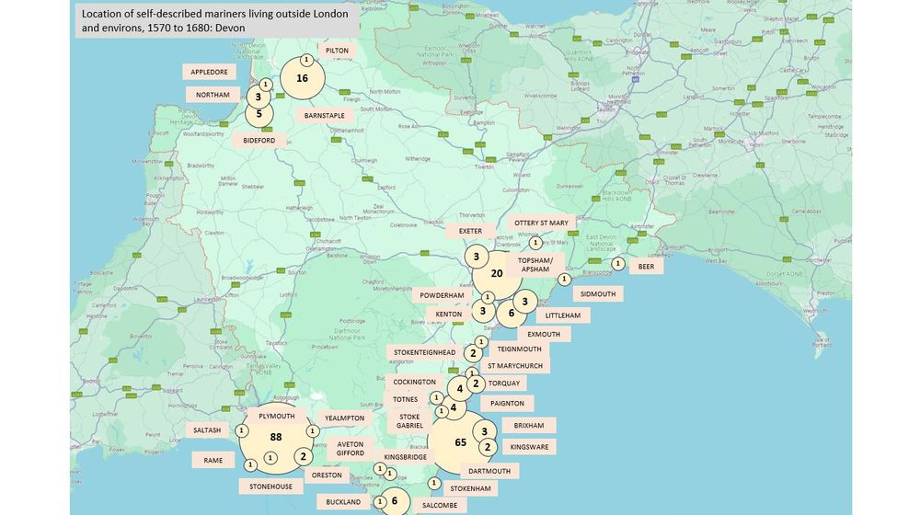

[[](https://bsky.app/profile/marinelives.bsky.social)](https://bsky.app/profile/marinelives.bsky.social)

[· 19/08/2024](https://bsky.app/profile/marinelives.bsky.social/post/3l23bgumons25)

Where did Early Modern English mariners live outside London? Data from the MarineLives SOLM-2024 database using English High Court of Admiralty deposition data [#Skystorians](https://bsky.app/hashtag/Skystorians) [#earlymodern](https://bsky.app/hashtag/earlymodern) [#c16](https://bsky.app/hashtag/c16) [#c17](https://bsky.app/hashtag/c17)

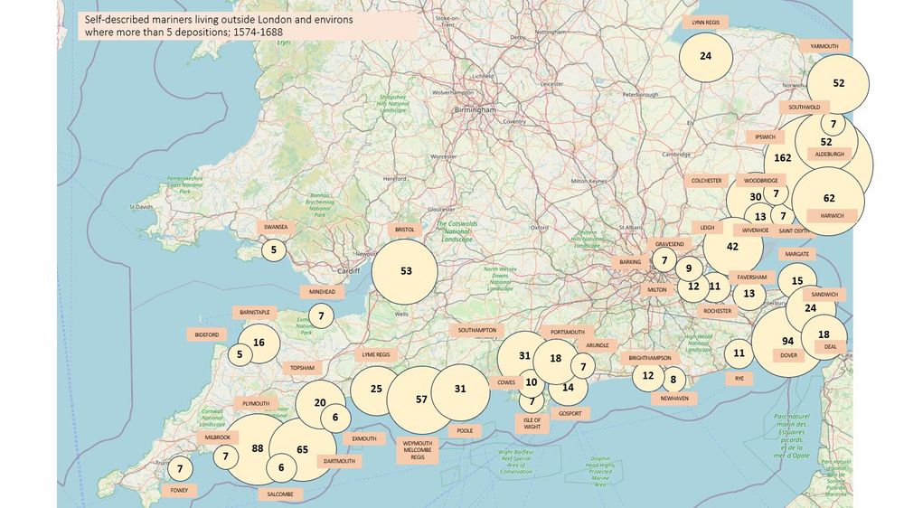

1

[[](https://bsky.app/profile/marinelives.bsky.social)](https://bsky.app/profile/marinelives.bsky.social)

[· 19/08/2024](https://bsky.app/profile/marinelives.bsky.social/post/3l23bkh34wt2o)

Adding more Northern data on the location of Early Modern English mariners [#skystorians](https://bsky.app/hashtag/skystorians) [#earlymodern](https://bsky.app/hashtag/earlymodern) [#c16](https://bsky.app/hashtag/c16) [#c17](https://bsky.app/hashtag/c17)

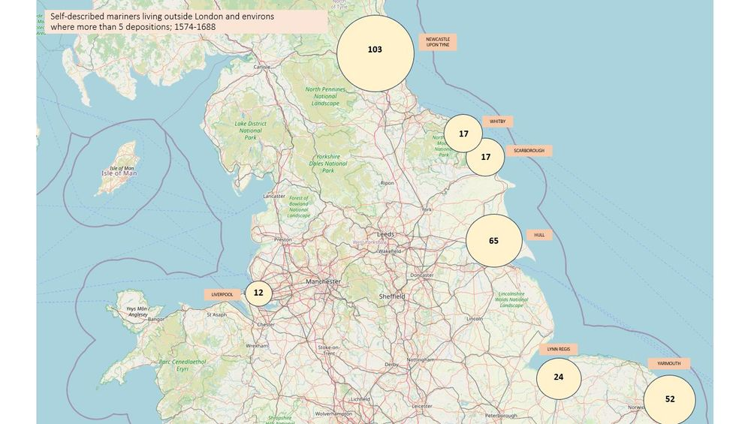

[[](https://bsky.app/profile/marinelives.bsky.social)](https://bsky.app/profile/marinelives.bsky.social)

[· 19/08/2024](https://bsky.app/profile/marinelives.bsky.social/post/3l23andyaes2q)

I wonder whether the huge growth of biological science has been one of the reasons that 'natural scientists' have proven receptive to modes of thinking coming out of the 'social sciences'. I studied Human Sciences at Oxford in the late 70s, which was predicated on exploring the bio/social frontier

[[](https://bsky.app/profile/annaalexandrova.bsky.social)](https://bsky.app/profile/annaalexandrova.bsky.social)

[· 15/08/2024](https://bsky.app/profile/annaalexandrova.bsky.social/post/3kzrvo2aetg25)

Resharing in the hope of submissions from the fresh bsky citizens #philsci #histsci #philsky #STS

[[](https://bsky.app/profile/marinelives.bsky.social)](https://bsky.app/profile/marinelives.bsky.social)

[· 19/08/2024](https://bsky.app/profile/marinelives.bsky.social/post/3l22p3vi3al26)

I'm working on an historical simulation suitable for Masters Level students using a mixture of GPT-4o tailored agents interacting with students

[@earlymodernjohn.bsky.social](https://bsky.app/profile/did:plc:43lv3dcbbiofwrn3v2kkbf3p)

[@lsangha.bsky.social](https://bsky.app/profile/did:plc:sizujj7y6vouiq7mh2rdvv6k)

[@clairejowitt.bsky.social](https://bsky.app/profile/did:plc:c72w2gbyfl7mljh3m6ttoid3)

[@bschmidt.bsky.social](https://bsky.app/profile/did:plc:r36govxkk4hmrcqlrjmbrjtl)

[@tedmccormick.bsky.social](https://bsky.app/profile/did:plc:ymninynadpwv67q7hxiqy7h2)

[@mcculloughp.bsky.social](https://bsky.app/profile/did:plc:33m6asmu2bwmf4jkr7wvols4)

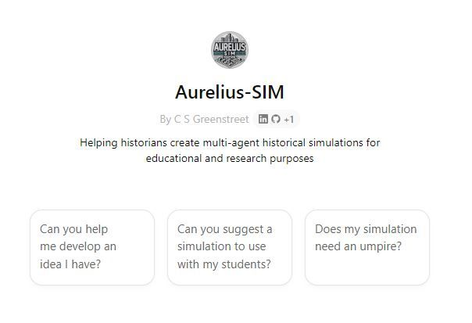

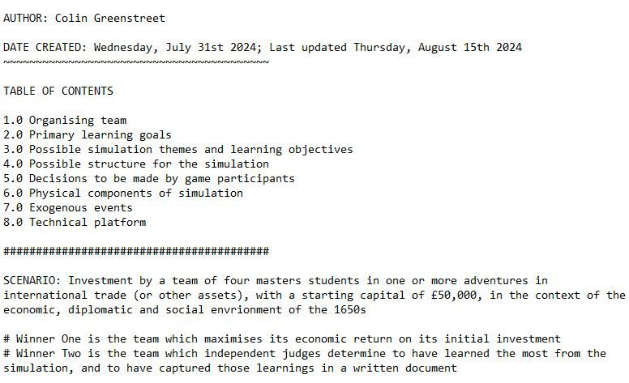

1

[[](https://bsky.app/profile/marinelives.bsky.social)](https://bsky.app/profile/marinelives.bsky.social)

[· 19/08/2024](https://bsky.app/profile/marinelives.bsky.social/post/3l22p7i6idg2c)

Link to the SIM bot (very early days, one of eight simulatin related bots to support the simulation) [chatgpt.com/g/g-iGznn7aF...](https://chatgpt.com/g/g-iGznn7aFh-aurelius-sim)

[[](https://chatgpt.com/g/g-iGznn7aFh-aurelius-sim)](https://chatgpt.com/g/g-iGznn7aFh-aurelius-sim" \t "_blank)

**[ChatGPT - Aurelius-SIM](https://chatgpt.com/g/g-iGznn7aFh-aurelius-sim" \t "_blank)**

[Helping historians create multi-agent historical simulations for educational and research purposes](https://chatgpt.com/g/g-iGznn7aFh-aurelius-sim" \t "_blank)

[chatgpt.com](https://chatgpt.com/g/g-iGznn7aFh-aurelius-sim" \t "_blank)

1

1

[[](https://bsky.app/profile/marinelives.bsky.social)](https://bsky.app/profile/marinelives.bsky.social)

[· 19/08/2024](https://bsky.app/profile/marinelives.bsky.social/post/3l22q2rceis2q)

Here is the vision behind the simulation and a link to a talk I gave on July 19th 2024 at the National Archives in Kew as part of their internal AI week [github.com/Addaci/HCA/b...](https://github.com/Addaci/HCA/blob/main/TNA_AI_Week_New_Skills_for_Historians_FINAL_WITH_EMAIL_19072024.pdf)

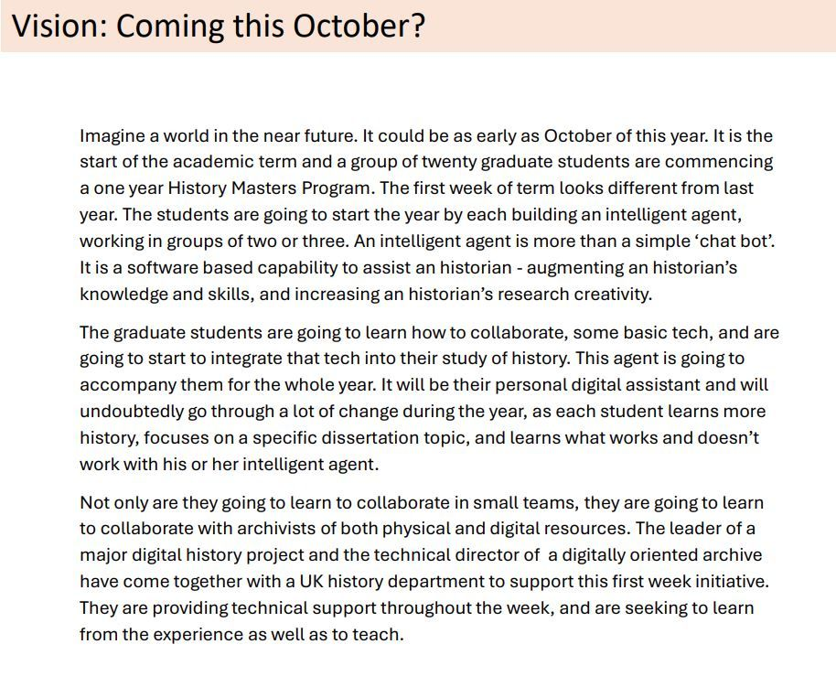

[[](https://bsky.app/profile/marinelives.bsky.social)](https://bsky.app/profile/marinelives.bsky.social)

[· 19/08/2024](https://bsky.app/profile/marinelives.bsky.social/post/3l22nlf4d6k2n)

I love GPT-4o. It is such a flexible tool and corrects my nascent python script writing skills on the fly [#digitalhistory](https://bsky.app/hashtag/digitalhistory) [#skyhistorians](https://bsky.app/hashtag/skyhistorians)

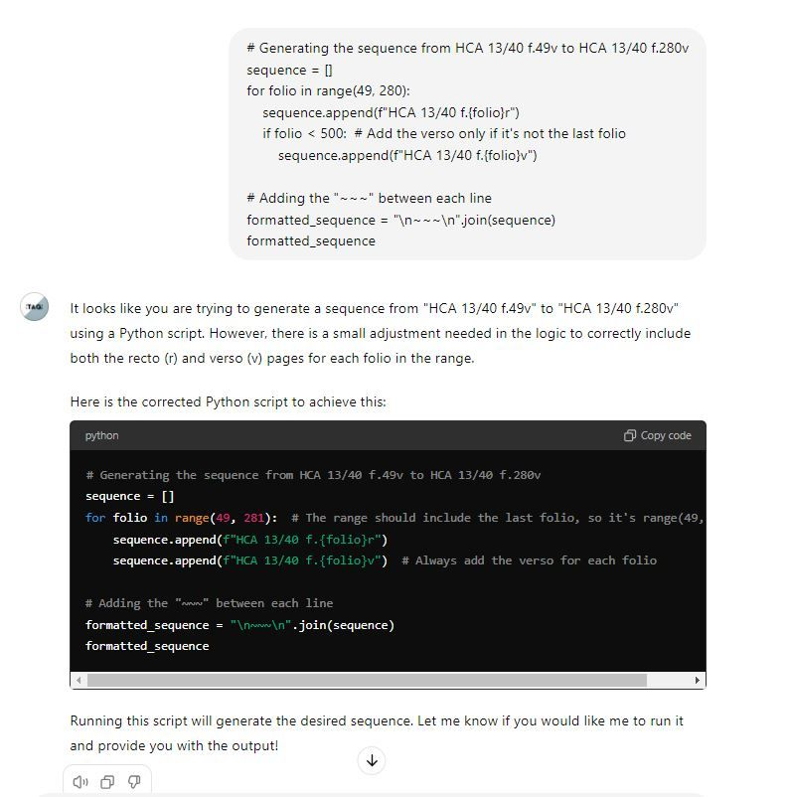

[[](https://bsky.app/profile/marinelives.bsky.social)](https://bsky.app/profile/marinelives.bsky.social)

[· 18/08/2024](https://bsky.app/profile/marinelives.bsky.social/post/3kzz5aqw2ty2j)

Next time I stay at an Ibis I will remember to put an hour galss in my besd, wait half an hour and check for condensation. If affirmative, then rip the sheets off and sleep on the floor in a blanket. Who says History isn't a Life Science?

[[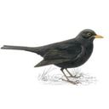](https://bsky.app/profile/jameshobson.bsky.social)](https://bsky.app/profile/jameshobson.bsky.social)

[· 18/08/2024](https://bsky.app/profile/jameshobson.bsky.social/post/3kzz4sk5kle26)

The dangers of damp sheets in the #Regency about1816.wordpress.com/2019/01/01/t...

[[](https://about1816.wordpress.com/2019/01/01/the-silent-killer-of-georgian-britain-damp-bed-sheets/)](https://about1816.wordpress.com/2019/01/01/the-silent-killer-of-georgian-britain-damp-bed-sheets/" \t "_blank)

**[The silent killer of Georgian Britain-damp bed sheets.](https://about1816.wordpress.com/2019/01/01/the-silent-killer-of-georgian-britain-damp-bed-sheets/" \t "_blank)**

[In 1816, the Chester Courant noticed that there was a rage for travelling amongst the rich. It did not know why. It could not understand it. The immediate cause was the end of the war with France, and...](https://about1816.wordpress.com/2019/01/01/the-silent-killer-of-georgian-britain-damp-bed-sheets/" \t "_blank)

[about1816.wordpress.com](https://about1816.wordpress.com/2019/01/01/the-silent-killer-of-georgian-britain-damp-bed-sheets/" \t "_blank)

[Reposted by you](https://bsky.app/profile/marinelives.bsky.social)

[[](https://bsky.app/profile/tedmccormick.bsky.social)](https://bsky.app/profile/tedmccormick.bsky.social)

[· 16/08/2024](https://bsky.app/profile/tedmccormick.bsky.social/post/3kzu6mygnr72x)

Looking forward to this, though of course I'm a bit partial [www.nacbs.org/event-detail...](https://www.nacbs.org/event-details/the-interlopers-with-vera-keller)

[[](https://www.nacbs.org/event-details/the-interlopers-with-vera-keller)](https://www.nacbs.org/event-details/the-interlopers-with-vera-keller" \t "_blank)

**[The Interlopers with Vera Keller | NACBS](https://www.nacbs.org/event-details/the-interlopers-with-vera-keller" \t "_blank)**

[Join NACBS to celebrate the publication of The Interlopers: Early Stuart Projects and the Undisciplining of Knowledge by Vera Keller. For this event, she will be joined in conversation by Frederik Alb...](https://www.nacbs.org/event-details/the-interlopers-with-vera-keller" \t "_blank)

[www.nacbs.org](https://www.nacbs.org/event-details/the-interlopers-with-vera-keller" \t "_blank)

1

**7**

[[](https://bsky.app/profile/marinelives.bsky.social)](https://bsky.app/profile/marinelives.bsky.social)

[· 17/08/2024](https://bsky.app/profile/marinelives.bsky.social/post/3kzwzullk7j2e)

Bloody Hell. When did an E-Book get to be so expensive????? Guess I'll go for the Hardback option [shop.elsevier.com/books/treati...](https://shop.elsevier.com/books/treatise-on-geophysics/schubert/978-0-444-53802-4#full-description)

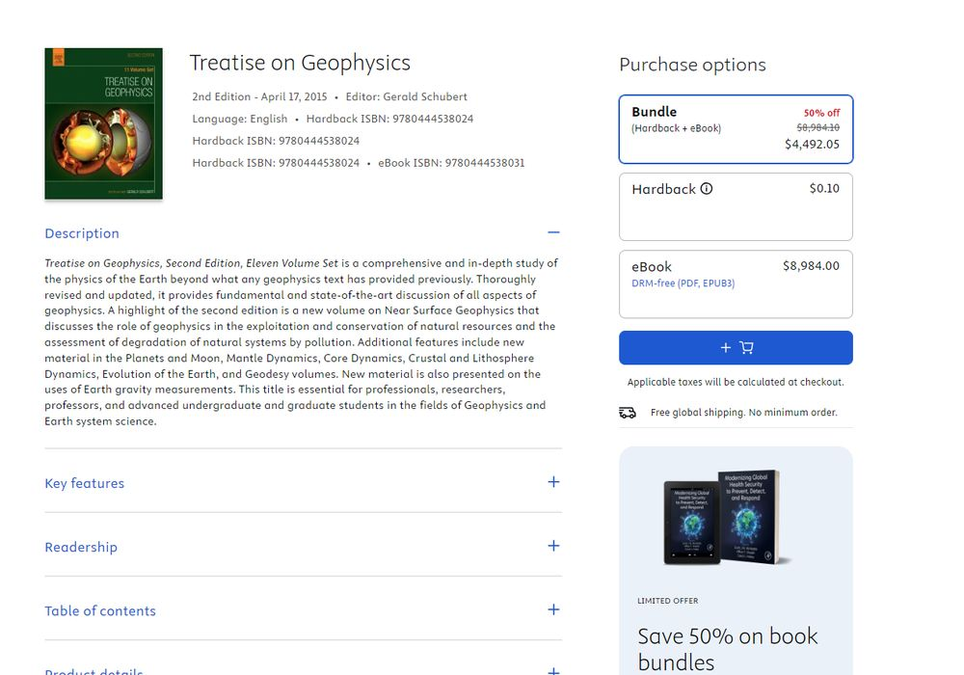

2

1

[[](https://bsky.app/profile/marinelives.bsky.social)](https://bsky.app/profile/marinelives.bsky.social)

[· 17/08/2024](https://bsky.app/profile/marinelives.bsky.social/post/3kzx2tao63h2w)

Looks a good option?

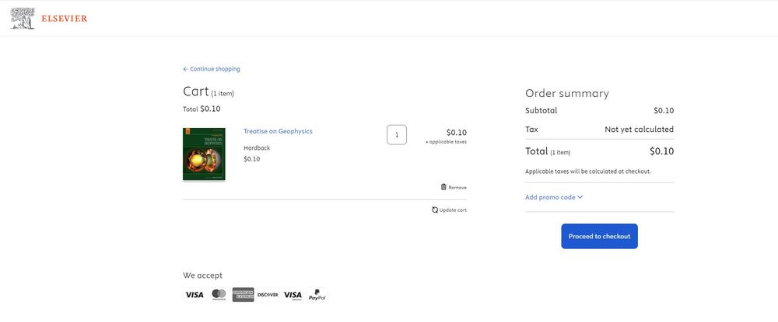

[[](https://bsky.app/profile/marinelives.bsky.social)](https://bsky.app/profile/marinelives.bsky.social)

[· 17/08/2024](https://bsky.app/profile/marinelives.bsky.social/post/3kzwzw6irpb2d)

Something weird is happening in cyberspace

[@geohenning.bsky.social](https://bsky.app/profile/did:plc:ypwk3a2va4sjhf635v2buswn)

[@timhitchcock.bsky.social](https://bsky.app/profile/did:plc:zazpgix5w4ldyytazeqzytmz)

[[](https://bsky.app/profile/marinelives.bsky.social)](https://bsky.app/profile/marinelives.bsky.social)

[· 17/08/2024](https://bsky.app/profile/marinelives.bsky.social/post/3kzwzullk7j2e)

Bloody Hell. When did an E-Book get to be so expensive????? Guess I'll go for the Hardback option shop.elsevier.com/books/treati...



[[](https://bsky.app/profile/marinelives.bsky.social)](https://bsky.app/profile/marinelives.bsky.social)

[· 17/08/2024](https://bsky.app/profile/marinelives.bsky.social/post/3kzwsu2fszb2l)

Why do DOG memes get all the action on BlueSky? What about CATS? [#dogs](https://bsky.app/hashtag/dogs) [#cats](https://bsky.app/hashtag/cats) [#interspecism](https://bsky.app/hashtag/interspecism)

[[](https://bsky.app/profile/marinelives.bsky.social)](https://bsky.app/profile/marinelives.bsky.social)

[· 17/08/2024](https://bsky.app/profile/marinelives.bsky.social/post/3kzwrj3srak2c)

Introducing Bartok. To hell with all those cat memes. This is my DOG!

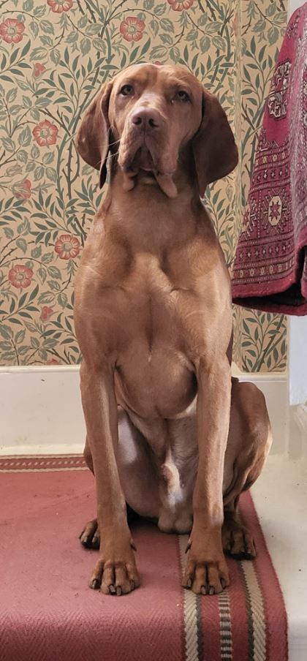

[[](https://bsky.app/profile/marinelives.bsky.social)](https://bsky.app/profile/marinelives.bsky.social)

[· 17/08/2024](https://bsky.app/profile/marinelives.bsky.social/post/3kzwrj3srak2c)

Introducing Bartok. To hell with all those cat memes. This is my DOG!



1

1

[View full thread](https://bsky.app/profile/did:plc:3haql47cl6jucf32mlqtre4p/post/3kzwrj3srak2c)

[[](https://bsky.app/profile/marinelives.bsky.social)](https://bsky.app/profile/marinelives.bsky.social)

[· 17/08/2024](https://bsky.app/profile/marinelives.bsky.social/post/3kzwskpvoyr2l)

But....He's my DOG.

1

[[](https://bsky.app/profile/marinelives.bsky.social)](https://bsky.app/profile/marinelives.bsky.social)

[· 17/08/2024](https://bsky.app/profile/marinelives.bsky.social/post/3kzwsrmg3t72w)

How depressing. End of my first day on BlueSky, and my most liked post is my DOG! I thought BlueSky was the creme de la creme, the intellectual Eiger. Guess we all need some down time? [#exhausted](https://bsky.app/hashtag/exhausted) [#surprised](https://bsky.app/hashtag/surprised) [#japanese](https://bsky.app/hashtag/japanese)

[[](https://bsky.app/profile/marinelives.bsky.social)](https://bsky.app/profile/marinelives.bsky.social)

[· 17/08/2024](https://bsky.app/profile/marinelives.bsky.social/post/3kzwsotdvu52j)

Ok, Maybe I have bitten off more than I understand. I have visited Japan four times, and still have the Japanese language tapes. Thank God, AI is progressing so I can image this BlueSky feed and figure out what it means [#help](https://bsky.app/hashtag/help)

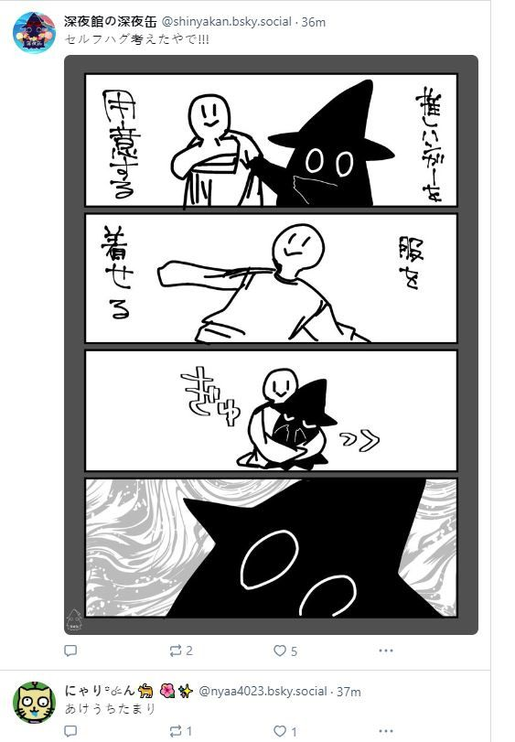

[[](https://bsky.app/profile/marinelives.bsky.social)](https://bsky.app/profile/marinelives.bsky.social)

[· 17/08/2024](https://bsky.app/profile/marinelives.bsky.social/post/3kzwi3ylxb22d)

[#earlymodern](https://bsky.app/hashtag/earlymodern) [#skystorians](https://bsky.app/hashtag/skystorians) [#textiles](https://bsky.app/hashtag/textiles) [#clothing](https://bsky.app/hashtag/clothing)

[[](https://bsky.app/profile/marinelives.bsky.social)](https://bsky.app/profile/marinelives.bsky.social)

[· 17/08/2024](https://bsky.app/profile/marinelives.bsky.social/post/3kzvhsjuemf23)

If you are interested in textiles, dyes and Early Modern Clothing we have a volunteer written gazeteer you will like: www.marinelives.org/wiki/Tools:\_...

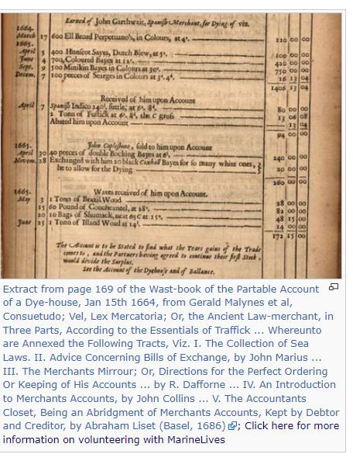

1

[[](https://bsky.app/profile/marinelives.bsky.social)](https://bsky.app/profile/marinelives.bsky.social)

[· 17/08/2024](https://bsky.app/profile/marinelives.bsky.social/post/3kzw5xotxjz2d)

I wonder why people are looking for Blue Skies? Comparison of 'Who to Follow' on the @MarineLives feed X versus BlueSky [bsky.app/profile/mari...](https://bsky.app/profile/marinelivesorg.bsky.social) [#earlymodern](https://bsky.app/hashtag/earlymodern) [#history](https://bsky.app/hashtag/history)

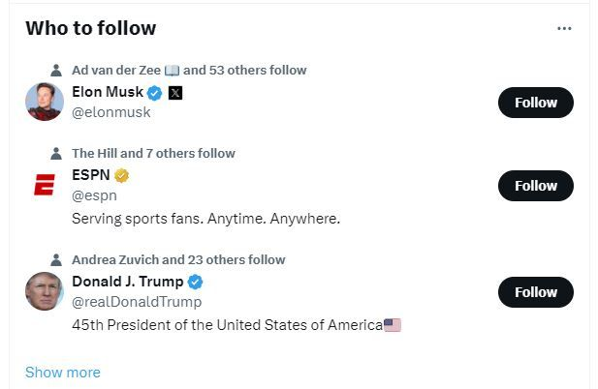

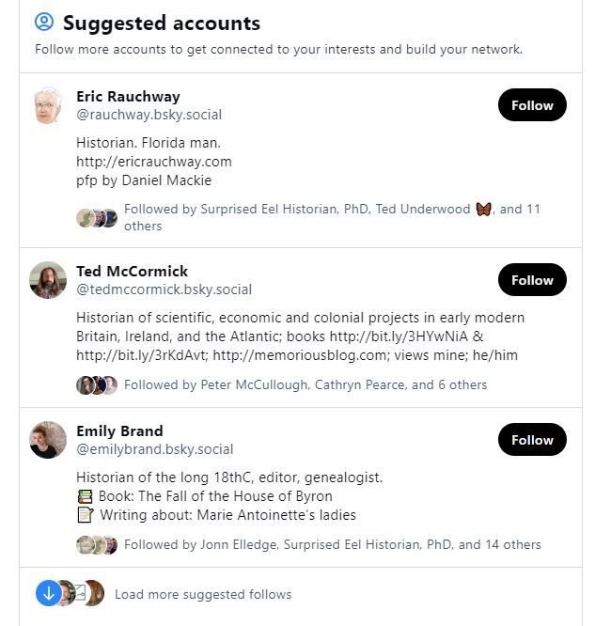

[[](https://bsky.app/profile/marinelives.bsky.social)](https://bsky.app/profile/marinelives.bsky.social)

[· 17/08/2024](https://bsky.app/profile/marinelives.bsky.social/post/3kzw53hmwbh2w)

Are you new to machine transcription of historical handrwriting (aka HTR)? I have built a GPT-4o powered bot to help out, with good knowledge of

[@transkribus.bsky.social](https://bsky.app/profile/did:plc:adbwqqtuasa27sf4ijch4zvt)

and other HTR packages [chatgpt.com/g/g-5RyFZvdj...](https://chatgpt.com/g/g-5RyFZvdjH-aurelius-htr) [#earlymodern](https://bsky.app/hashtag/earlymodern) [#history](https://bsky.app/hashtag/history) [#GPT-4](https://bsky.app/hashtag/GPT-4) [#ai](https://bsky.app/hashtag/ai) [#digitalhistory](https://bsky.app/hashtag/digitalhistory)

[[](https://chatgpt.com/g/g-5RyFZvdjH-aurelius-htr)](https://chatgpt.com/g/g-5RyFZvdjH-aurelius-htr" \t "_blank)

**[ChatGPT - Aurelius-HTR](https://chatgpt.com/g/g-5RyFZvdjH-aurelius-htr" \t "_blank)**

[Helping historians work with Transkribus and other open source HTR programs to generate and clean up HTR-text.](https://chatgpt.com/g/g-5RyFZvdjH-aurelius-htr" \t "_blank)

[chatgpt.com](https://chatgpt.com/g/g-5RyFZvdjH-aurelius-htr" \t "_blank)

3

[[](https://bsky.app/profile/marinelives.bsky.social)](https://bsky.app/profile/marinelives.bsky.social)

[· 17/08/2024](https://bsky.app/profile/marinelives.bsky.social/post/3kzvujuqjcb2l)

"They did call one an other pupies and rascall and foole and loggerhead and the like opprobious termes" [www.marinelives.org/wiki/HCA\_13/...](http://www.marinelives.org/wiki/HCA_13/71_f.601v_Annotate#head-7792b396c165940a2ef3372031f6dbb64b71233e)

**[HCA 13/71 f.601v Annotate - MarineLives](http://www.marinelives.org/wiki/HCA_13/71_f.601v_Annotate" \l "head-7792b396c165940a2ef3372031f6dbb64b71233e" \t "_blank)**

[www.marinelives.org](http://www.marinelives.org/wiki/HCA_13/71_f.601v_Annotate" \l "head-7792b396c165940a2ef3372031f6dbb64b71233e" \t "_blank)

[[](https://bsky.app/profile/marinelives.bsky.social)](https://bsky.app/profile/marinelives.bsky.social)

[· 17/08/2024](https://bsky.app/profile/marinelives.bsky.social/post/3kzvuhtqerr2s)

"Did tell the sayd Welch that those his Letters of Marque were good for nothing but to wipe his breeche with" [www.marinelives.org/wiki/HCA\_13/...](http://www.marinelives.org/wiki/HCA_13/72_f.218v_Annotate#head-7792b396c165940a2ef3372031f6dbb64b71233e)

**[HCA 13/72 f.218v Annotate - MarineLives](http://www.marinelives.org/wiki/HCA_13/72_f.218v_Annotate" \l "head-7792b396c165940a2ef3372031f6dbb64b71233e" \t "_blank)**

[www.marinelives.org](http://www.marinelives.org/wiki/HCA_13/72_f.218v_Annotate" \l "head-7792b396c165940a2ef3372031f6dbb64b71233e" \t "_blank)

[[](https://bsky.app/profile/marinelives.bsky.social)](https://bsky.app/profile/marinelives.bsky.social)

[· 17/08/2024](https://bsky.app/profile/marinelives.bsky.social/post/3kzvufw4zw62g)

"Called the sayd Woods Pedler and old roague and Churle and other reproachfull names and says if hee the sayd Woods were not an old man hee the sayd Grove would drubb him" [www.marinelives.org/wiki/HCA\_13/...](http://www.marinelives.org/wiki/HCA_13/72_f.280r_Annotate#head-7792b396c165940a2ef3372031f6dbb64b71233e)

**[HCA 13/72 f.280r Annotate - MarineLives](http://www.marinelives.org/wiki/HCA_13/72_f.280r_Annotate" \l "head-7792b396c165940a2ef3372031f6dbb64b71233e" \t "_blank)**

[www.marinelives.org](http://www.marinelives.org/wiki/HCA_13/72_f.280r_Annotate" \l "head-7792b396c165940a2ef3372031f6dbb64b71233e" \t "_blank)

[[](https://bsky.app/profile/marinelives.bsky.social)](https://bsky.app/profile/marinelives.bsky.social)

[· 17/08/2024](https://bsky.app/profile/marinelives.bsky.social/post/3kzvucyhrx52h)

Bad Behaviour and Invective: A MarineLives guide: "Did very barbarously and inhumanely use and entertaine this deponent threatning with pistolls and cutlases to kill him or to cutt his throat, calling him damned dogg and devell" (HCA 13/72 f.280r) [www.marinelives.org/wiki/Bad\_beh...](http://www.marinelives.org/wiki/Bad_behaviour_%26_Invective)

**[Bad behaviour & Invective - MarineLives](http://www.marinelives.org/wiki/Bad_behaviour_%26_Invective" \t "_blank)**

[www.marinelives.org](http://www.marinelives.org/wiki/Bad_behaviour_%26_Invective" \t "_blank)

[[](https://bsky.app/profile/marinelives.bsky.social)](https://bsky.app/profile/marinelives.bsky.social)

[· 17/08/2024](https://bsky.app/profile/marinelives.bsky.social/post/3kzvhsjuemf23)

If you are interested in textiles, dyes and Early Modern Clothing we have a volunteer written gazeteer you will like: [www.marinelives.org/wiki/Tools:\_...](http://www.marinelives.org/wiki/Tools:_Textiles,_garments,_%26_dyes_glossary)



6

[[](https://bsky.app/profile/marinelives.bsky.social)](https://bsky.app/profile/marinelives.bsky.social)

[· 17/08/2024](https://bsky.app/profile/marinelives.bsky.social/post/3kzvhbgvarz2d)

The wonderfully named Henry Roundkettle. You can access more English High Court of Admiralty depositions here: [github.com/Addaci/HCA/w...](https://github.com/Addaci/HCA/wiki)

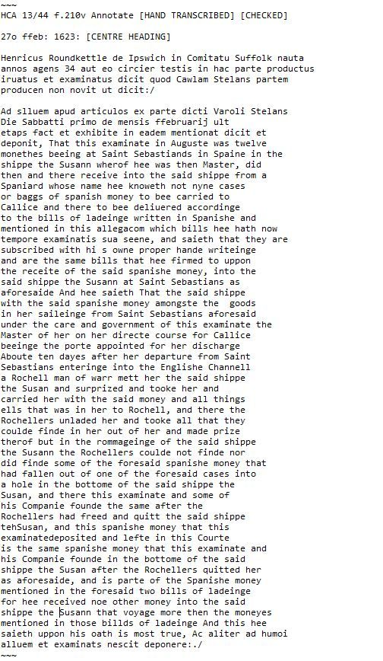

[[](https://bsky.app/profile/marinelives.bsky.social)](https://bsky.app/profile/marinelives.bsky.social)

[· 17/08/2024](https://bsky.app/profile/marinelives.bsky.social/post/3kzvh5ehpcn2e)

Account of massacre of Chinese during the seizure of Polaroone from the English by the Dutch in the early C17th

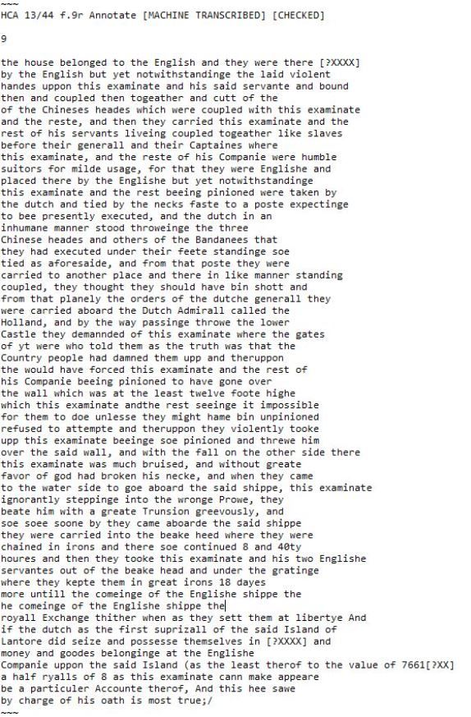

[[](https://bsky.app/profile/marinelives.bsky.social)](https://bsky.app/profile/marinelives.bsky.social)

[· 16/08/2024](https://bsky.app/profile/marinelives.bsky.social/post/3kzuaof2gmn2w)

We have recently launched a fund raising campaign to machine transcribe over 100 years of Early Modern History (1570 to 1685). 50,000 manuscript images. 30 million words. All published free into tHE Commons. If you can make a small donation, we would go THANKS! [www.gofundme.com/f/help-marin...](https://www.gofundme.com/f/help-marinelives-write-history)

[[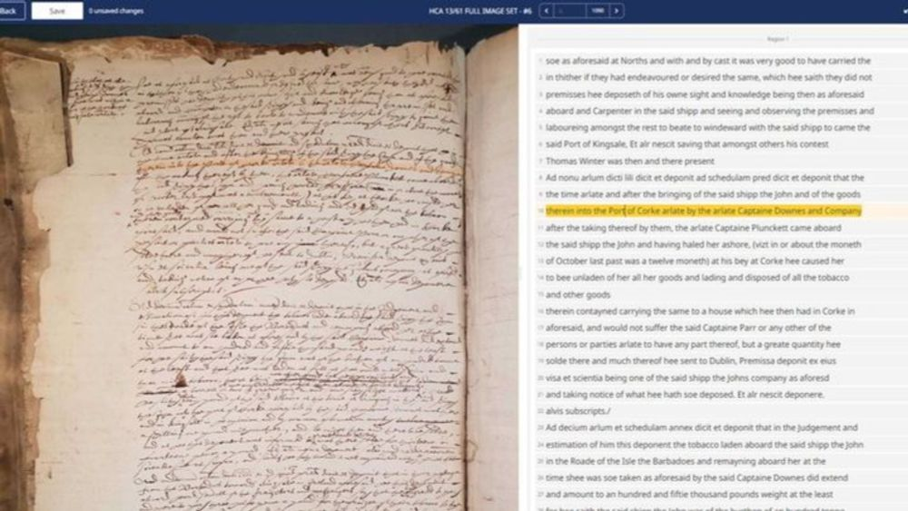](https://www.gofundme.com/f/help-marinelives-write-history)](https://www.gofundme.com/f/help-marinelives-write-history" \t "_blank)

**[Help MarineLives write history, organized by Colin Greenstreet](https://www.gofundme.com/f/help-marinelives-write-history" \t "_blank)**

[MarineLives is a group of volunteers committed to the publication of Early Modern leg… Colin Greenstreet needs your support for Help MarineLives write history](https://www.gofundme.com/f/help-marinelives-write-history" \t "_blank)

[www.gofundme.com](https://www.gofundme.com/f/help-marinelives-write-history" \t "_blank)

1

[[](https://bsky.app/profile/marinelives.bsky.social)](https://bsky.app/profile/marinelives.bsky.social)

[· 16/08/2024](https://bsky.app/profile/marinelives.bsky.social/post/3kzu7vnhnks2r)

Excellent review of Bronowski's career. I watched the Ascent of Man in the early 1970s and he was mesmorizing and mind opening, in a way that Kenneth Clarke never was.

[[](https://bsky.app/profile/davidhendy.bsky.social)](https://bsky.app/profile/davidhendy.bsky.social)

[· 16/08/2024](https://bsky.app/profile/davidhendy.bsky.social/post/3kzta2avngw2v)

Jacob Bronowski, the BBC, and MI5. My latest Substack open.substack.com/pub/davidhen...

[[](https://open.substack.com/pub/davidhendy/p/bronowski-beat?r=37fy4o&utm_campaign=post&utm_medium=web)](https://open.substack.com/pub/davidhendy/p/bronowski-beat?r=37fy4o&utm_campaign=post&utm_medium=web" \t "_blank)

**[Bronowski Beat](https://open.substack.com/pub/davidhendy/p/bronowski-beat?r=37fy4o&utm_campaign=post&utm_medium=web" \t "_blank)**

[Jacob Bronowski's epic 1973 TV series 'The Ascent of Man', a troubled broadcasting career, and MI5 interference in the BBC](https://open.substack.com/pub/davidhendy/p/bronowski-beat?r=37fy4o&utm_campaign=post&utm_medium=web" \t "_blank)

[open.substack.com](https://open.substack.com/pub/davidhendy/p/bronowski-beat?r=37fy4o&utm_campaign=post&utm_medium=web" \t "_blank)

[[](https://bsky.app/profile/marinelives.bsky.social)](https://bsky.app/profile/marinelives.bsky.social)

[· 16/08/2024](https://bsky.app/profile/marinelives.bsky.social/post/3kzu6kpg7af2d)

Would like to talk with historians interested in building GPT4o tailored agents to support historical research. Working with Cambridge and the LSE to test this out this Fall. Happy to share a presentation I gave to a UK National Archives AI workshop from the perspective of a user. [#BlueSkyHistorians](https://bsky.app/hashtag/BlueSkyHistorians)



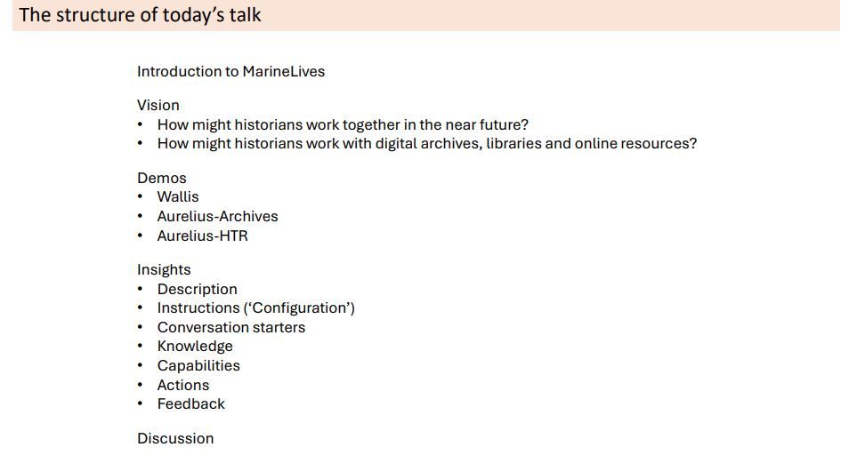

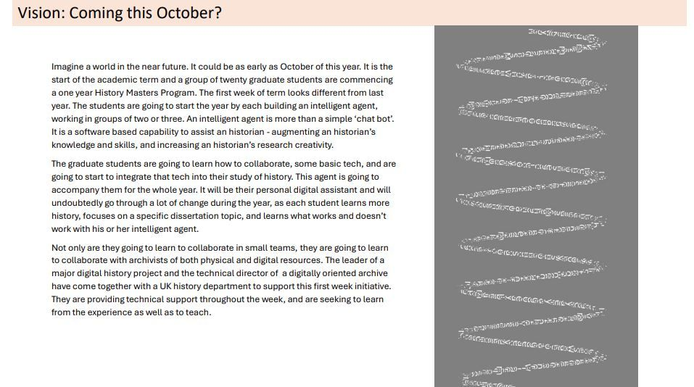

2

1

[[](https://bsky.app/profile/marinelives.bsky.social)](https://bsky.app/profile/marinelives.bsky.social)

[· 16/08/2024](https://bsky.app/profile/marinelives.bsky.social/post/3kzu7doaeaz2d)

Here is a link to the presentation on the MarineLives GitHubplatform (together with 5 million words of free C16tha nd C17th data) [github.com/Addaci/HCA/b...](https://github.com/Addaci/HCA/blob/main/TNA_AI_Week_New_Skills_for_Historians_FINAL_WITH_EMAIL_19072024.pdf)

**[https://github.com/Addaci/HCA/blob/main/TNA\_AI\_Week\_New\_Skills\_for\_Historians\_FINAL\_WITH\_EMAIL\_19072024.pdf](https://github.com/Addaci/HCA/blob/main/TNA_AI_Week_New_Skills_for_Historians_FINAL_WITH_EMAIL_19072024.pdf" \t "_blank)**

[github.com](https://github.com/Addaci/HCA/blob/main/TNA_AI_Week_New_Skills_for_Historians_FINAL_WITH_EMAIL_19072024.pdf" \t "_blank)

[[](https://bsky.app/profile/marinelives.bsky.social)](https://bsky.app/profile/marinelives.bsky.social)

[· 16/08/2024](https://bsky.app/profile/marinelives.bsky.social/post/3kzu74sfe7r2s)

Who would like to read a presentation I made about the potential for GPT-4o intelligent agents to support historical research? I talked on this topic on July 19th this year. I'm testing this out this fall at University of Cambridge and London School of Economics. [github.com/Addaci/HCA/b...](https://github.com/Addaci/HCA/blob/main/TNA_AI_Week_New_Skills_for_Historians_FINAL_WITH_EMAIL_19072024.pdf)

**[https://github.com/Addaci/HCA/blob/main/TNA\_AI\_Week\_New\_Skills\_for\_Historians\_FINAL\_WITH\_EMAIL\_19072024.pdf](https://github.com/Addaci/HCA/blob/main/TNA_AI_Week_New_Skills_for_Historians_FINAL_WITH_EMAIL_19072024.pdf" \t "_blank)**

[github.com](https://github.com/Addaci/HCA/blob/main/TNA_AI_Week_New_Skills_for_Historians_FINAL_WITH_EMAIL_19072024.pdf" \t "_blank)

[[](https://bsky.app/profile/marinelives.bsky.social)](https://bsky.app/profile/marinelives.bsky.social)

[· 16/08/2024](https://bsky.app/profile/marinelives.bsky.social/post/3kzu6xxdbzw2y)

Replied to you

Actually, you can read the presentation here - I have uploaded it to the MarineLives GitHub site: [github.com/Addaci/HCA/b...](https://github.com/Addaci/HCA/blob/main/TNA_AI_Week_New_Skills_for_Historians_FINAL_WITH_EMAIL_19072024.pdf)

**[https://github.com/Addaci/HCA/blob/main/TNA\_AI\_Week\_New\_Skills\_for\_Historians\_FINAL\_WITH\_EMAIL\_19072024.pdf](https://github.com/Addaci/HCA/blob/main/TNA_AI_Week_New_Skills_for_Historians_FINAL_WITH_EMAIL_19072024.pdf" \t "_blank)**

[github.com](https://github.com/Addaci/HCA/blob/main/TNA_AI_Week_New_Skills_for_Historians_FINAL_WITH_EMAIL_19072024.pdf" \t "_blank)

[Reposted by you](https://bsky.app/profile/marinelives.bsky.social)

[[](https://bsky.app/profile/serenaj1642.bsky.social)](https://bsky.app/profile/serenaj1642.bsky.social)

[· 16/08/2024](https://bsky.app/profile/serenaj1642.bsky.social/post/3kzu6kmsexl23)

Ooh, Marine Lives is here 😊 I really enjoyed the Twitter account.

[[](https://bsky.app/profile/marinelives.bsky.social)](https://bsky.app/profile/marinelives.bsky.social)

[· 16/08/2024](https://bsky.app/profile/marinelives.bsky.social/post/3kztyz2gpfx2j)

This feels weird. After 12 years on Twitter (can't get used to 'X') I now have zero followers. So let me say hello to @timhitchcock.bsky.social who tells me this is the place to hang out

1

**3**

[[](https://bsky.app/profile/marinelives.bsky.social)](https://bsky.app/profile/marinelives.bsky.social)

[· 16/08/2024](https://bsky.app/profile/marinelives.bsky.social/post/3kzu67ilsoj2j)

I'm loving this. All these people saying hello who I have never heard of, but I read their BlueSky profiles, and it is...they would be interesting to meet. Speed dating for historians, archivists, and obsessed GPT-4o historical agent builders (me)

1

[[](https://bsky.app/profile/marinelives.bsky.social)](https://bsky.app/profile/marinelives.bsky.social)

[· 16/08/2024](https://bsky.app/profile/marinelives.bsky.social/post/3kzu3chlhnw2p)

Agrees

[@stuartdunn.bsky.social](https://bsky.app/profile/did:plc:s26bnxpiqgmx2oly76x7gsmr)

Here's an overlay with English mariners letters sent and received as recorded in English High Court of Admiralty Court records

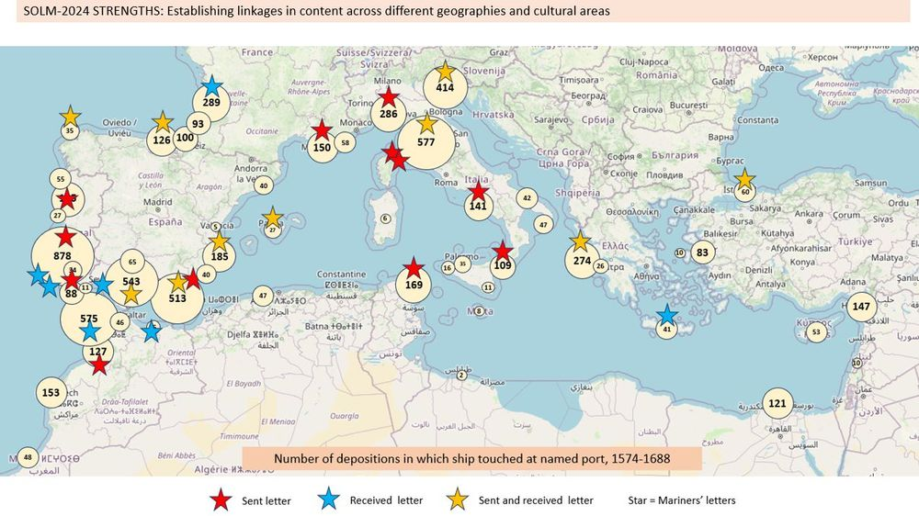

[[](https://bsky.app/profile/stuartdunn.bsky.social)](https://bsky.app/profile/stuartdunn.bsky.social)

[· 16/08/2024](https://bsky.app/profile/stuartdunn.bsky.social/post/3kzu35kqybd2z)

Who, honestly, doesn't love a good map??

1

[[](https://bsky.app/profile/marinelives.bsky.social)](https://bsky.app/profile/marinelives.bsky.social)

[· 16/08/2024](https://bsky.app/profile/marinelives.bsky.social/post/3kztzt45gxz2s)

Who likes maps? Here's a map of English High Copurt of Admiralty depositions mentioning ships which touched at specific Mediterranean ports, 1574 to 1688 [#BlueSkyhistorians](https://bsky.app/hashtag/BlueSkyhistorians)

[@stuartdunn.bsky.social](https://bsky.app/profile/did:plc:s26bnxpiqgmx2oly76x7gsmr)

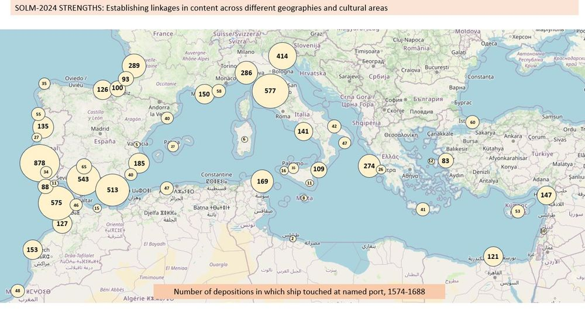

2

[[](https://bsky.app/profile/marinelives.bsky.social)](https://bsky.app/profile/marinelives.bsky.social)

[· 16/08/2024](https://bsky.app/profile/marinelives.bsky.social/post/3kzu35atavr2j)

My first ever BlueSky like!!! I feel new born.

[[](https://bsky.app/profile/marinelives.bsky.social)](https://bsky.app/profile/marinelives.bsky.social)

[· 16/08/2024](https://bsky.app/profile/marinelives.bsky.social/post/3kztzphv54o2y)

Who likes historical data? How old were Early Modern mariners? Well it depends... [#BlueSkyhistorians](https://bsky.app/hashtag/BlueSkyhistorians)

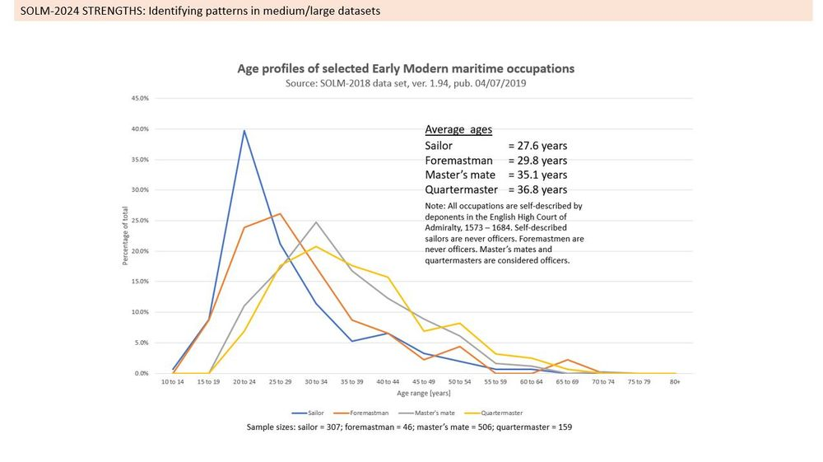

[[](https://bsky.app/profile/marinelives.bsky.social)](https://bsky.app/profile/marinelives.bsky.social)

[· 16/08/2024](https://bsky.app/profile/marinelives.bsky.social/post/3kztzj735dj2s)

[@greenleejw.bsky.social](https://bsky.app/profile/did:plc:vtulckfwhlh3ndn4iqfcg3an)

[@alexislitvine.bsky.social](https://bsky.app/profile/did:plc:lg7oudq5ynie5r6vfx76o7l2)

[@ihr.bsky.social](https://bsky.app/profile/did:plc:msb74n73t2heaaacburngrwh)

[@transkribus.bsky.social](https://bsky.app/profile/did:plc:adbwqqtuasa27sf4ijch4zvt)

[@bldigischol.bsky.social](https://bsky.app/profile/did:plc:gtarnb7xku46icu67cyrxomu)

[@camhistory.bsky.social](https://bsky.app/profile/did:plc:6dcv5zxvlb5oybsmyxuqys3e)

[[](https://bsky.app/profile/marinelives.bsky.social)](https://bsky.app/profile/marinelives.bsky.social)

[· 16/08/2024](https://bsky.app/profile/marinelives.bsky.social/post/3kztyz2gpfx2j)

This feels weird. After 12 years on Twitter (can't get used to 'X') I now have zero followers. So let me say hello to @timhitchcock.bsky.social who tells me this is the place to hang out

1

1

[[](https://bsky.app/profile/marinelives.bsky.social)](https://bsky.app/profile/marinelives.bsky.social)

[· 16/08/2024](https://bsky.app/profile/marinelives.bsky.social/post/3kztzbpjesi23)

Interested in history? Like free stuff in the Commons? You can access 5 million words (12,000 manuscript pages plus) of Early Modern social, economic, legal and marine history by checking out the MarineLives GitHub repository [#Blueskyhistorians](https://bsky.app/hashtag/Blueskyhistorians) [github.com/Addaci/HCA/t...](https://github.com/Addaci/HCA/tree/main)

[[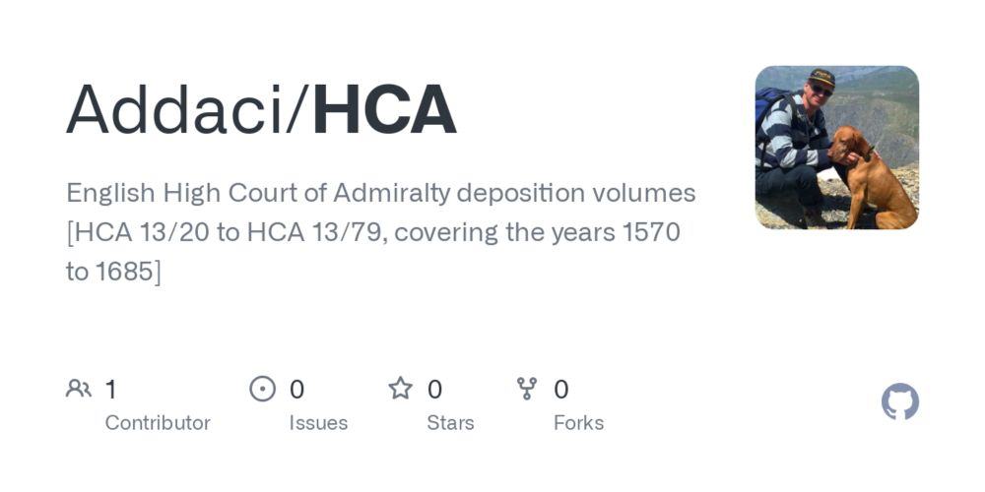](https://github.com/Addaci/HCA/tree/main)](https://github.com/Addaci/HCA/tree/main" \t "_blank)

**[GitHub - Addaci/HCA: English High Court of Admiralty deposition volumes [HCA 13/20 to HCA 13/79, covering the years 1570 to 1685]](https://github.com/Addaci/HCA/tree/main" \t "_blank)**

[English High Court of Admiralty deposition volumes [HCA 13/20 to HCA 13/79, covering the years 1570 to 1685] - Addaci/HCA](https://github.com/Addaci/HCA/tree/main" \t "_blank)

[github.com](https://github.com/Addaci/HCA/tree/main" \t "_blank)

[[](https://bsky.app/profile/marinelives.bsky.social)](https://bsky.app/profile/marinelives.bsky.social)

[· 16/08/2024](https://bsky.app/profile/marinelives.bsky.social/post/3kztz4brzby26)

Guess I will have to post some content to see if I can interest [#blueskyhistorians](https://bsky.app/hashtag/blueskyhistorians). Here's an early C17th deposition concerning the fear of turning Turk by an enslaved two year old surgeon, who was son of a London grocer

[@timhitchcock.bsky.social](https://bsky.app/profile/did:plc:zazpgix5w4ldyytazeqzytmz)

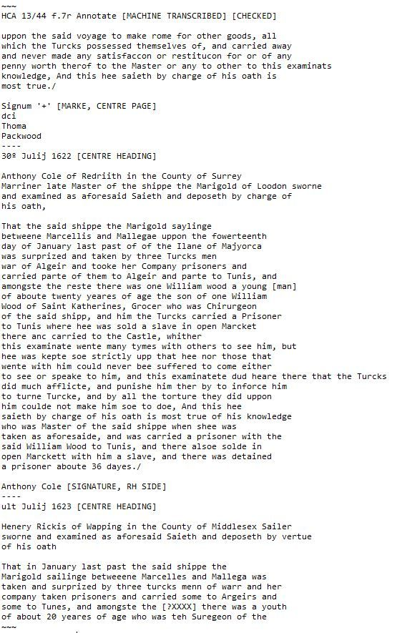

[[](https://bsky.app/profile/marinelives.bsky.social)](https://bsky.app/profile/marinelives.bsky.social)

[· 16/08/2024](https://bsky.app/profile/marinelives.bsky.social/post/3kztyz2gpfx2j)

This feels weird. After 12 years on Twitter (can't get used to 'X') I now have zero followers. So let me say hello to

[@timhitchcock.bsky.social](https://bsky.app/profile/did:plc:zazpgix5w4ldyytazeqzytmz)

who tells me this is the place to hang out

4

7

[[](https://bsky.app/profile/marinelives.bsky.social)](https://bsky.app/profile/marinelives.bsky.social)

[· 16/08/2024](https://bsky.app/profile/marinelives.bsky.social/post/3kztywmgtyx2v)

Hello World! Colin Greenstreet from @MarineLivesorg migrating to BlueSky. And it feels like home.

